台南縣仁德國小 九十八學年度第二學期 期末評量英文科試題

命題範圍：佳音版第四冊Unit4至Review 2 四年___班___號 姓名：_________________

家長簽章：_________________
I. Listen and Check. 聽一聽，勾選出聽到的單字。(18%)
1.  king 2.  whip 3.  thin
 ring  whisk  thick

4.  tank 5.  this 6.  dolphin
 pink  that  Philip
II. Write. 看圖寫出正確的字母。 (9%)
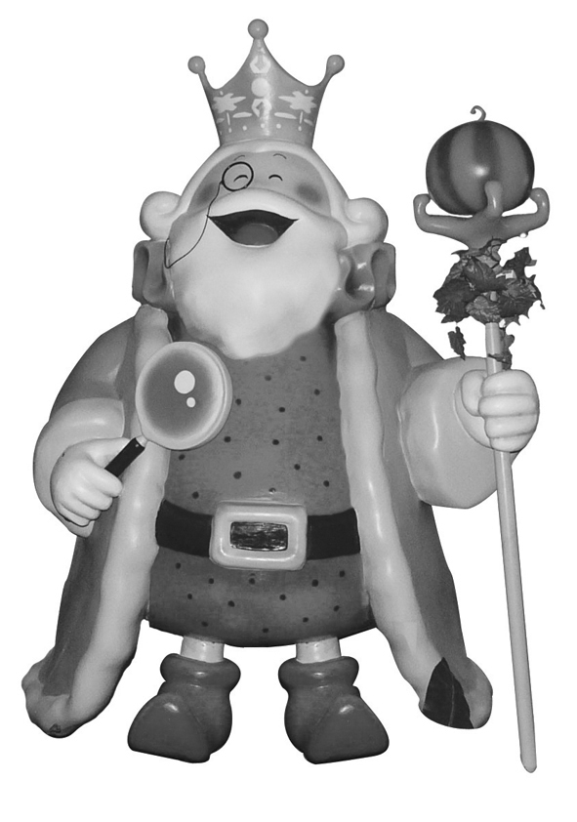
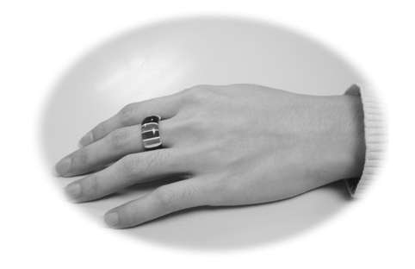
1. 2. 3.
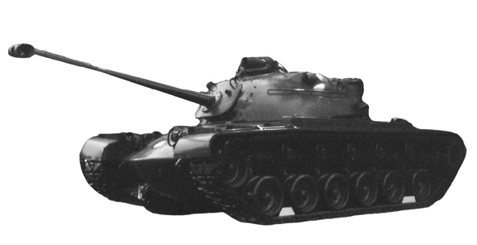

n g
n g
n k
k i t a r i

III. Write. 看圖片完成句子。(24%)
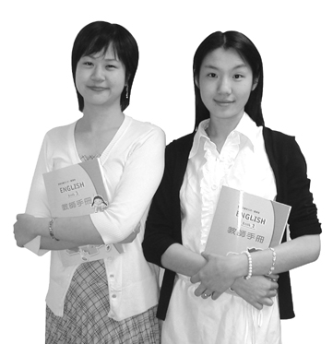
1.
They are______teachers________.
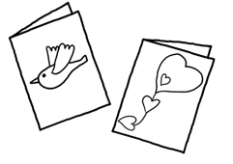

2. Are they_______cards_________? Yes, they are.
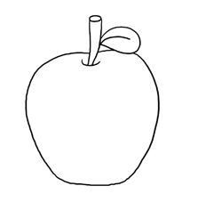

3.
What are________these_______? They are apples.
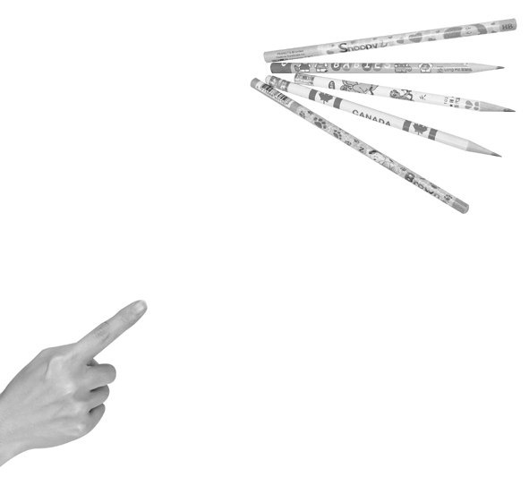

4. What are those?
They are_____pencils__________.
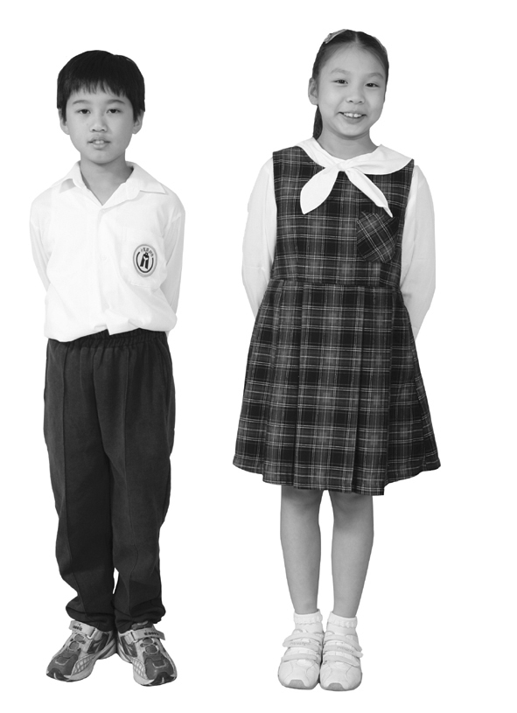

5. They are_______students________.
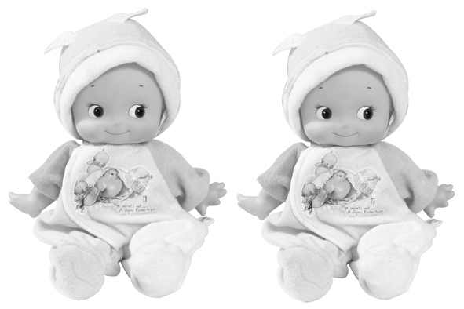

6. They are______dolls____________.

IV. Choose. 選出正確的答案。(18%)

( b ) 1. What _____ these?
(a) is (b) are (c) am
( a ) 2. They are _____.
(a) cups (b) cup (c) a cup
( b ) 3. A: Are they books? B: No, _____.
(a) they are (b) they aren’t (c) it’s not
( c ) 4. A: This is for you. B: _____
(a) They are pies. (b) You are welcome. (c) Thank you.
( b ) 5. A: It’s good to see you, Jim. B: _____
(a) See you soon. (b) It’s good to see you, too.
(c) It’s great.
( c ) 6. What are _____?
(a) it (b) this (c)those

V. Choose. 看圖選出正確的單字。(16%)
 door
 dolls
 doll
1. 2.
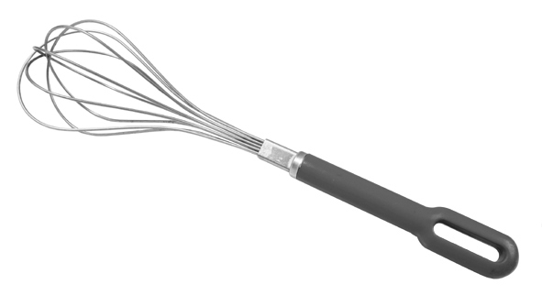
 whisk
 whip
 what

3. 4.
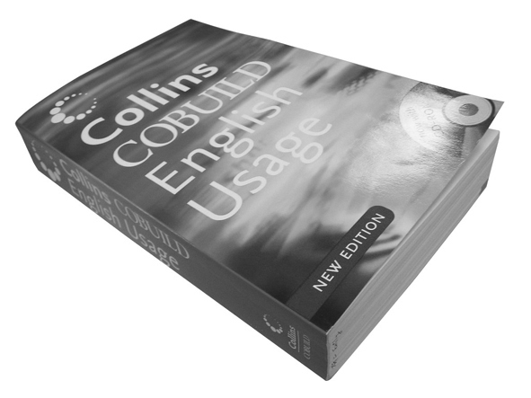
 thin
 thick
 this
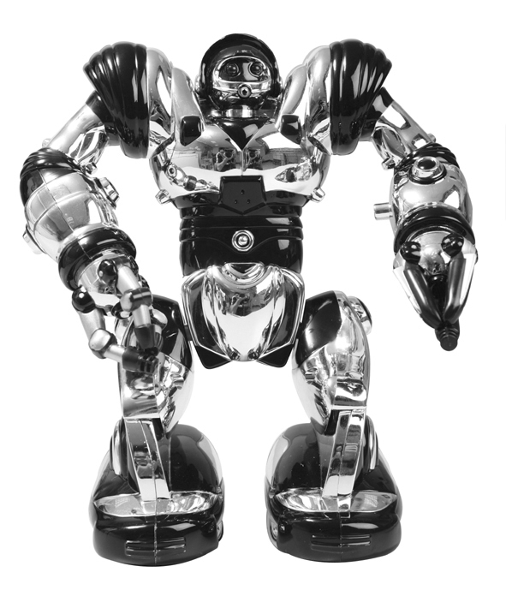
 red
 robot
 robots

VI. Unscramble. 重組句子。(15%)
1. They / . / dolls / are
They are dolls.

2. are / They / . / pencils / not
They are not pencils.

3. is / so good / . / see you / It / ,too / to
It is so good to see you, too.

