台南縣仁德國小九十八學年度第二學期期末評量英語科試題
命題範圍:康軒版第二冊Lesson 4到Review 2 三年____班____號 姓名：___________家長簽名：

1 Listen and Mark
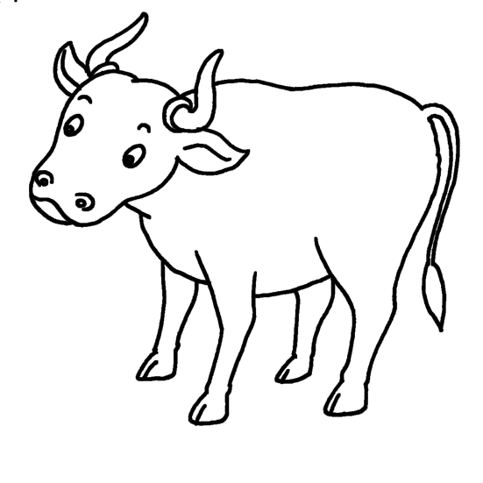
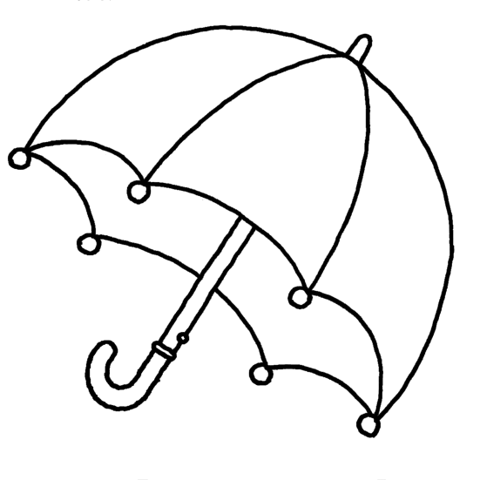
發音相符寫○，不符寫× (8%)
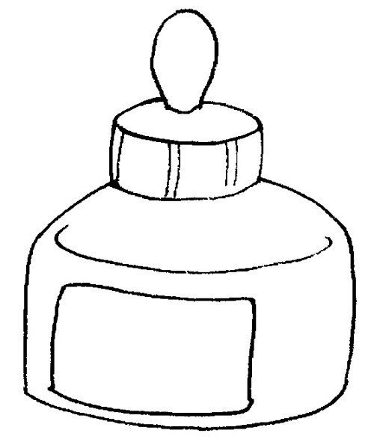
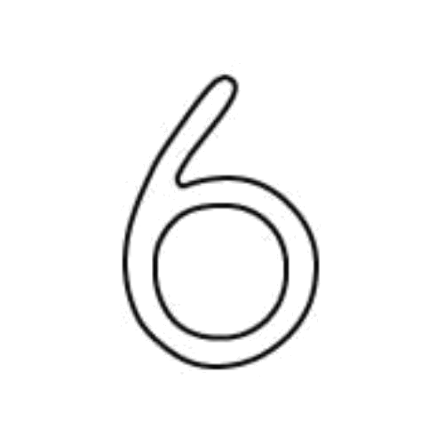

1. 2.

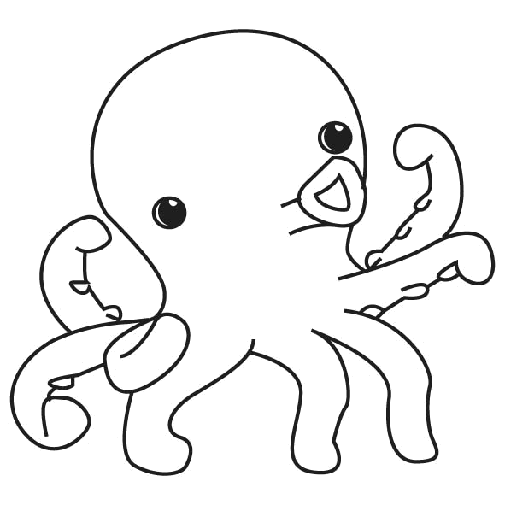

3. 4.
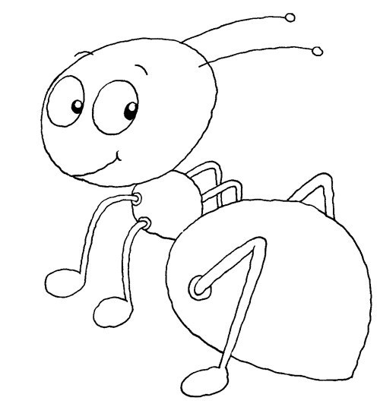
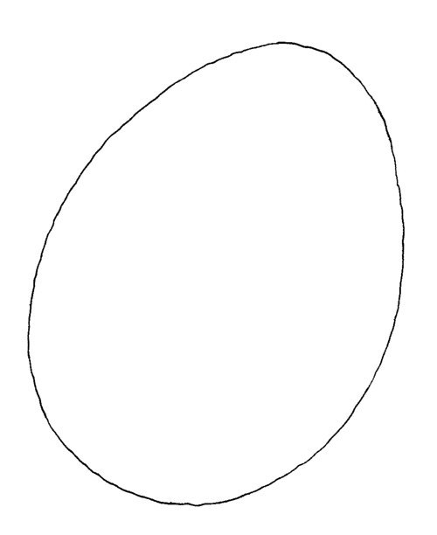

2 Listen and Circle圈選正確的字母 (8%)
1. 2.
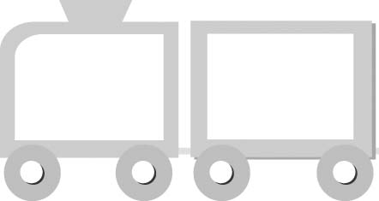
i

u
a

o

3. 4.
o

i
u

e

3 Listen and Check勾選正確的圖片 (18%)
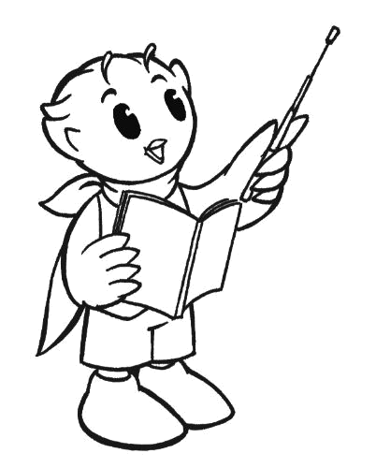
1.
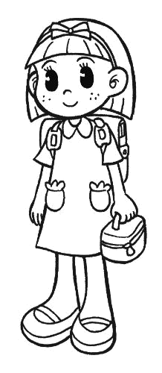

2.
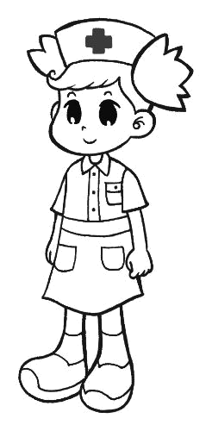
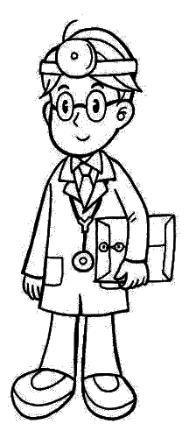

3.
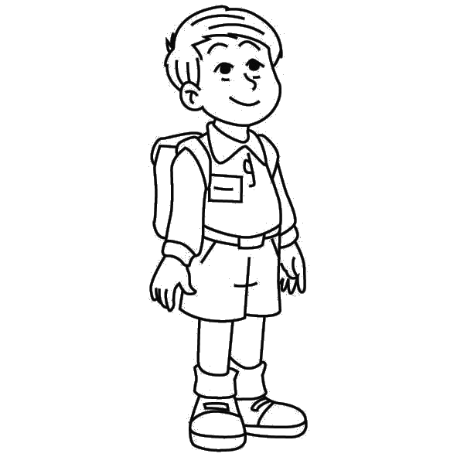

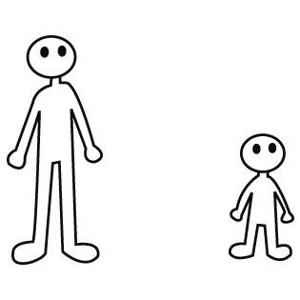
4.

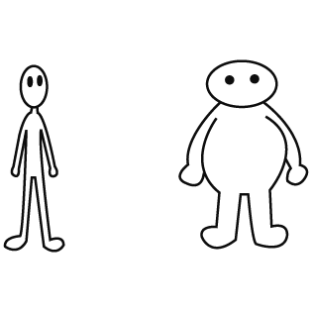
5.

6.

4 Listen and Number
在圖片上按順序寫出號碼 (16%)

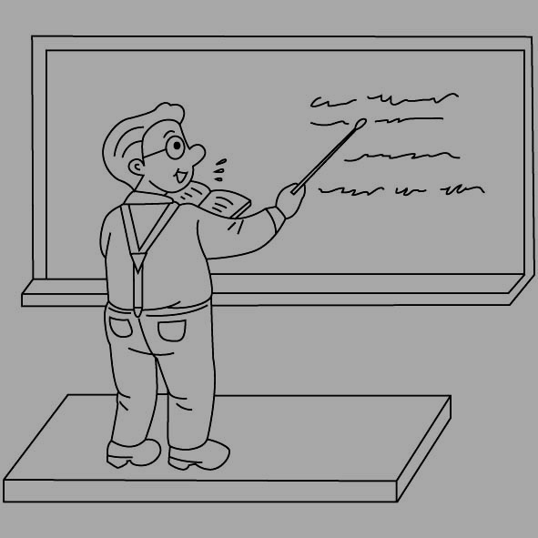

（請翻面繼續作答）

5 Look, Read and Mark
✓
讀一讀，圖和文字相符寫○，不符寫×(12%)
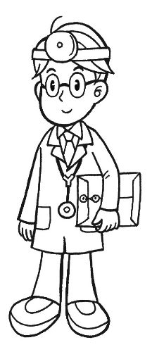
1. 2.

doctor

student

3. 4.

short

nurse

5. 6.

tall

thin

6 Look, Read and Check看圖勾選正確的對話 (18%)
1.
Is your sister a student?
Yes, she is.

No, she isn’t.

2.
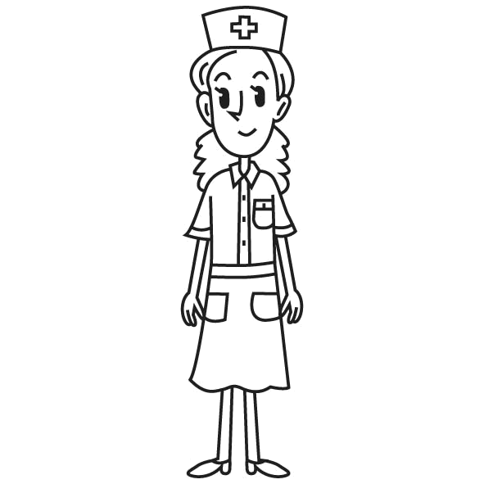
Is your mother a teacher?
No, he isn’t.

No, she isn’t.

3.
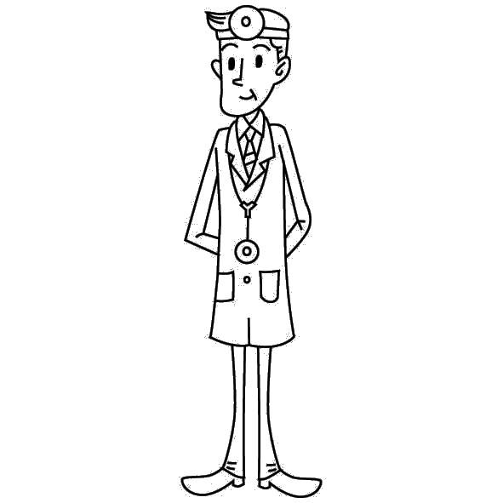
Is your father a doctor?
Yes, she is.

Yes, he is.

4.
Is he tall?
Yes, he is.

Yes, she is.

5.
Is she thin?
Yes, she is.

No, she isn’t.

6.
Is she short?
No, she isn’t. She is heavy.

No, she isn’t. She is tall.

7 Look, Read and Write
看一看，讀一讀，填入正確的代號 (20%)
A He is heavy. B Oh,I see!
C Is your father a doctor?
No, he isn’t. He is a teacher.
D My sister is a student.
E My mother isn’t a doctor. She’s a nurse.
1.

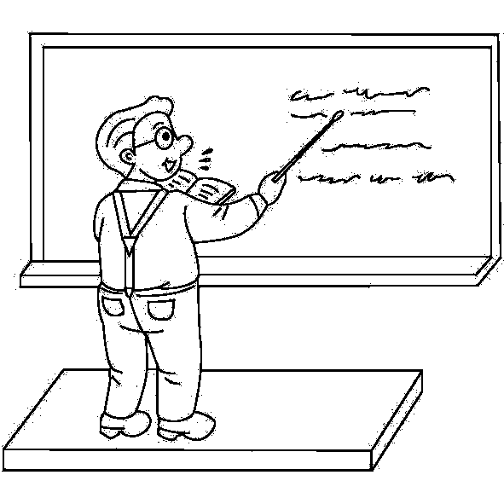
2.

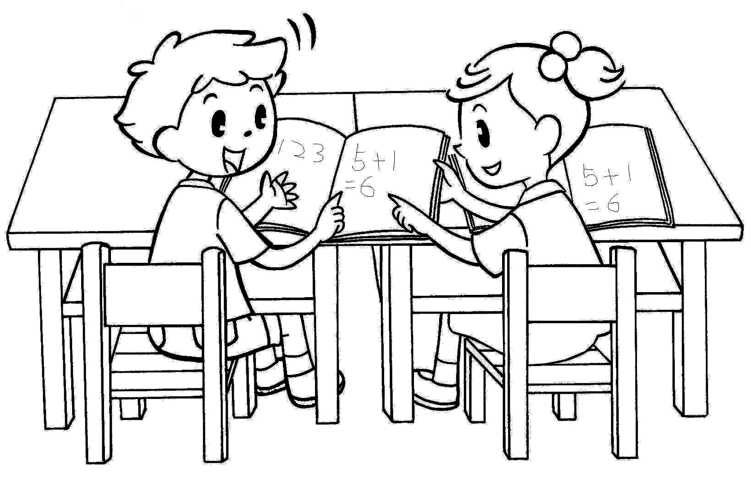
3.

4.

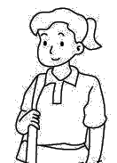

5.

