台南縣仁德國小 九十八學年度第二學期 期中評量英文科試題
命題範圍：何嘉仁版第八冊Starter Unit至Review 1 六年___班___號 姓名：________
A.仔細聽，勾選出正確的圖片，並寫出正確的單字: 24% (每題4分)
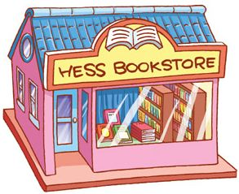
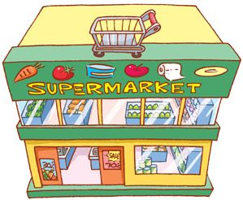
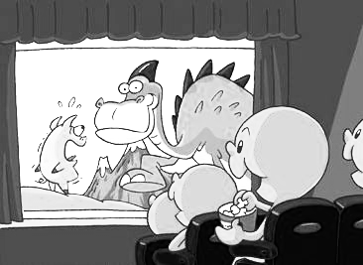
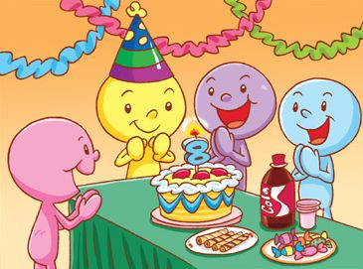
  - 2.

___________________________ _____________________________

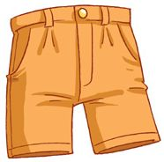
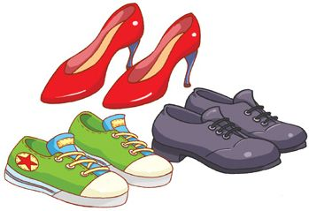
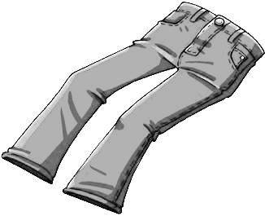
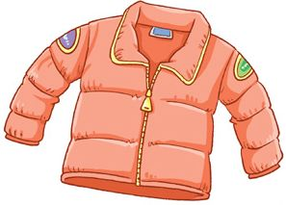
3. 4.

____________________________ _____________________________

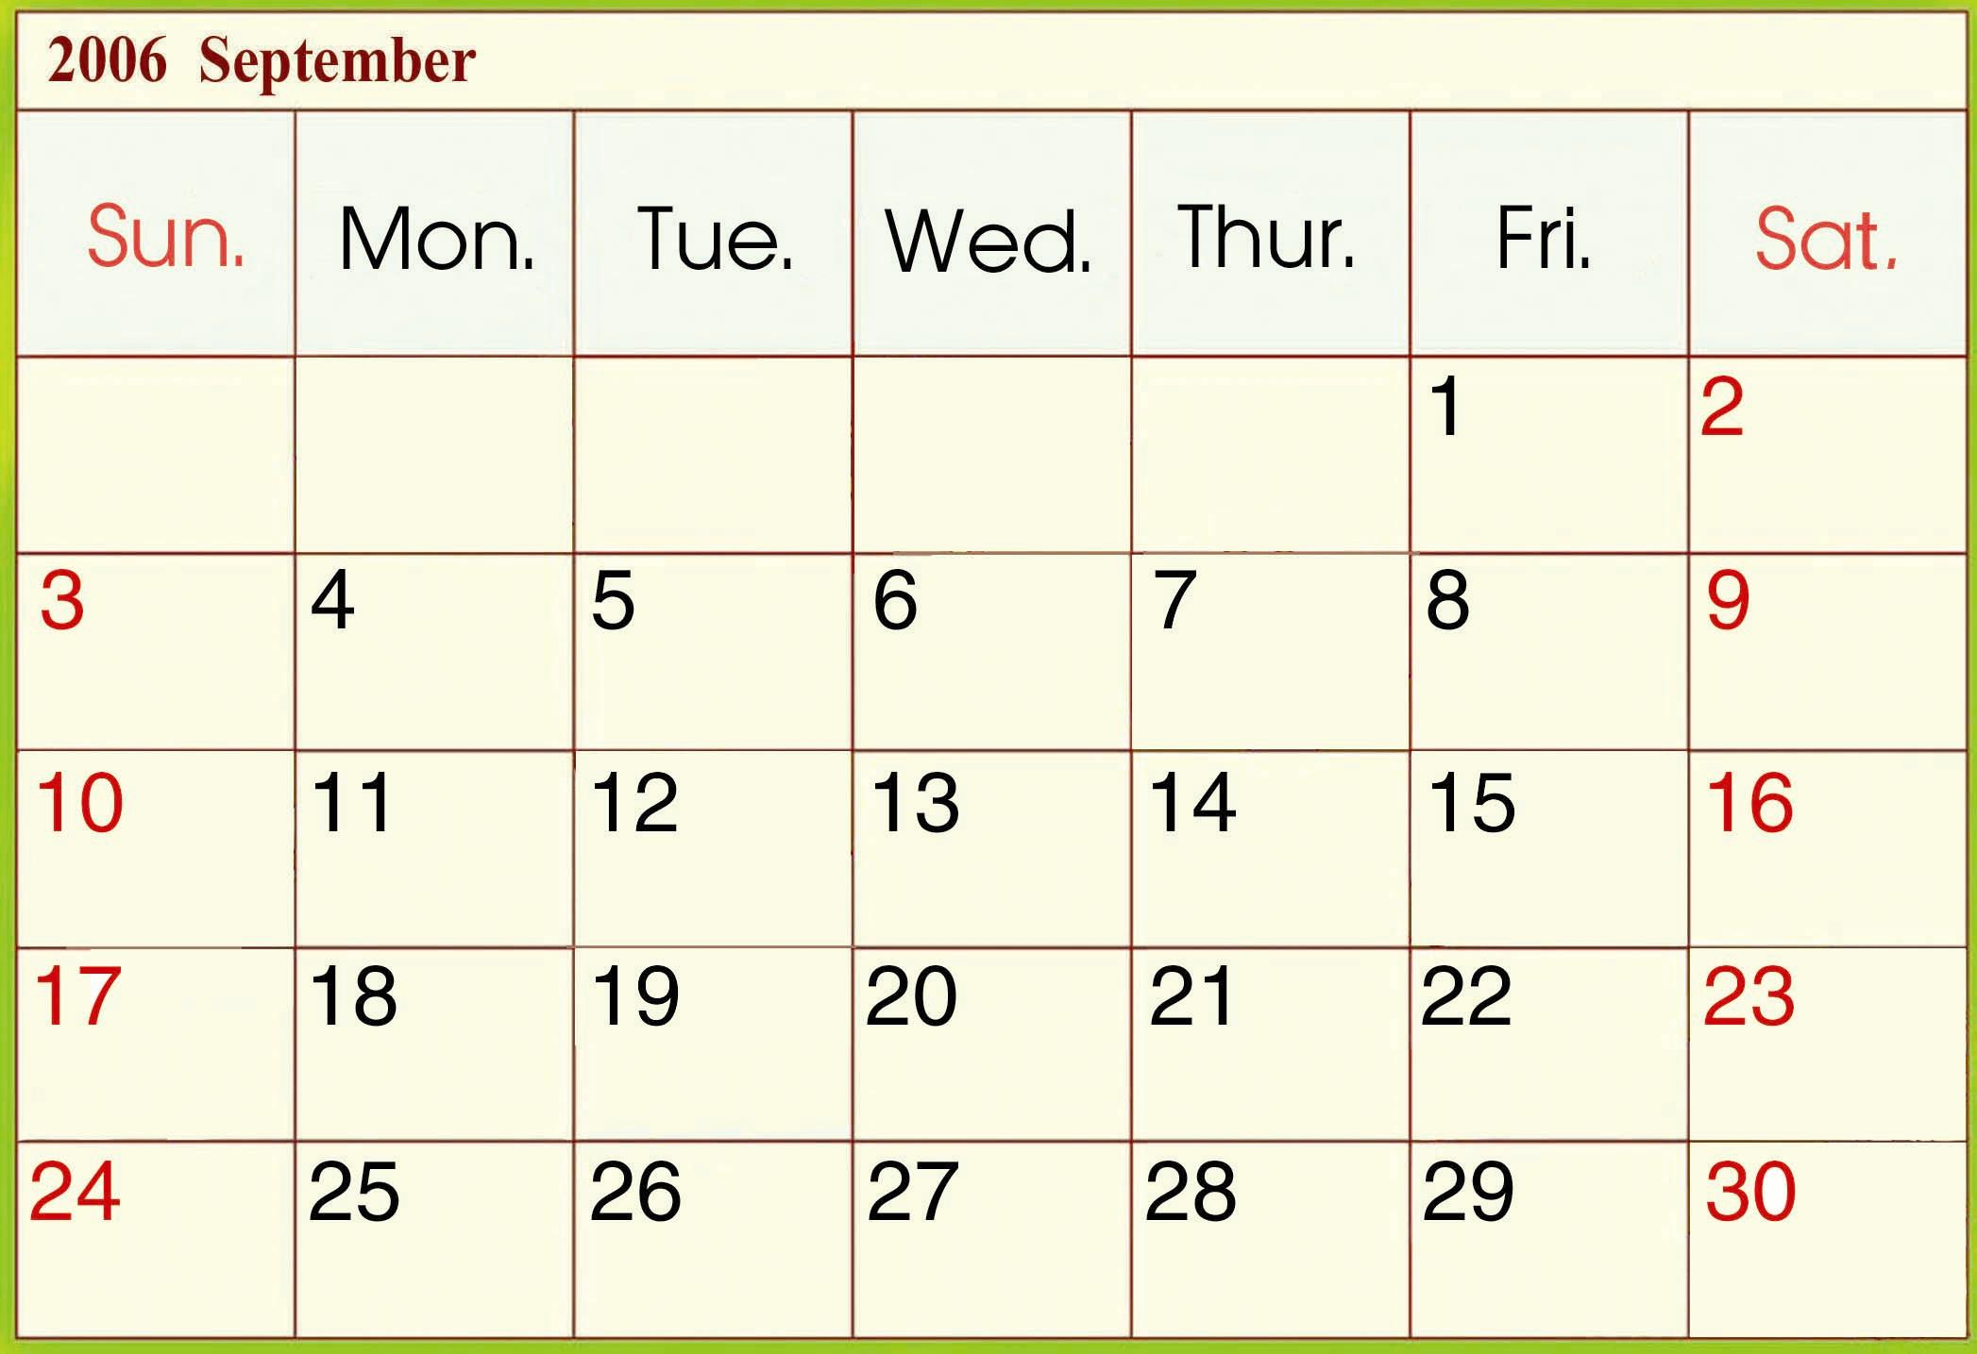
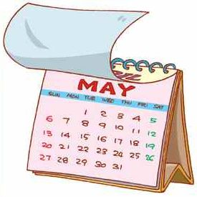
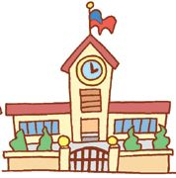
5. 6.
?
this week

__________________________ _____________________________
B.仔細讀，並將對話代號填入適當的圖片中: 8% (每題2分)
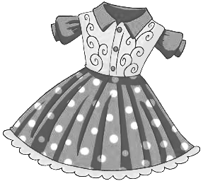
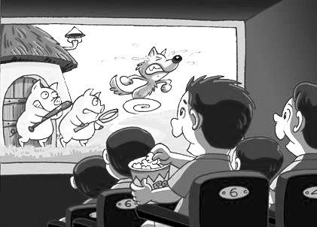
1. 2.
(a) A: What will Willy do next month?
B: He’ll see a movie.

(b) A: Will you go to the bookstore tomorrow?
B: Yes, I will.

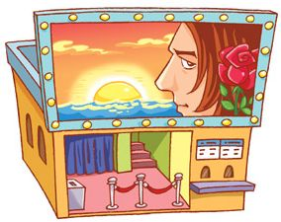
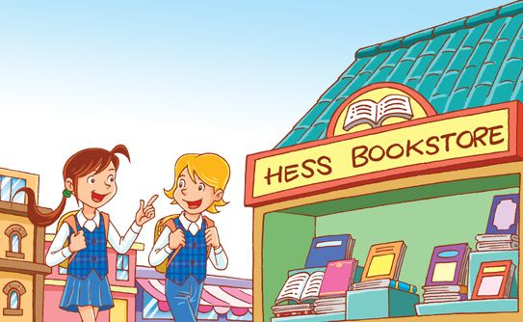
3. 4.
(c) A: What are you going to wear?
B: I’m going to wear the dress.

(d) A: Where will you go next week?
B: I’ll go to the theater.

C.諺語翻譯：8% (每題4分)
1.人要衣裝，佛要金裝。_______________________________________________________________________
2.熟能生巧。
_______________________________________________________________________

D.畫線部分的發音，相同請打○，不同請打╳。
：10%(每題2分)
(1) ( ) moon spoon
(2) ( ) good foot
(3) ( ) goose box
(4) ( ) soil boy
(5) ( ) say soy

E.文法選擇：15%(每題3分)
1. ( ) ____ you going to wear a T-shirt?
(a. Are b. Will c. Do )

2. ( ) What ____ you going to wear for the party?(a. will b. is c. are)

3. ( ) Where ____ you go tomorrow?
(a. are b. will c. do)

4. ( ) A: Will you go to the zoo next week?
B: No, I _____. I’ll go to the park.
(a. am not b. can’t c. won’t)

5. ( ) A: Will she wear a dress next Sunday?
B: Yes, she ____.
(a. is b. will c. are)

F.看圖回答問題：20% (每題4分)

1. A: Where will she go next month?
B：She’ll _________________
______________________

2. A: What will they do next week?

B: They’ll ________________
_______________________


3. A: Will you write a card for Bella?
B:_______________________
_______________________
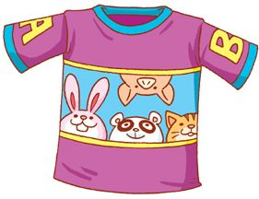
4. A: What is he going to wear?
B: He is going to __________
_______________________
5. A: Are you going to wear jeans tomorrow?
B: _______________________
_______________________
G.選出正確的答句：15%(每題3分)
1. ( ) What will you do tomorrow morning?
(a) Yes, I will go to school.
(b) We’ll buy some food.
2. ( ) Is Lisa going to wear those shoes tomorrow?
(a) Yes, she is.
(b) No, she’s going to see a movie.
3. ( ) Will Linda have a party next month?
(a) Yes, she is.
(b) No, she will have a party next week.
4. ( ) Where will you and your father go tomorrow?
(a) We’ll go to the theater.
(b) I’ll write an e-mail.
5. ( ) What is Lisa going to wear for Jason’s party?
(a) She’ll go to the party.
(b) A red dress.

家長簽章：_________________

