台南縣仁德國小九十八學年度第二學期期中評量英語科試題 (解答篇)
命題範圍:康軒版第二冊Lesson 1到Review 1 三年____班____號 姓名：___________
A. Listen and Number 聽一聽在 中，寫出正確的數字。12%(每題2分) 5 1 3 6 2 4
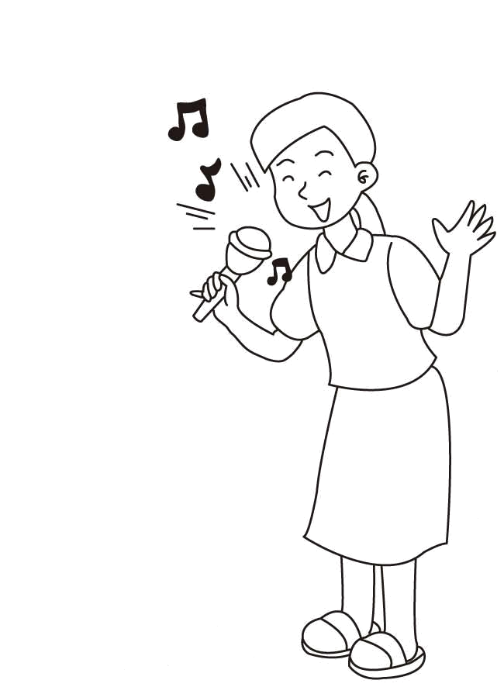
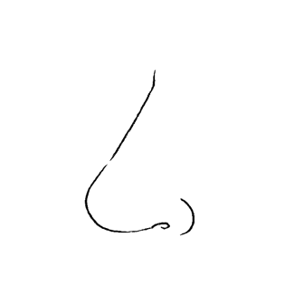
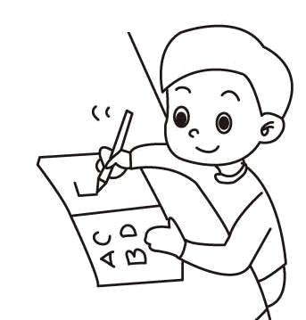
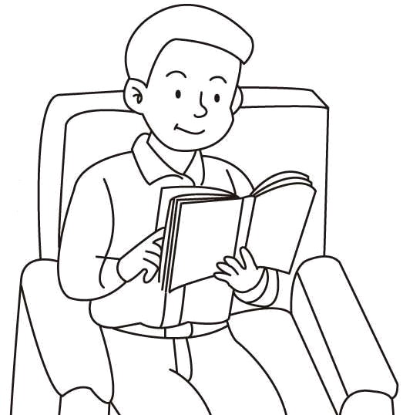
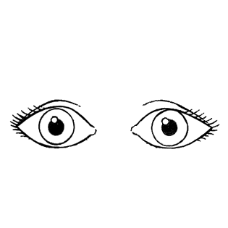
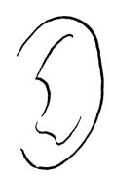
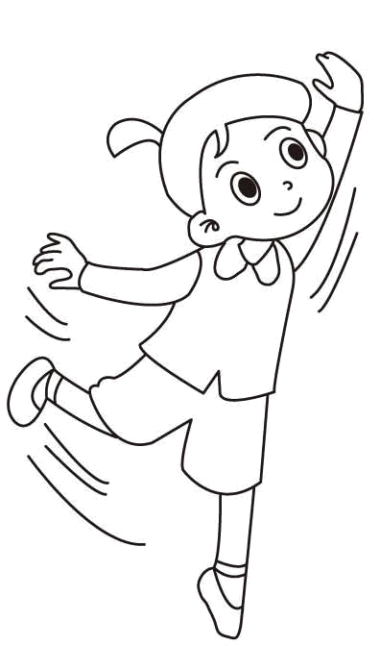

B. Listen and Circle圈選正確的字母。12%(每題2分) 1.a 2.i 3.e 4.a 5.i 6.e


1. 2. 3.
a

i
i

e

Can you dance?
Yes, I can.
No, I can’t.

√
e

a

4. 5. 6.
e

a

i

a

e
i

C. Listen and Circle圈選所聽到的正確數字16%(每題2分) 1. 5 2. 8 3.seven 4.nine
5. 9 6. 4 7.two 8.three
1. | 5 | 4 | 2. | 3 | 8 | 3. | six | seven | 4. | nine |  | one
5. | 8 | 9 | 6. | 7 | 4 | 7. | two | ten | 8. | three |  | eight

D. Listen and Check聽一聽，在正確的答案中打 V 12%(每題2分)
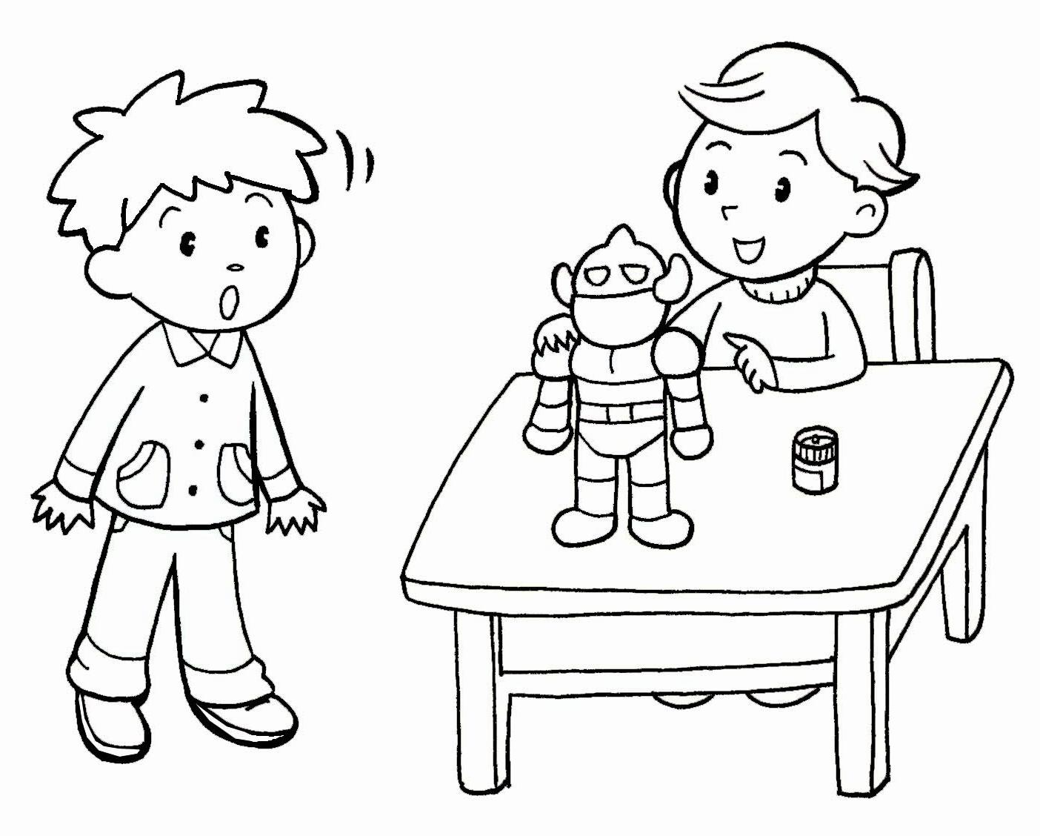
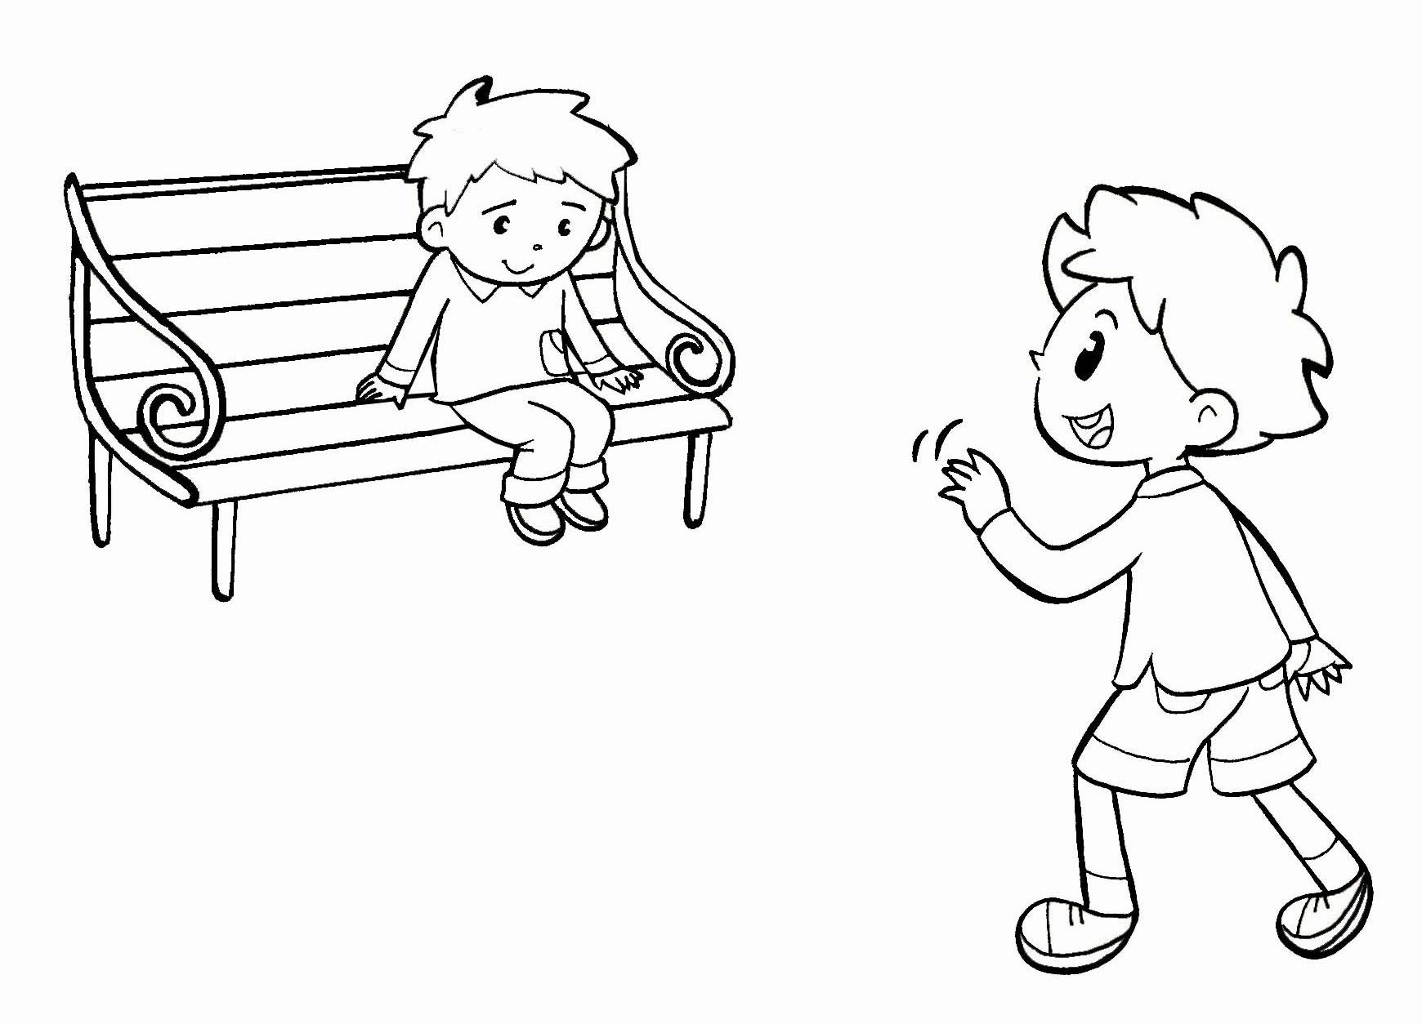
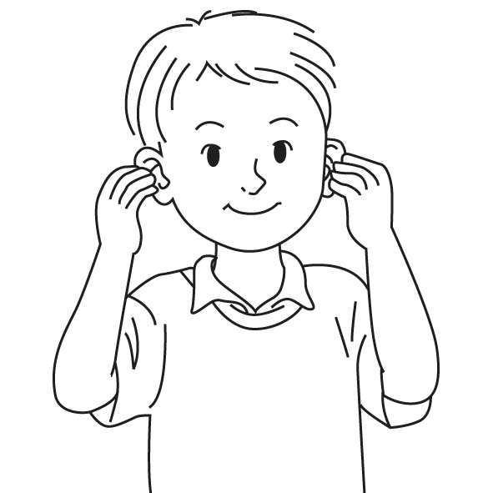
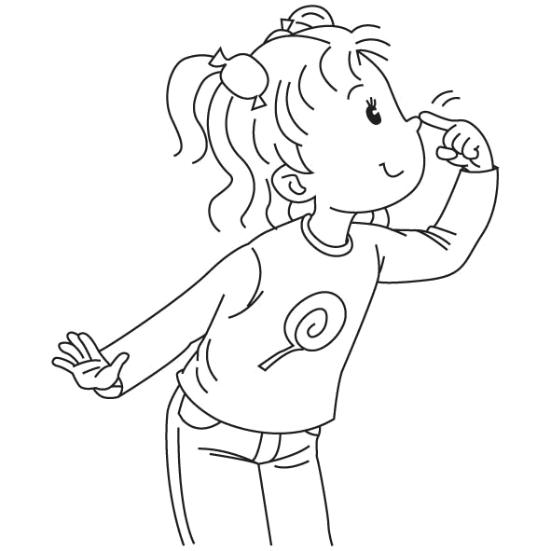
1. 2.
V
V

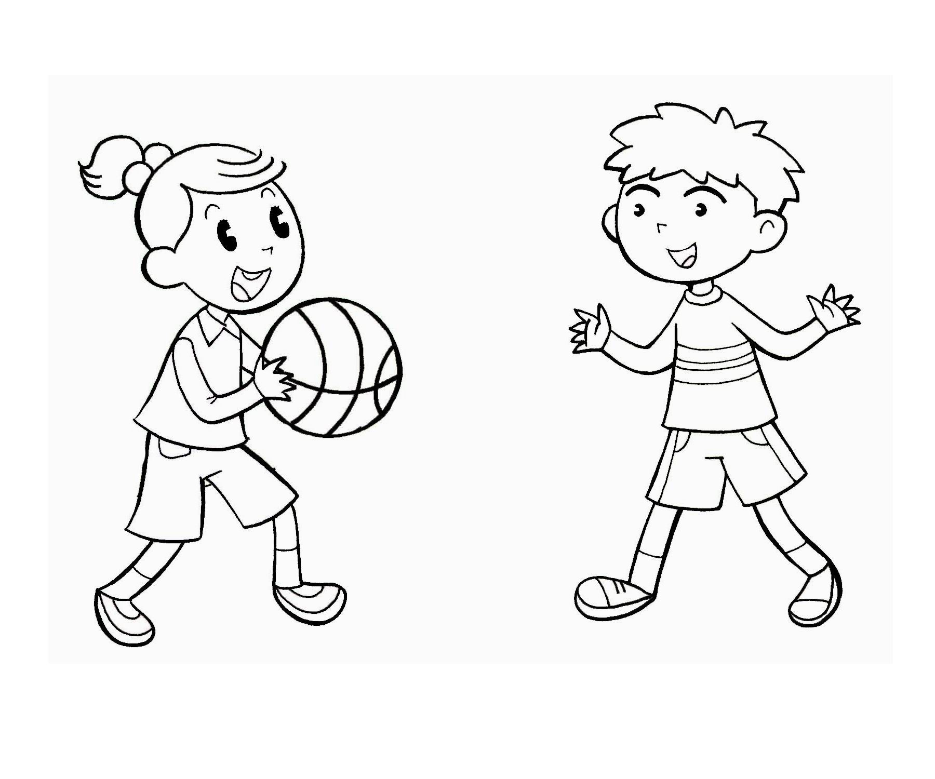
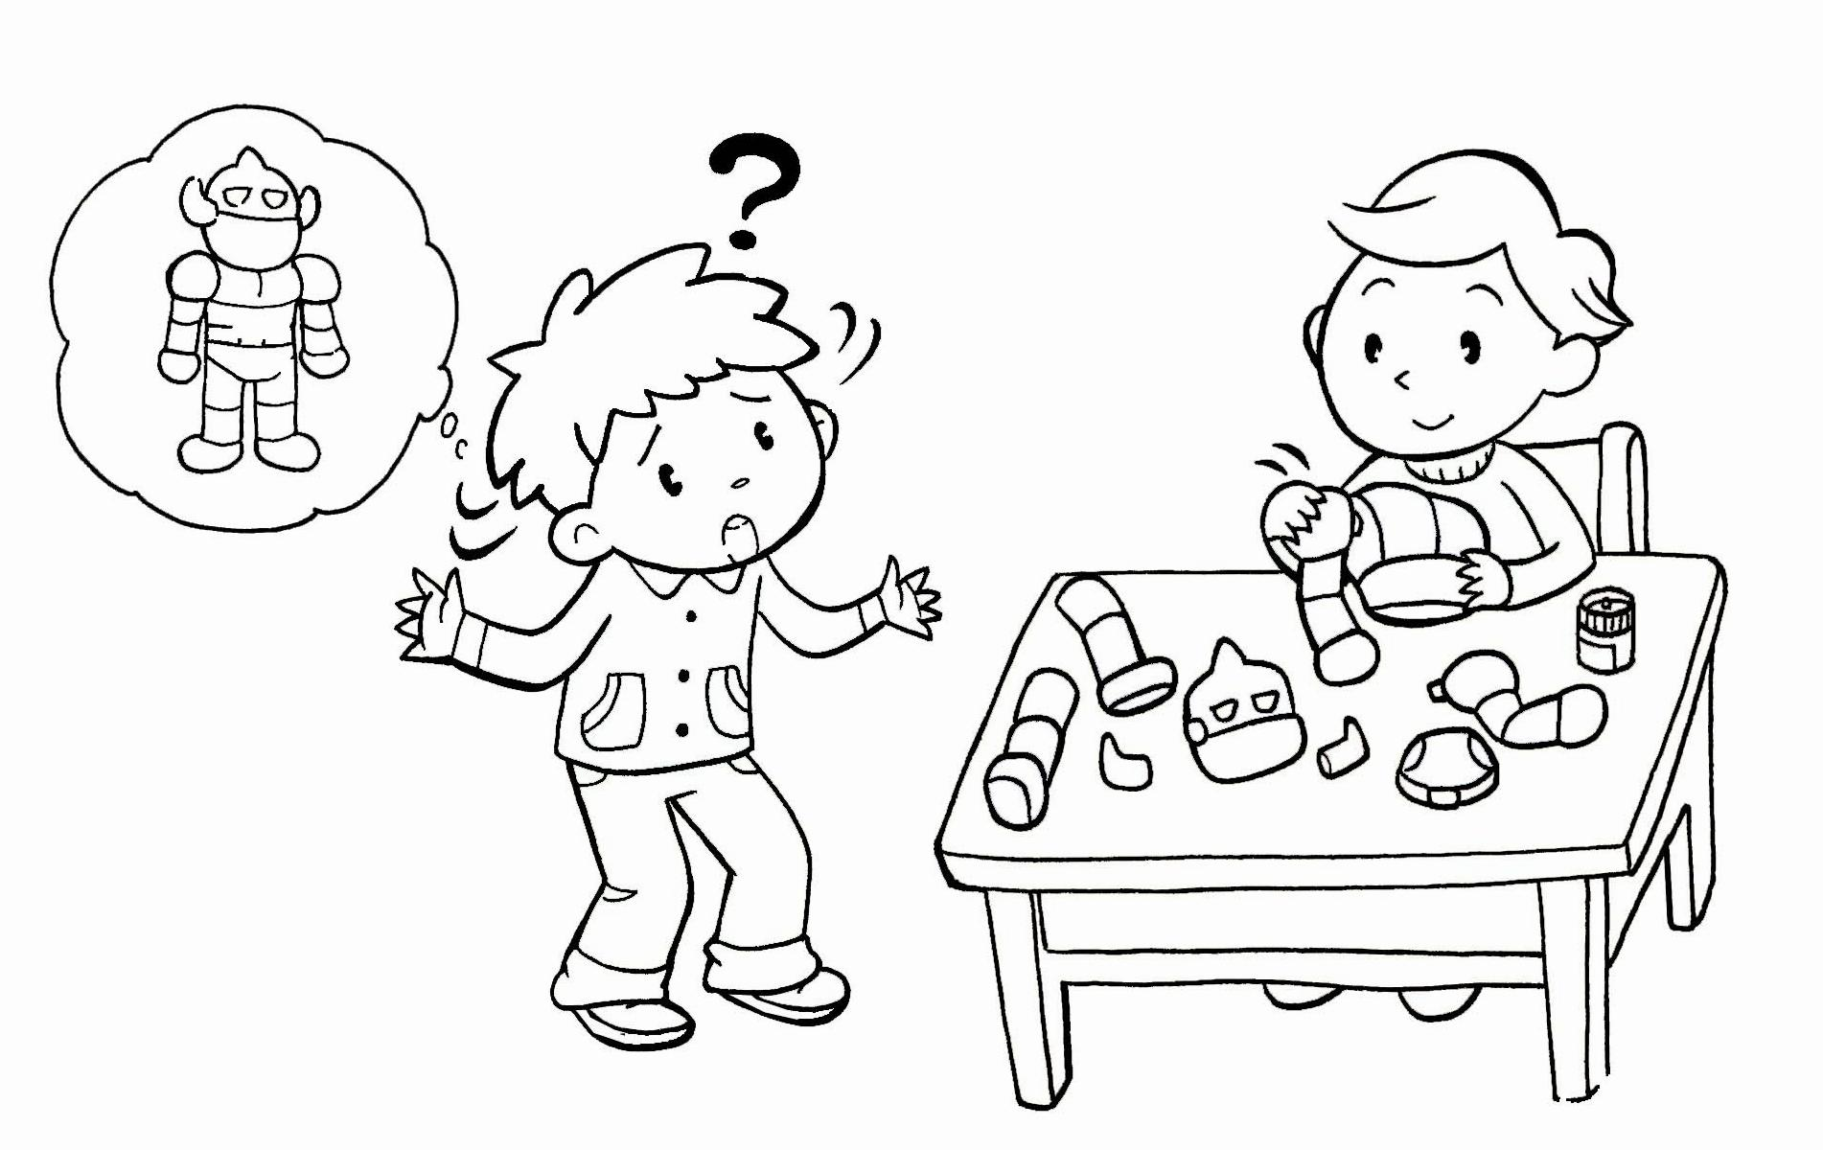
3. 4.
V
V

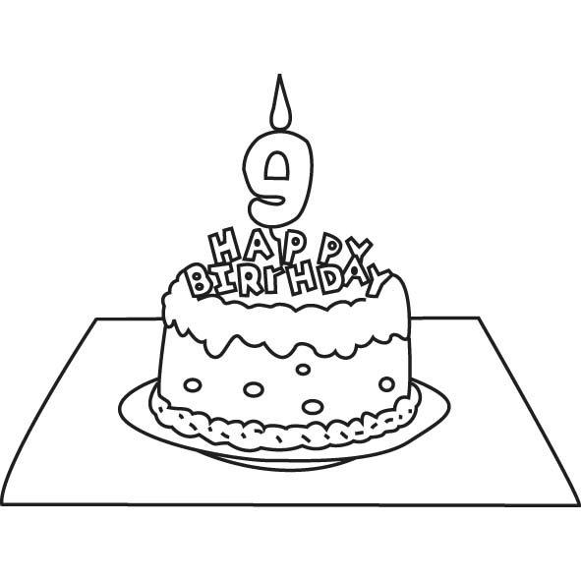
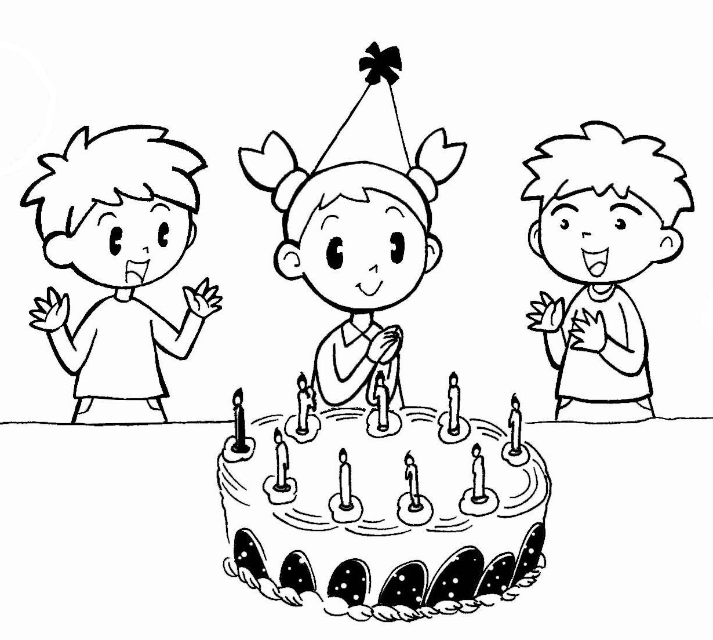
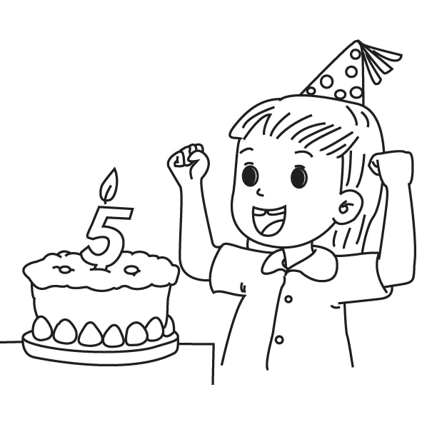
5. 6.
V
V

E. Read and Choose讀一讀，選出正確的答案12%(每題2分) A A B C B C
( ) 1. A: I’m seven. How about you? B: _____________________
(A) I’m seven, too. (B) I’m nine, too. (C) Thank you.
( ) 2. A: Happy birthday, Andy. B: _____________________
(A) Thank you. (B) I’m nine. (C) OK.
( ) 3. A: Can you draw, Candy? B: _____________________
(A) No, I’m not. (B) No, I can’t. (C) No, she’s not.
( ) 4. A: Let’s play. B: _____________________
(A) I’m five. (B) Thank you. (C) OK.
( ) 5. A: _____________________ B: I’m ten.
(A) What’s your name? (B) How old are you? (C) How about you?
( ) 6. A: Can you write? B: __________________________
(A) Yes, I am. (B) Yes, she can. (C) Yes, I can.
F. Look, Read and Check與圖意相符的句子打 12%(每題2分)
V

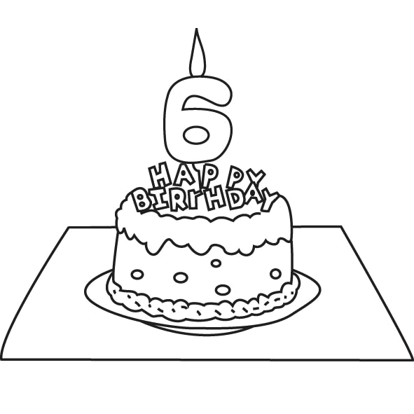
1.
I’m ten years old.
I’m six years old.

V
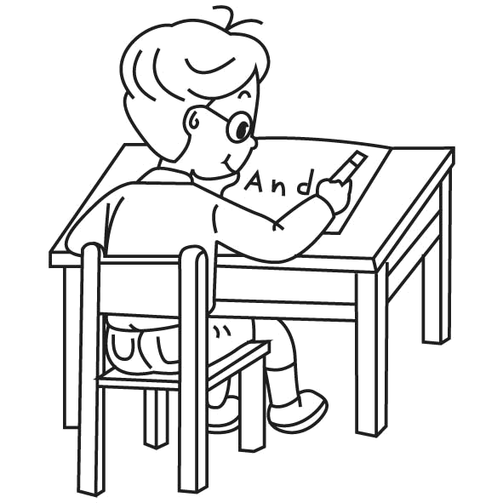
2.
I can write.
I can dance.

V

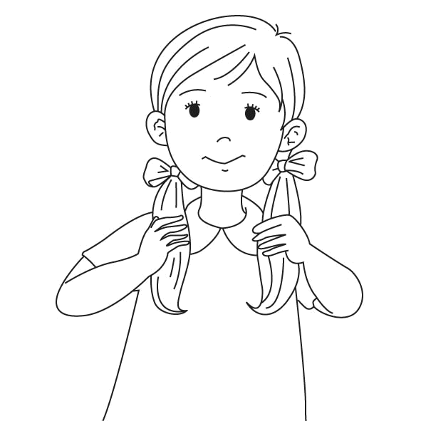
3.
Touch your ears.
Touch your hair.

V
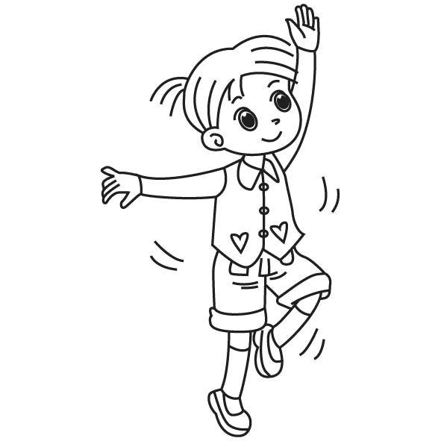
4.
Can you dance?
Can you write?

V

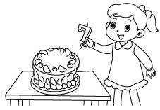
5.
I’m six.
I’m seven.

V
Can you sing?
Can you read?
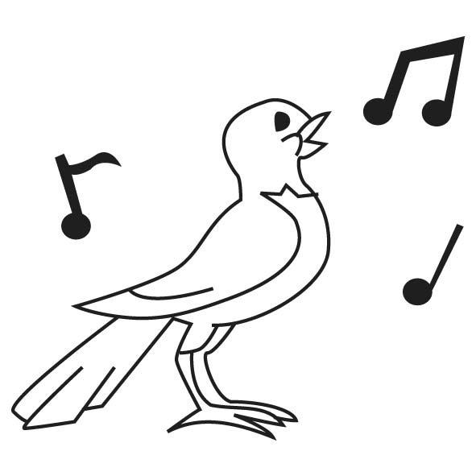
6.
V

G. Look and Write 寫出圖片的代表單字12%(每格1分)
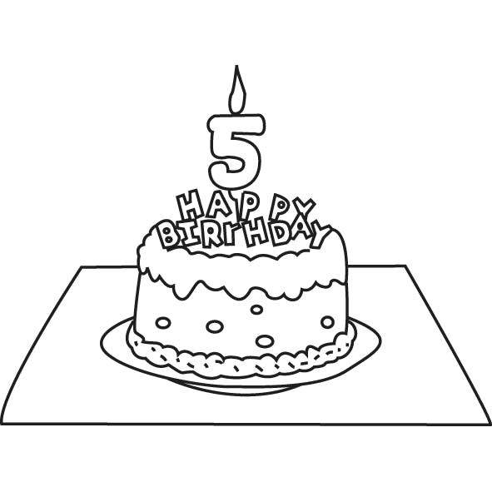
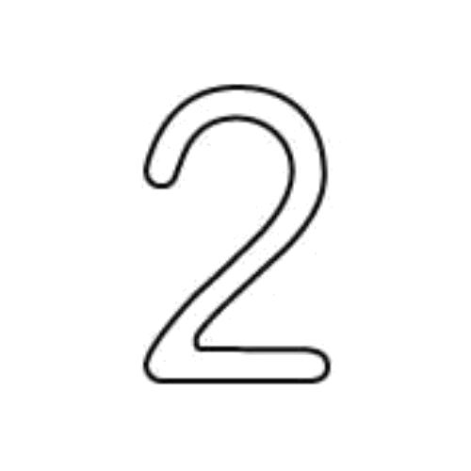
1. 2. 3.

_f_ i v e t w o r e a d
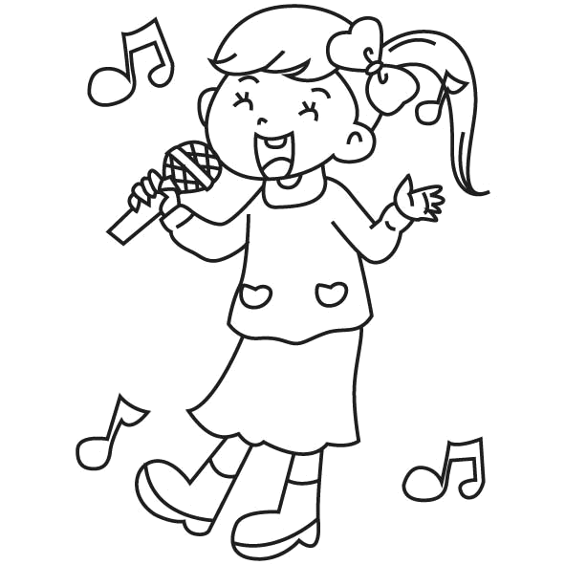
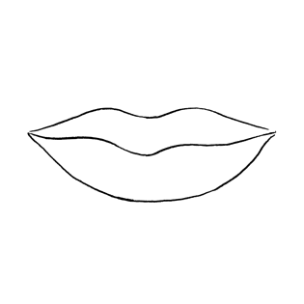
4. 5. 6.

m o u t h e y e s i ng
H. Unscramble the Sentences請重組句子，重新寫在格線上12%(每題3分)

1. about/ How / you / ? (How about you?)
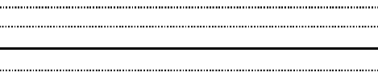

2. your / eyes / . / Touch (Touch your eyes.)

3. I / ten / . / am (I am ten.)


4. draw/ . / I / can (I can draw.)

