台南縣仁德國小九十八學年度第二學期期中評量英語科試題
命題範圍:康軒版第二冊Lesson 1到Review 1 三年____班____號 姓名：___________
A. Listen and Number 聽一聽在 中，寫出正確的數字。 12%(每題2分)
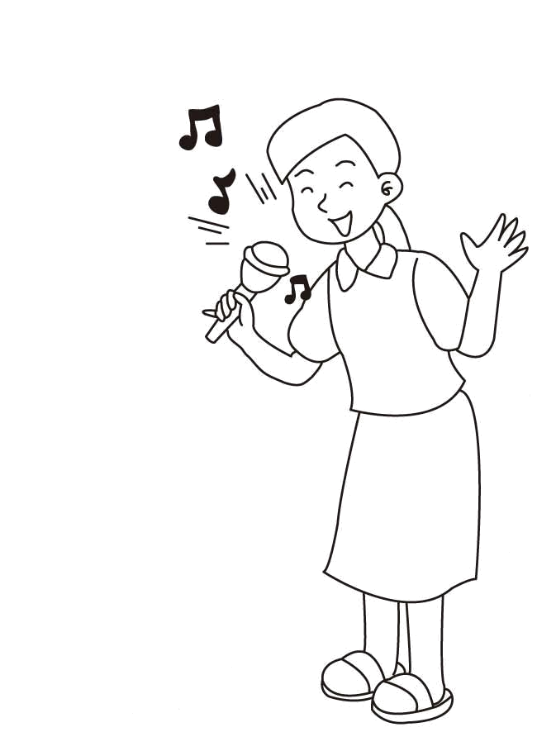
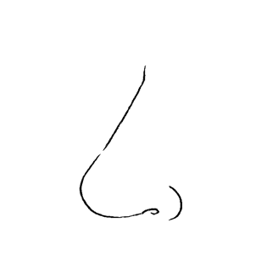
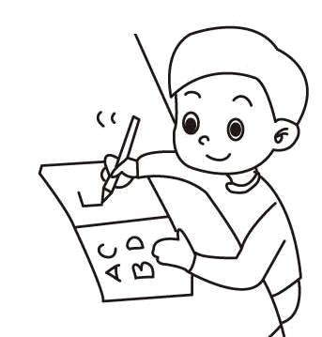
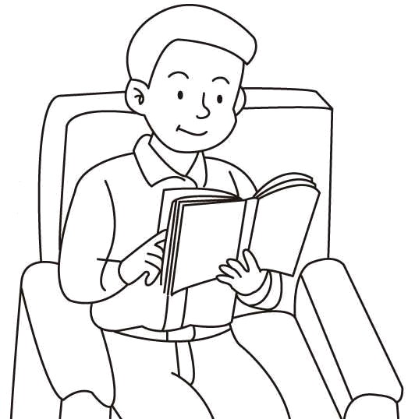
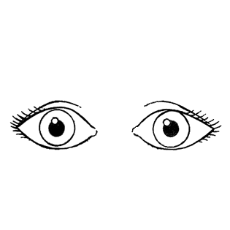
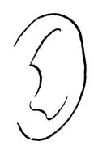
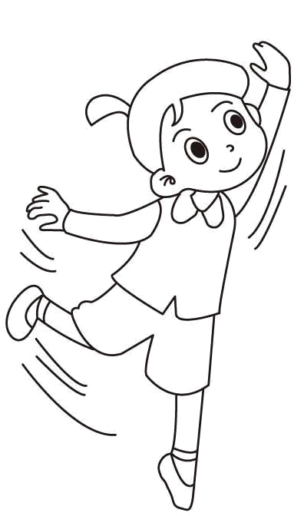

B. Listen and Circle圈選正確的字母。12%(每題2分)


1. 2. 3.
a

i
i

e

Can you dance?
Yes, I can.
No, I can’t.

√
e

a

4. 5. 6.
e

a

i

a

e
i

C. Listen and Circle圈選所聽到的正確數字。 16%(每題2分)

1. | 5 | 4 | 2. | 3 | 8 | 3. | six | seven | 4. | nine |  | one
5. | 8 | 9 | 6. | 7 | 4 | 7. | two | ten | 8. | three |  | eight

D. Listen and Check 聽一聽，在正確的答案中打 V 12%(每題2分)

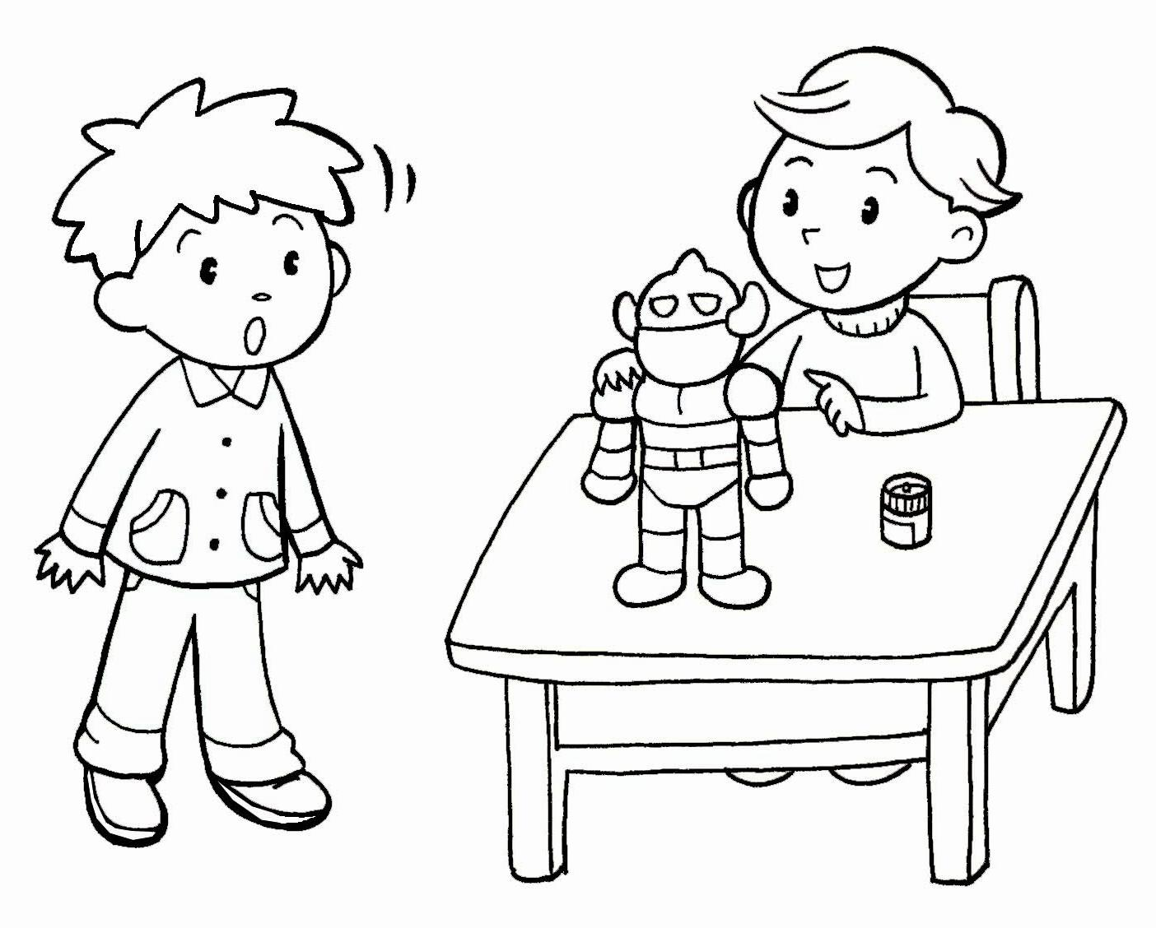
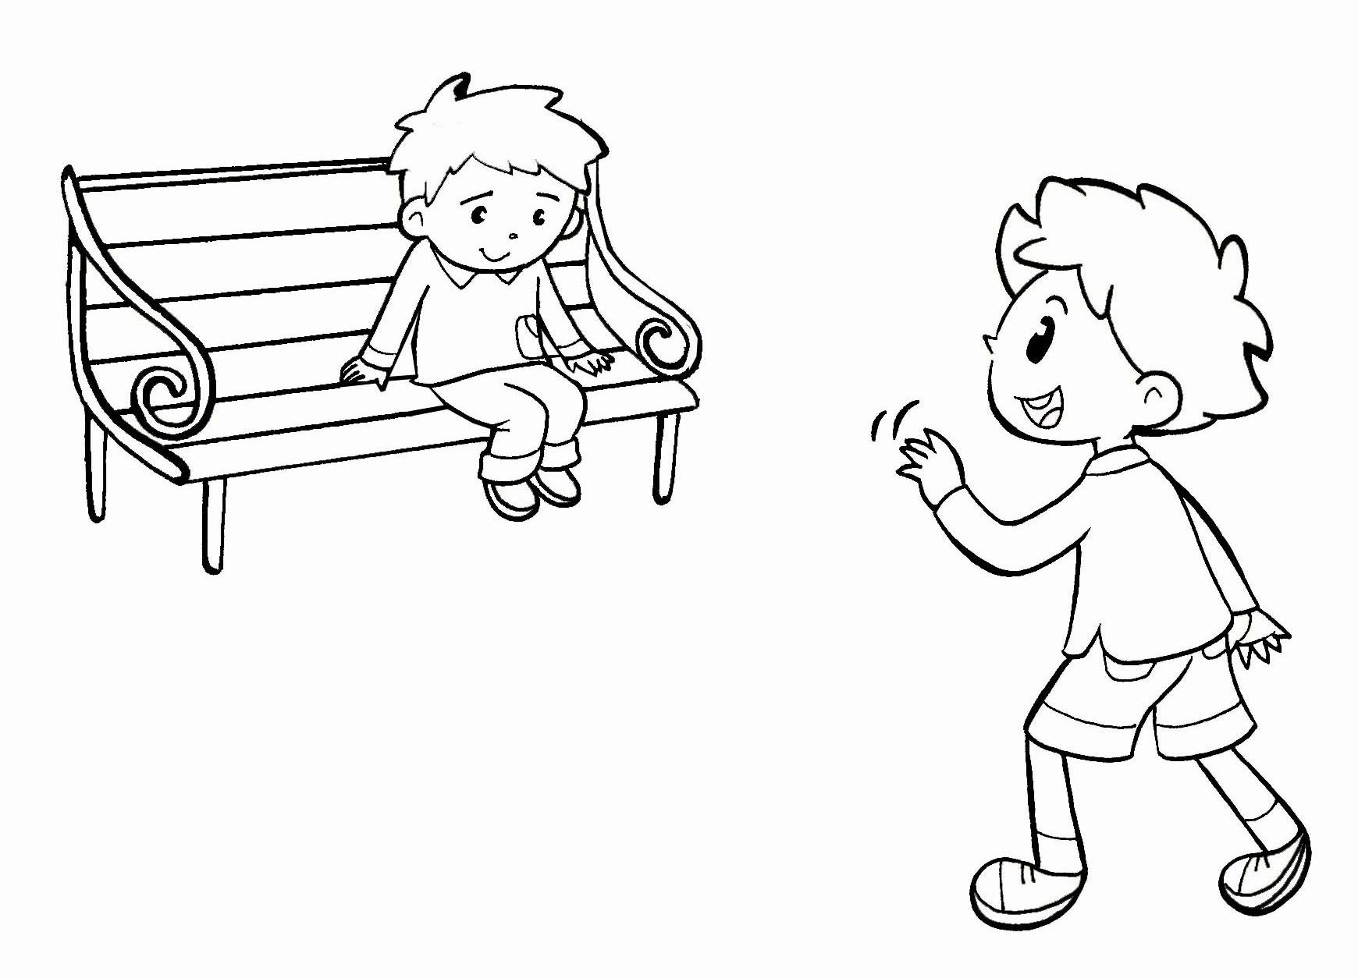
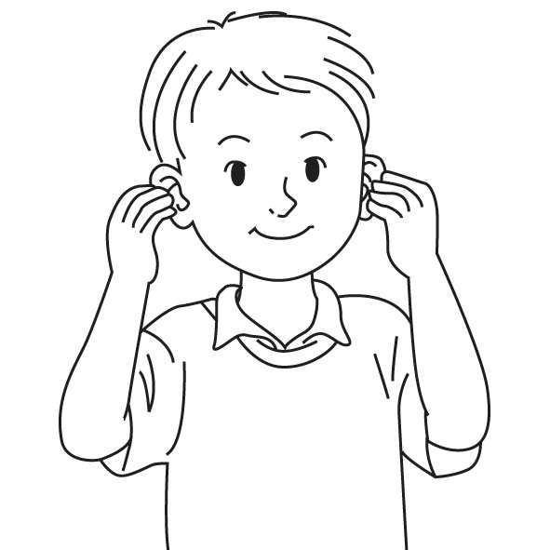
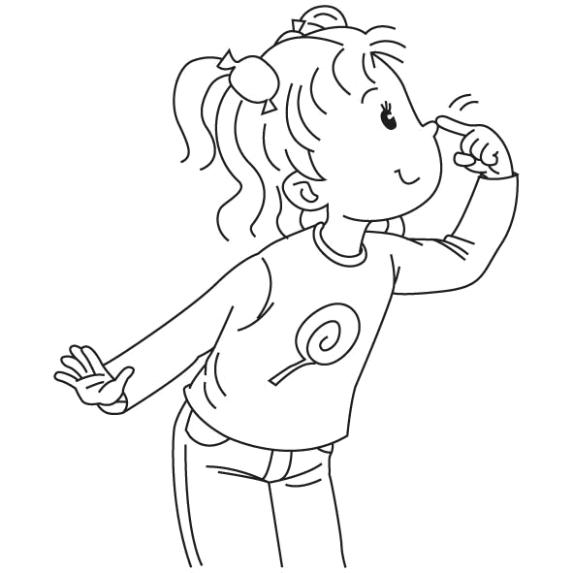
1. 2.

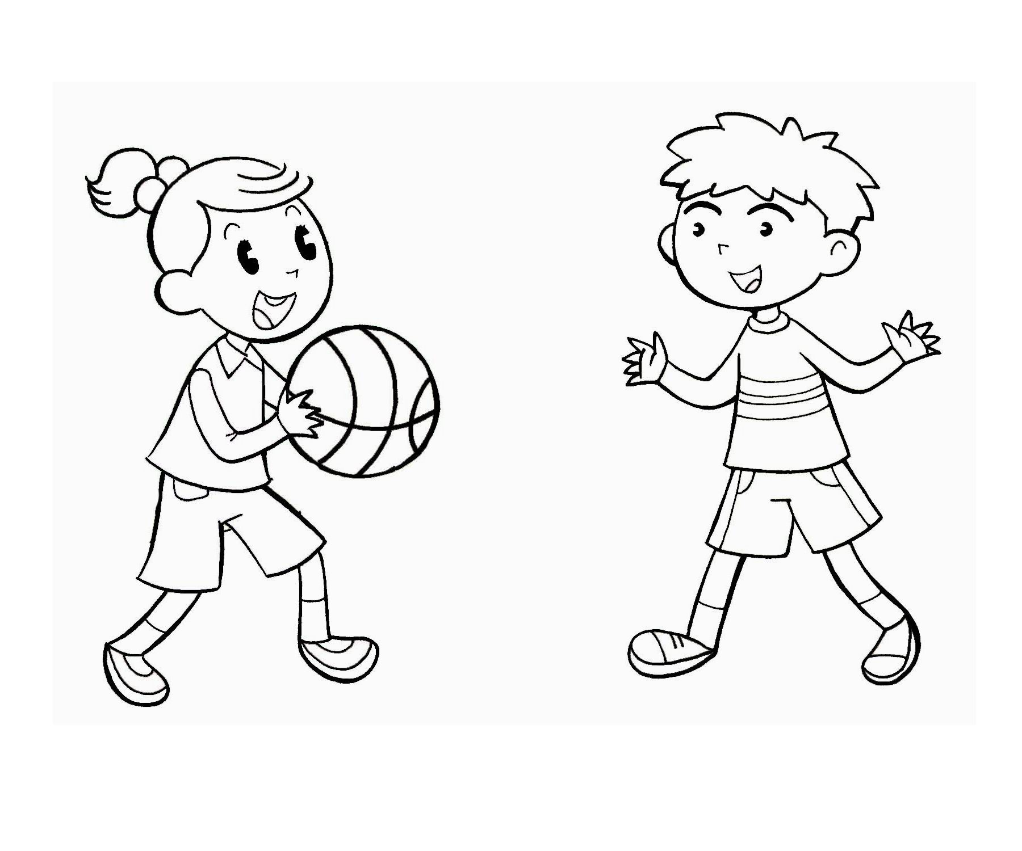
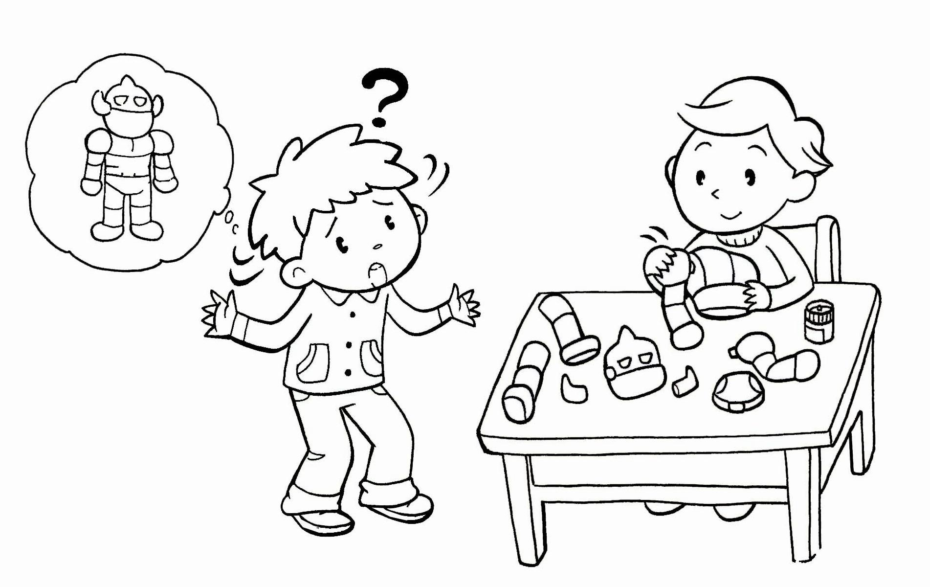
3. 4.

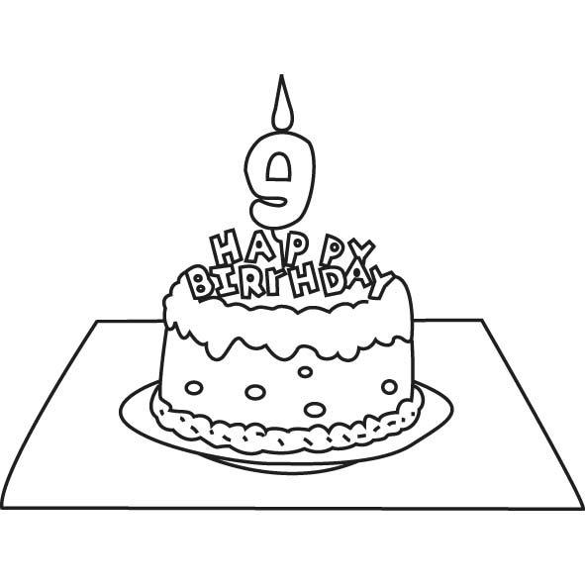
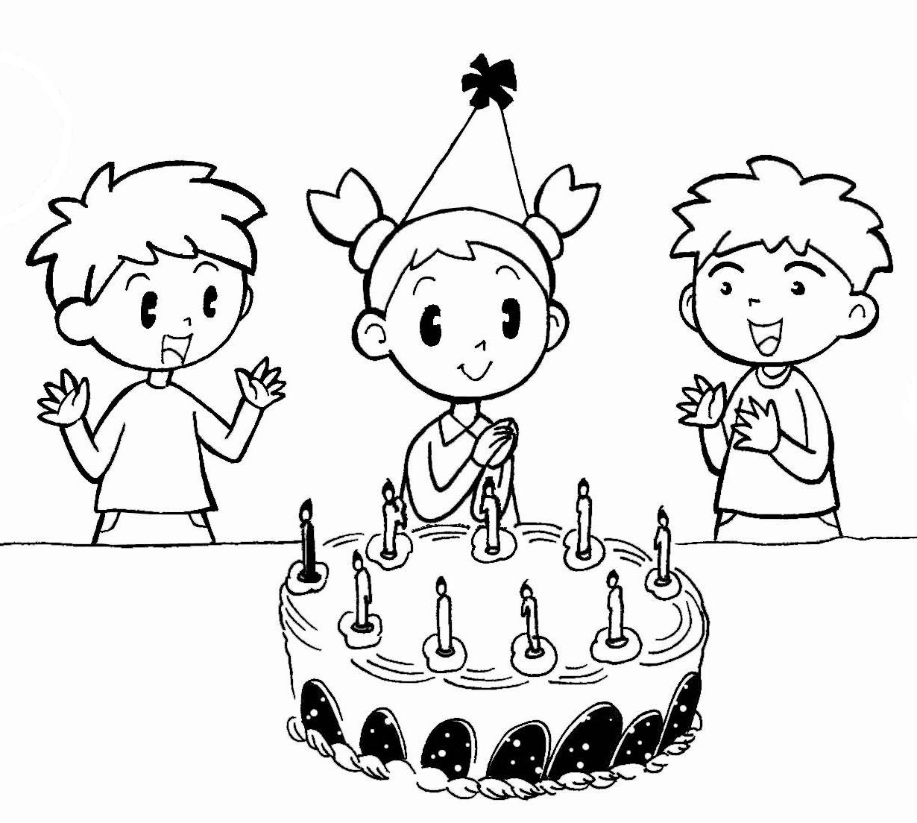
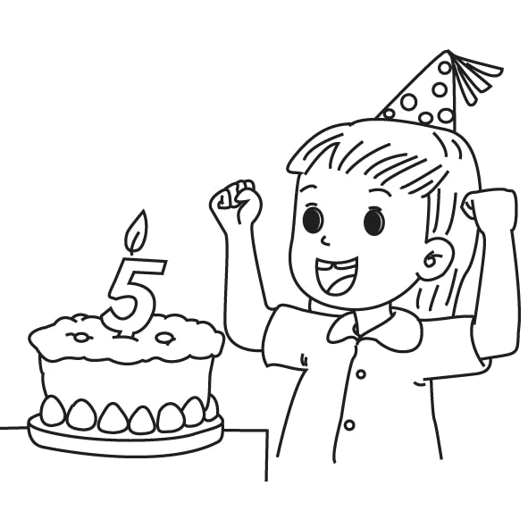
5. 6.

E. Read and Choose讀一讀，選出正確的答案。 12%(每題2分)
( ) 1. A: I’m seven. How about you? B: _____________________
(A) I’m seven, too. (B) I’m nine, too. (C) Thank you.
( ) 2. A: Happy birthday, Andy. B: _____________________
(A) Thank you. (B) I’m nine. (C) OK.
( ) 3. A: Can you draw, Candy? B: _____________________
(A) No, I’m not. (B) No, I can’t. (C) No, she’s not.
( ) 4. A: Let’s play. B: _____________________
(A) I’m five. (B) Thank you. (C) OK.
( ) 5. A: _____________________ B: I’m ten.
(A) What’s your name? (B) How old are you? (C) How about you?
( ) 6. A: Can you write? B: __________________________
(A) Yes, I am. (B) Yes, I can. (C) Yes, she can.
F. Look, Read and Check與圖意相符的句子打 12%(每題2分)

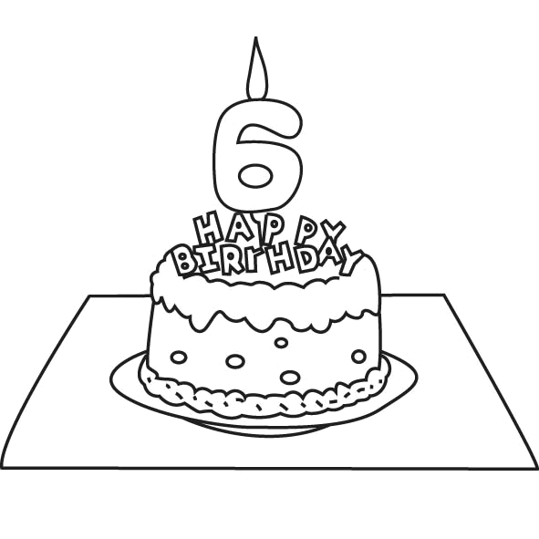
1.
I’m ten years old.
I’m six years old.

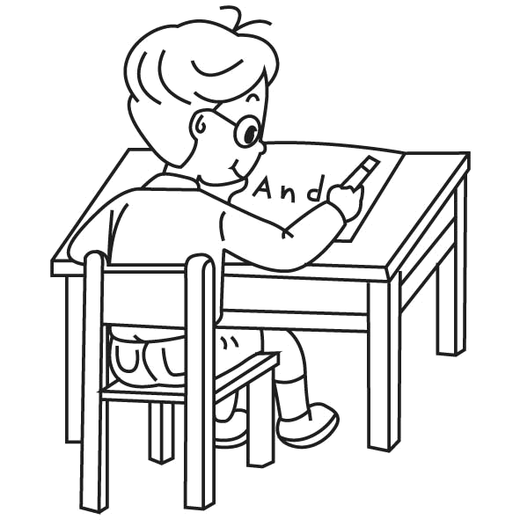
2.
I can write.
I can draw.

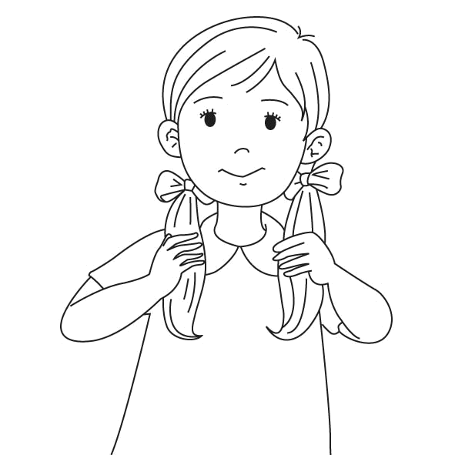
3.
Touch your ears.
Touch your hair.

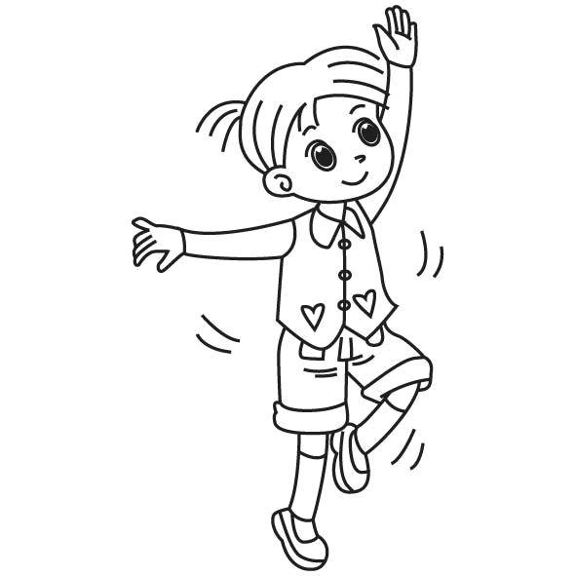
4.
Can you dance?
Can you write?

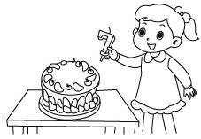
5.
I’m six.
I’m seven.

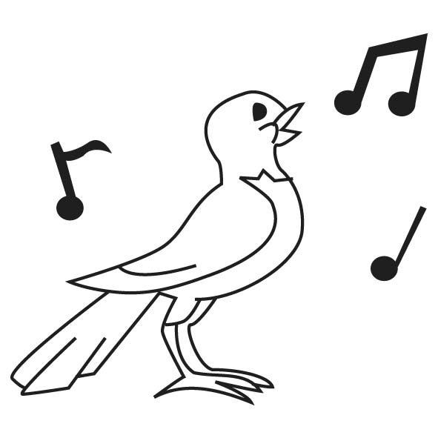
6.
Can you sing?
Can you read?

G. Look and Write 寫出圖片的代表的單字。 12%(每格1分)
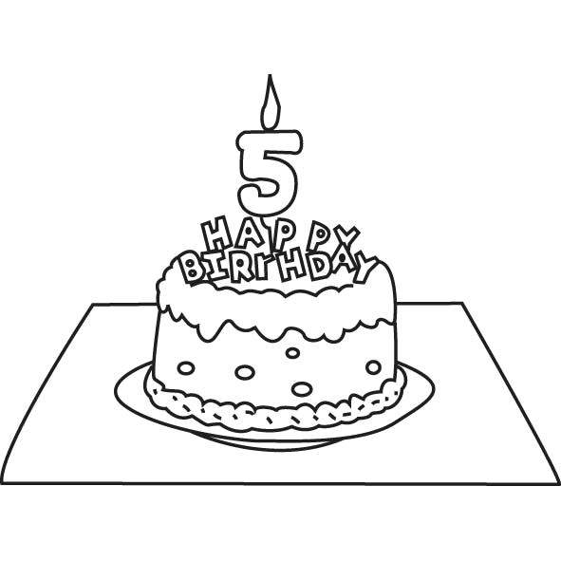
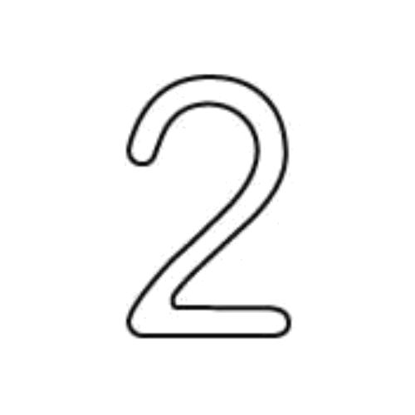
1. 2. 3.

____ i ____ e _____ ______ o ______ e ______ d
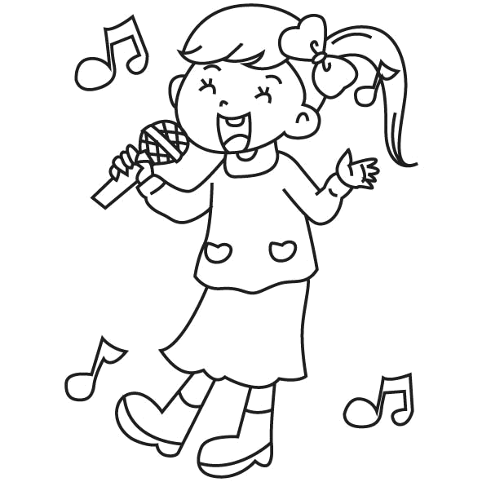
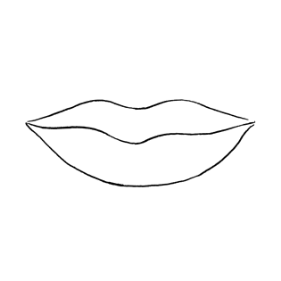
4. 5. 6.

_____o _____ t h _____ y ______ _____ _____ ng
H. Unscramble the Sentences請重組句子，重新寫在格線上。 12%(每題3分)

1. about/ How / you / ?
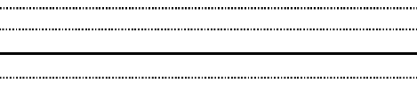

2. your / eyes / . / Touch

3. I / ten / . / am


4. draw/ . / I / can

