台南縣仁德國小九十八學年度第一學期期末評量英語科試題 解答版
命題範圍:何嘉仁版第六冊Unit 4至Review 2 五年____班____號 姓名：___________

A. Listen and Check 仔細聽，找出每個人的交通工具，並在空格中打勾。10% (每題2分)
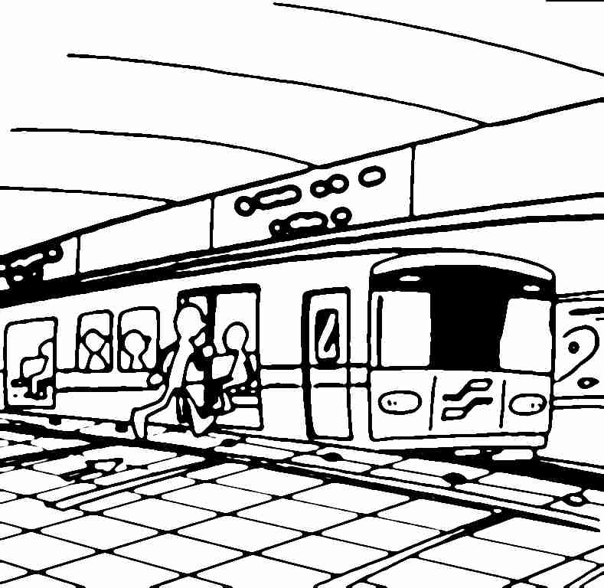
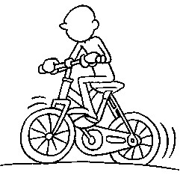
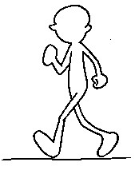
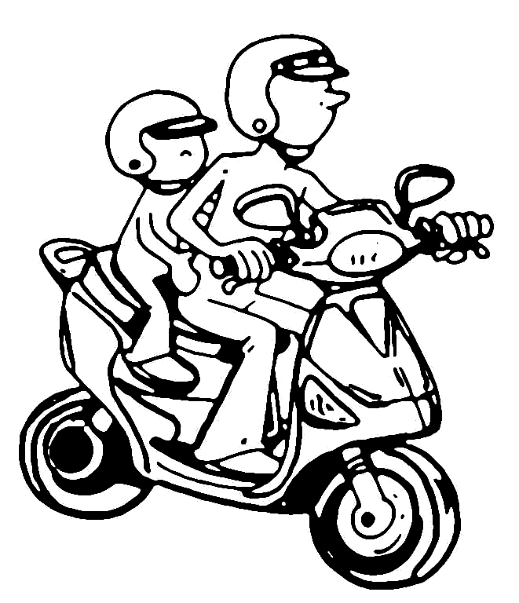
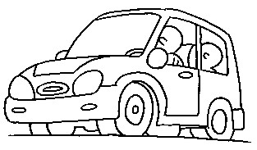

    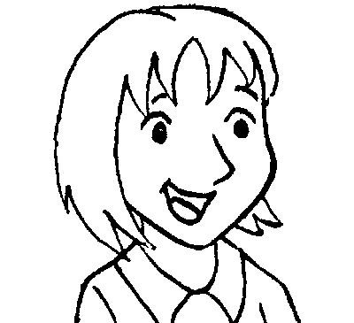      1 |  |  |  |  | V
2 |  | V
3 |  |  |  | V
4 |  |  | V
5 | V

B. Listen and Check 仔細聽，勾選出適當的答句。10% (每題2分)
(1) (V ) Yes, it’s Tuesday.
( ) No, it’s not. It’s Thursday.
(2) (V ) No, I don’t. I go to school by bike.
( ) I go to school on Monday.
(3) ( ) No, I don’t.
(V ) I have English and Chinese.
(4) ( ) They are hamburgers.
(V ) I go to bed at 9:30.
(5) (V ) I go home by MRT.
( ) I go to school by scooter.

C. Listen and Check 仔細聽，在◇中勾選出聽到的單字。5% (每題1分)
(1)
they V
three

(2)
sick
thick V

(3)
wheat V
heat

(4)
where
there V

(5)
mouth V
mother

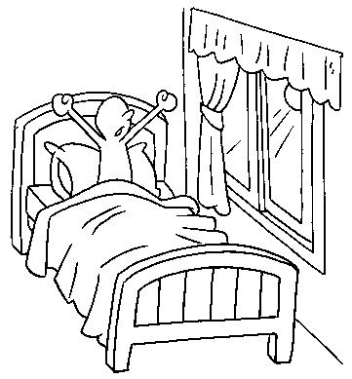
D. Write the correct words. 寫出正確的單字：18%(每格2分)
1.
___get__ ___up____
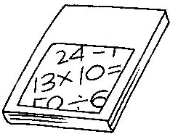
2.
_____math____
3.

___by___ ____car_____
4.

___on_____ ____foot____
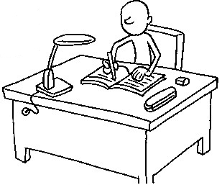
5.

___do___ your _homework__
E. Choice questions選擇題10%(每題2分)
1. (d ) No, I _____. I go to the shop on foot.
(a) do (b) am (c) does (d) don’t
2. ( a ) Nancy, is _____ your card?
(a) this (b) the (c) these (d) those
3. ( b ) I go home _____ foot.
(a) to (b) on (c) in (d) by
4. ( b ) A: _____ do you go to school?
B: By bike.
(a) What time (b) How (c) What (d) Where
5.( d ) Do you go to the park _____ bus?
(a) on (b) at (c) with (d) by

F. Unscramble the sentences重組句子：
15% (每題3分)
1. the/park/I/by/./go/scooter/to
à_I go to the park by scooter. _
________________________________
2. have/PE/Do/you/?/on/Tuesday/and art
à_Do you have PE and art on Tuesday?____
________________________________
3. at/Do/you/home/go/four/?/o’clock
à__Do you go home at four o’clock? __
________________________________
4. go/./to/I/school/bike/by
à__I go to school by bike. ____
________________________________
5. on/Thursday/I/and English/have/./music
à__I have music and English on Thursday. _
________________________________
G. Write true or false 判斷句子，對的打○，錯的打╳：10% (每題2分)
Mon. | Tue. | Wed. | Thur. | Fri. | Sat.
math | English | music | art | Chinese | 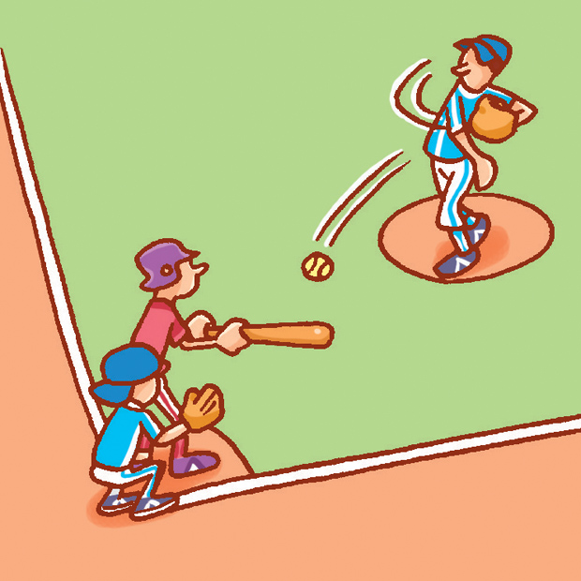  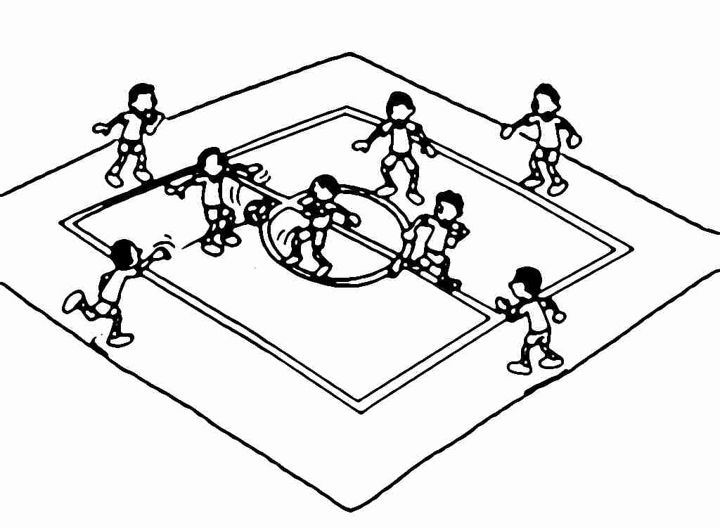
math | English | Chinese | math | PE
依照上表判斷句子對錯。
(1) (╳ ) I have music on Monday.
(2) (╳ ) I have English and PE on Thursday.
(3) (○ ) I have Chinese on Friday.
(4) (○ ) I have music and Chinese on Wednesday.
(5) ( ╳ ) I play basketball on Saturday.
H. Look and Match 仔細看，將圖片和相對應的句子連起來。10%(每題2分)
(A) Walk. (B) Excellent! (C) Stop!
(D) That’s OK. (E) Sorry, I’m late.
(1) ( ) (C) (2) ( ) (B) (3) ( ) (A)
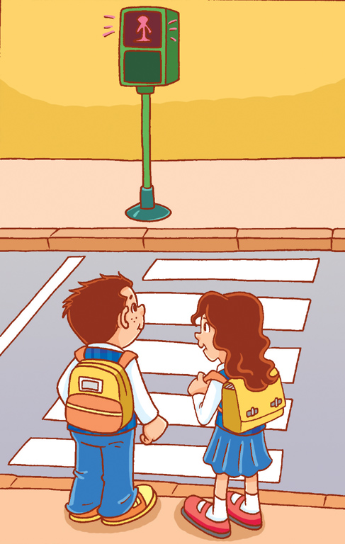
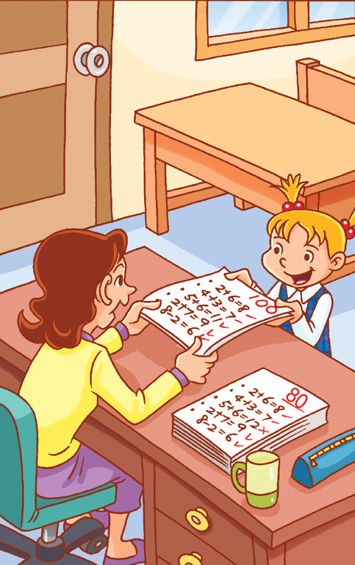
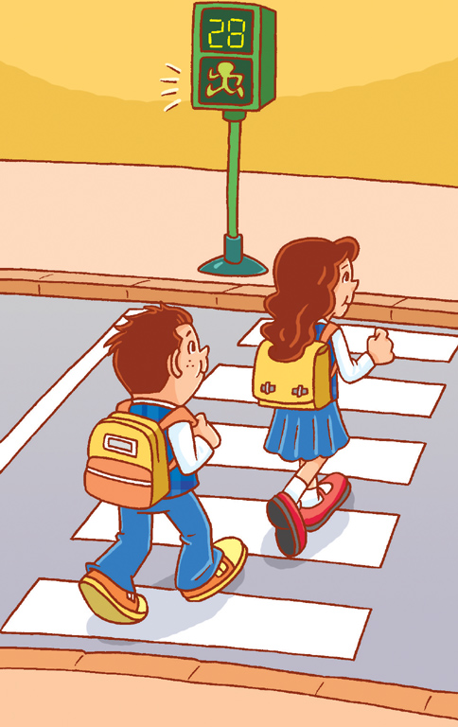

(4) ( ) (E) (5) ( ) (D)
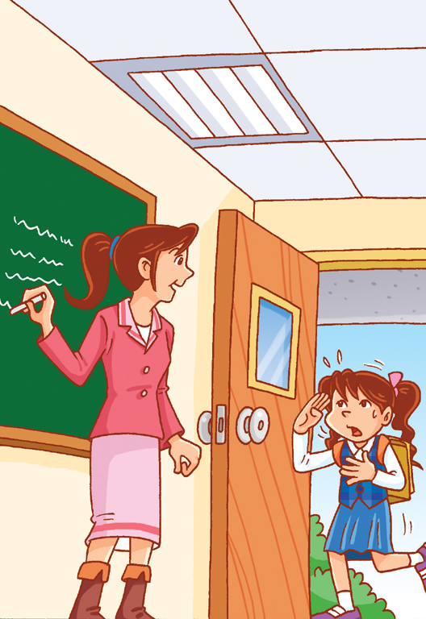
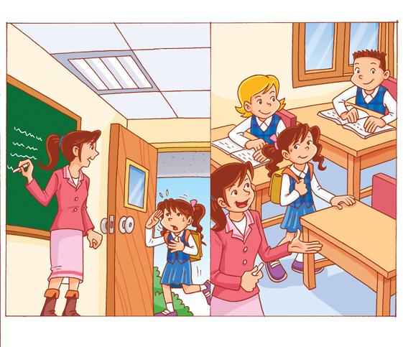

I. Read, Look, and Write 依據圖片，寫出正確的答句。12%(每題3分)
1. A: What time do you do your homework?
5:23
B: ____________________________
(I do my homework at 5:23.)
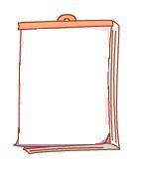
2.A: What day is today?
19
Fri.

B: ____________________________
(It’s Friday.)
3.A: What classes do you have on Thursday?
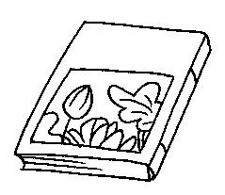
國語
B: ____________________________
(I have Chinese on Thursday.)
4.A: Do you go to school by scooter?
B: ___________________________
___________________________
(No, I don’t. I go to school by MRT.)

(家長簽名)
Parent’s signature:___________________
聽力稿
- Listen and Check
1. How do you go home?
I go home by car.
2. Do you go to school by MRT?
No, I don’t. I go to school by bike.
3. How do you go to school?
I go to school on foot.
4. Do you go to school by scooter?
Yes, I do.
5. How do you go home?
By MRT.

- Listen and Check
a 1. Is today Tuesday?
a 2. Do you go to school by car?
b 3. What classes do you have on Wednesday?
b 4. What time do you go to bed?
a 5. How do you go home?

- Listen and Check
1. (they)
2. (thick)
3. (wheat)
4. (there)
5. (mouth)

