台南縣仁德國小九十八學年度第一學期期末評量英語科試題
命題範圍:何嘉仁版第六冊Unit 4至Review 2 五年____班____號 姓名：___________

A. Listen and Check 仔細聽，找出每個人的交通工具，並在空格中打勾V。10% (每題2分)
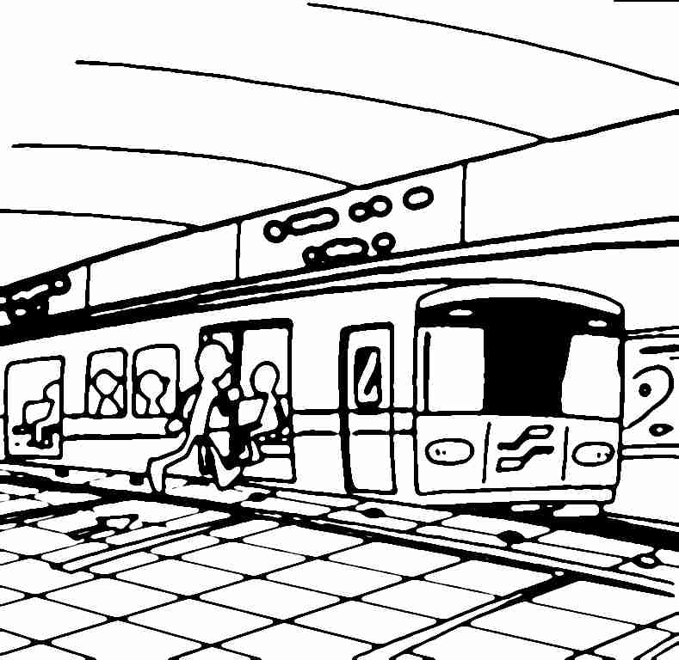
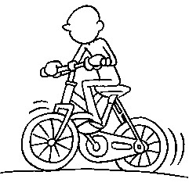
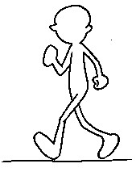
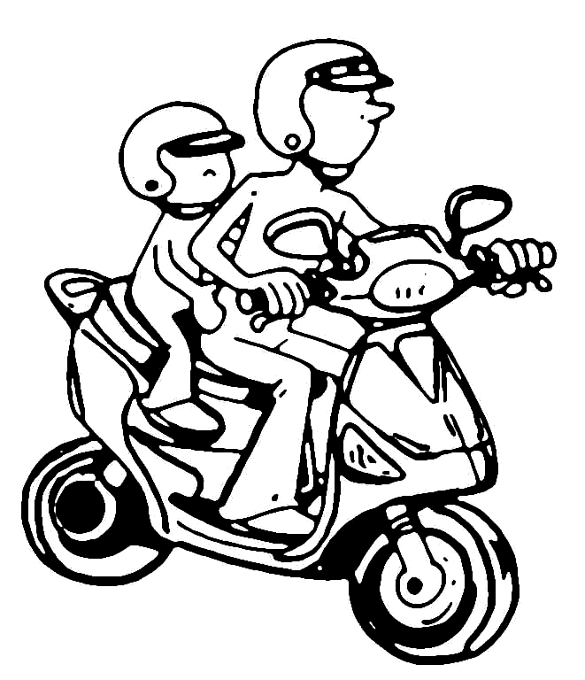
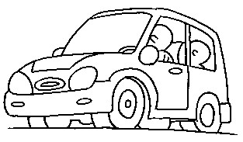



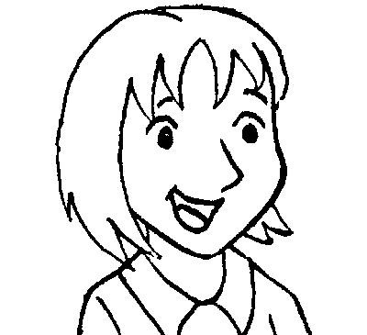


1
2
3
4
5

B. Listen and Check 仔細聽，勾選出適當的答句。10% (每題2分)
(1) ( ) Yes, it’s Tuesday.
( ) No, it’s not. It’s Thursday.
(2) ( ) No, I don’t. I go to school by bike.
( ) I go to school on Monday.
(3) ( ) No, I don’t.
( ) I have English and Chinese.
(4) ( ) They are hamburgers.
( ) I go to bed at 9:30.
(5) ( ) I go home by MRT.
( ) I go to school by scooter.

C. Listen and Check 仔細聽，在◇中勾選出聽到的單字。5% (每題1分)
(1)
they
three

(2)
sick
thick

(3)
wheat
heat

(4)
where
there

(5)
mouth
mother

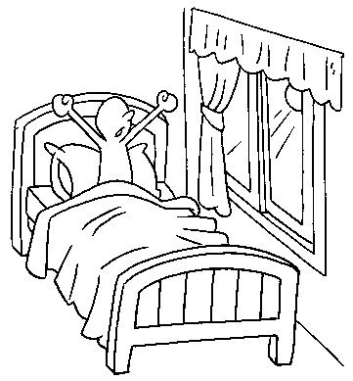
D. Write the correct words. 寫出正確的單字：18%(每格2分)
1.
__________ _________
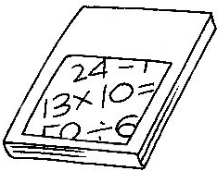
2.
____________________
3.

_________ ____________
4.

__________ ___________

5.

_________ your _________
E. Choice questions選擇題10%(每題2分)
1. ( ) No, I _____. I go to the shop on foot.
(a) do (b) am (c) does (d) don’t
2. ( ) Nancy, is _____ your card?
(a) this (b) the (c) these (d) those
3. ( ) I go home _____ foot.
(a) to (b) on (c) in (d) by
4. ( ) A: _____ do you go to school?
B: By bike.
(a) What time (b) How (c) What (d) Where
5.( ) Do you go to the park _____ bus?
(a) on (b) at (c) with (d) by
F. Unscramble the sentences重組句子：
15% (每題3分)
1. the/park/I/by/./go/scooter/to
à________________________________
________________________________
2. have/PE/Do/you/?/on/Tuesday/and art
à________________________________
________________________________
3. at/Do/you/home/go/four/?/o’clock
à________________________________
________________________________
4. go/./to/I/school/bike/by
à________________________________
________________________________
5. on/Thursday/I/and English/have/./music
à________________________________
________________________________

G. Write true or false 判斷句子，對的打○，錯的打╳：10% (每題2分)
Mon. | Tue. | Wed. | Thur. | Fri. | Sat.
math | English | music | art | Chinese | 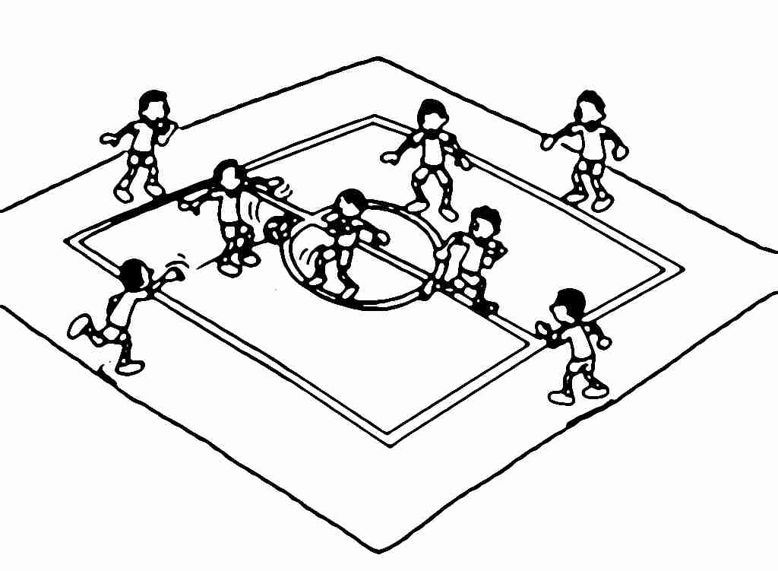  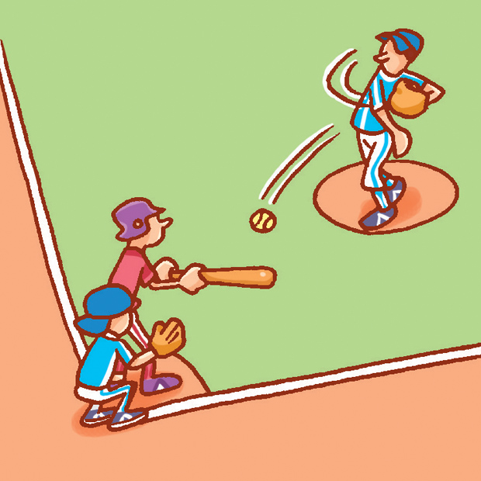
math | English | Chinese | math | PE
依照上表判斷句子對錯。
(1) ( ) I have music on Monday.
(2) ( ) I have English and PE on Thursday.
(3) ( ) I have Chinese on Friday.
(4) ( ) I have music and Chinese on
Wednesday.
(5) ( ) I play basketball on Saturday.
H. Look and Match 仔細看，將圖片和相對應的句子連起來。10%(每題2分)
(A) Walk. (B) Excellent! (C) Stop!
(D) That’s OK. (E) Sorry, I’m late.
(1) ( ) (2) ( ) (3) ( )
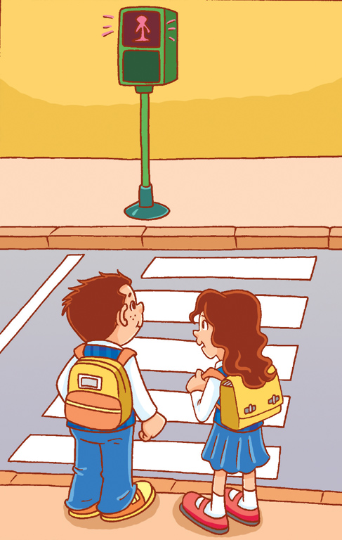
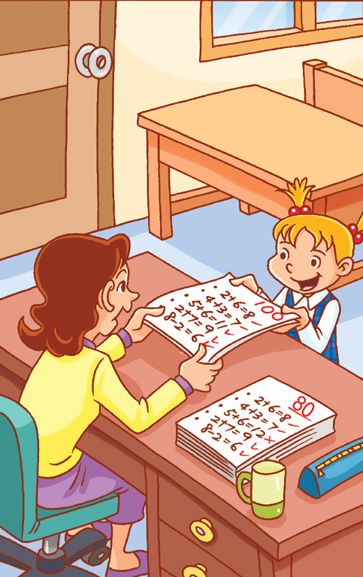
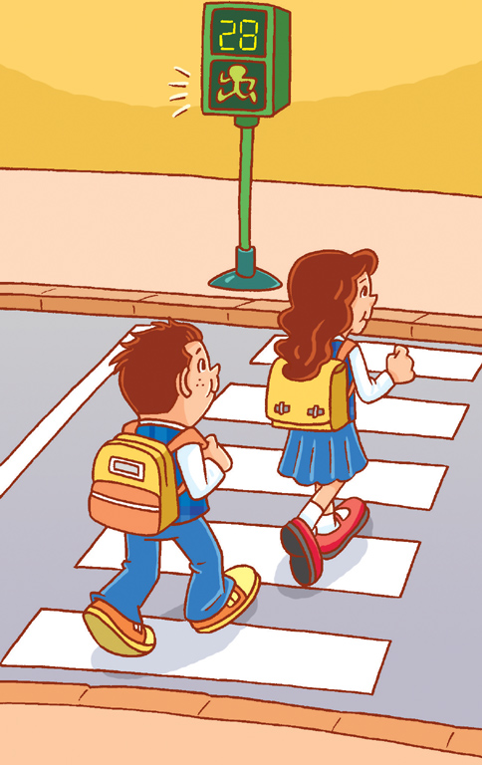

(4) ( ) (5) ( )
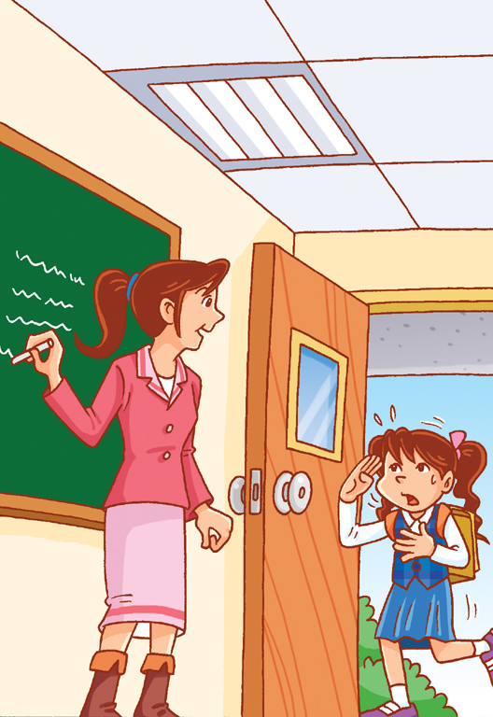
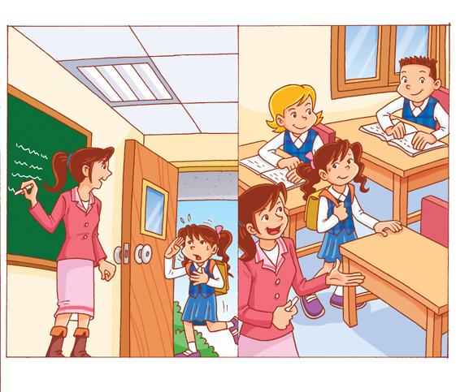

I. Read, Look, and Write 依據圖片，寫出正確的答句。12%(每題3分)
1. A: What time do you do your homework?
5:23
B: ____________________________
________________________
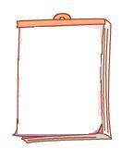
2.A: What day is today?
19
Fri.
B: ____________________________
________________________

3.A: What classes do you have on Thursday?
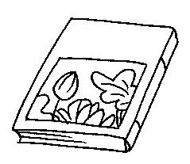
國語
B: ____________________________
________________________

4.A: Do you go to school by scooter?
B: ___________________________
___________________________

(家長簽名)
Parent’s signature:___________________

