台南縣仁德國小九十八學年度第一學期期末評量英語科試題
命題範圍:康軒版第一冊Lesson 4到Review 2 三年____班____號 姓名：___________
A. Listen and write. 聽一聽寫出正確的字母。20%(每題2分)
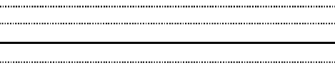
1. 2. 3. 4. 5.

6. 7. 8. 9. 10.

B. Listen & Check. 聽一聽，勾選正確的答案 16%(每題2分)

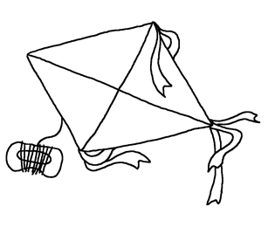
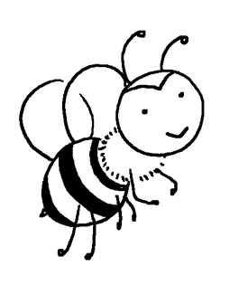
1.

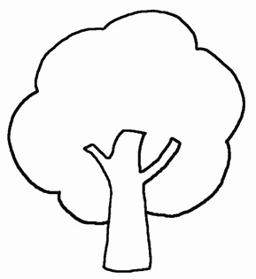

3.

green

5. flower star
7. bee tree
C. Look & Circle 看一看，圈出答案 10%
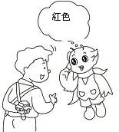1. 2.
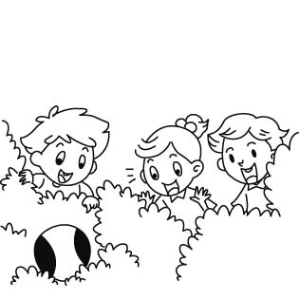
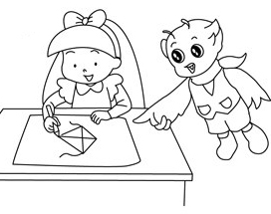
2.

4.

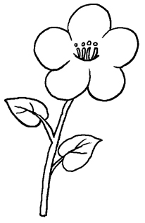

6. yellow red
8. white black

What color is it?
It’s ( red ∕ green ). 4.
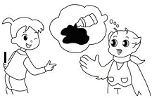3.

What ( name ∕ color ) is it?
It’s black.
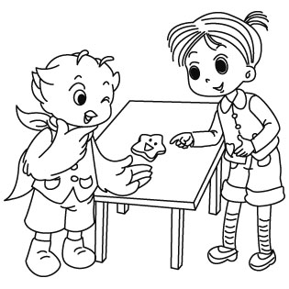
5.

Look! Is this a ( star/bee )?

Is that a ( tree ∕ flower )?
Yes, it is.

Is this a ( star ∕ kite )?
No, it’s not.

D.Write Aa-Zz 請寫出大小寫Aa到Zz 26%(每字各0.5分)
1. 2. 3. 4. 5. 6. 7. 8. 9. 10. 11. 12. 13.

14. 15. 16 17. 18. 19. 20. 21. 22. 23. 24. 25. 26.

E. Write the right number in the ( ) 填入正確數字 16%(每題2分)
(1) green (2) star (3) bee (4) tree (5)flower (6) kite (7) yellow (8) black

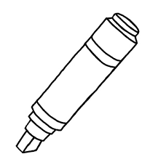
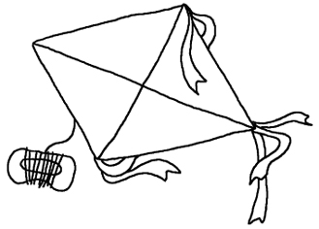
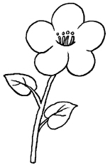
( ) ( ) 黃色 ( ) 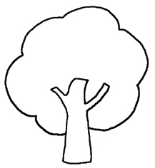 ( )
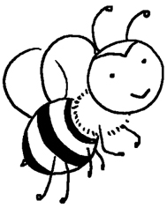
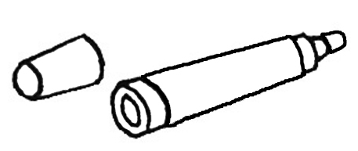



( ) ( ) 綠色 ( ) 黑色 ( )

F. Read and Match讀一讀，將相符的句子連一連 (12%)
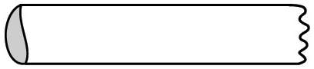
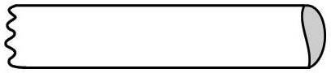
1.
●

Is that a tree?

Yes, it is.
It’s a kite.

●

●

What’s that?

No, it’s not.

●

2.

3.
Is this a kite?

It’s a flower.

●

●

What color is it?

4.
●

Good morning!

●

Good morning!
?

●

●

Yes, it is.
It’s a bee.

5.


6.
Is that a bee?
?

It’s green.

●

●

Parent’s signature:_______________ (家長簽名)

