台南縣仁德國小九十八學年度第一學期期中評量英語科試題 家長簽章：
命題範圍：佳音版第一冊Starter unit至Review1 四年 班 號 姓名：
一.聽力測驗：(每題2分)共 40分
1、Listen and circle. 聽一聽，圈出字首字母。
1. b p 2. b p 3. d t
4. d t 5. g k 6. g k
(1.belt 2.pad 3.duck 4.top 5.gum 6.kiss)
2、Listen and Number 仔細聽，依序將圖片編號 (2413)
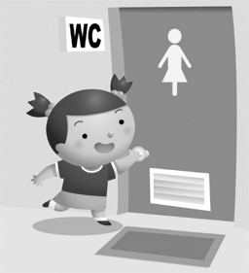

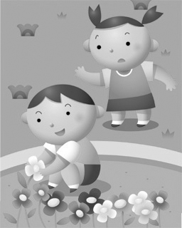

(1. Don’t do that! 2.Go to the restroom . 3. Be careful. 4. Let’s go home.)

3、Listen and check. 聽一聽，將正確的回答打勾。 (1221)
1. Be careful! 2. It’s a beautiful doll.
It’s orange. It’s a beautiful girl.

3. It’s a small mountain. 4. It’s 458-5237.
It’s a tall mountain. It’s 498-5327.
4、Listen and write. 聽一聽，寫出聽到的阿拉伯數字。
1. _38__ 2. __62__ 3. __56__ 4. __45__ 5. __100_ 6. __87_


二、看圖寫出正確的單字：(每題2分)共 12 分
1. 2. 3.


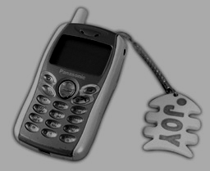




4. 5. 6.

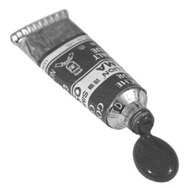
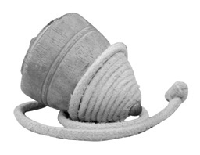
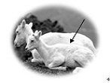 紅色

(1.cell phone 2.big 3.telephone 4.kid 5.red 6.top)
三、Choose. 選出正確的答案。(共 24分)
( C ) 1. _____ a green mountain. (A) Its (A) It’is (C) It’s
( C ) 2. I ______ know. (A) am (B) doesn't (C) don't
( A ) 3. It is ______. (A) pink (B) a pink (C) pinks
( C ) 4. Her cell phone _____ cool! (A) am (B) are (C) is
( C ) 5. It is ______. (A) small duck (B) small a duck (C) a small duck
( B ) 6. ＿＿＿＿＿＿＿＿＿＿ you later. (A) Where (B)See (C) What
( C ) 7. Let＿＿＿＿＿＿＿＿ see! (A) I (B) my (3) me
( B ) 8. Her cell phone is ＿＿＿＿＿＿＿＿＿＿. (A) a bell (B) cool (C) number
( A ) 9. Hello, this is ＿＿＿＿＿＿＿＿. (A) Jane (B) cell phone (C) name
( B ) 10. It's a ＿＿＿＿＿＿＿＿ ox. (A) pen (B) dirty (C) pot
( B ) 11.(A) It are black and blue. (B) It's a black and blue ball. (C) They are a black and blue ball .
( A ) 12.(A) You're great! (B) you are great ? (C) Your great!
四、Unscramble the Sentences. 重組句子。：共14分
number / your / ?/cell phone / What’s (What’s your cell phone number?)

- is / . / yellow/ It (It is yellow.)

- is/?/color / What / it ( What color is it?)

五、Match 連連看：共10分
forty | 。 |  | 。53
twenty-eight | 。 |  | 。40
fifty-three | 。 |  | 。28
one hundred | 。 |  | 。60
sixty | 。 |  | 。100

