台南縣仁德國小九十七學年度第二學期期末評量英語科試題家長簽名:____________
命題範圍:佳音版第二冊Unit4至Review 2 三年____班____號 姓名：___________

A. Listen and write. 聽一聽，將聽到的單字標上阿拉伯數字順序。12%(每題2分)
a. b. c.
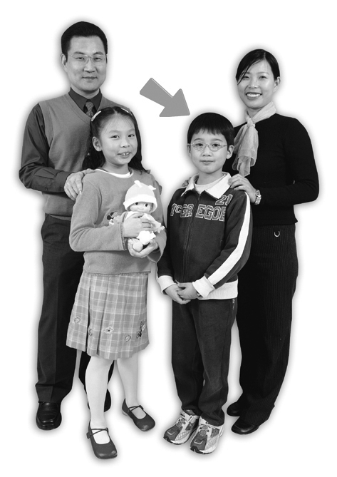
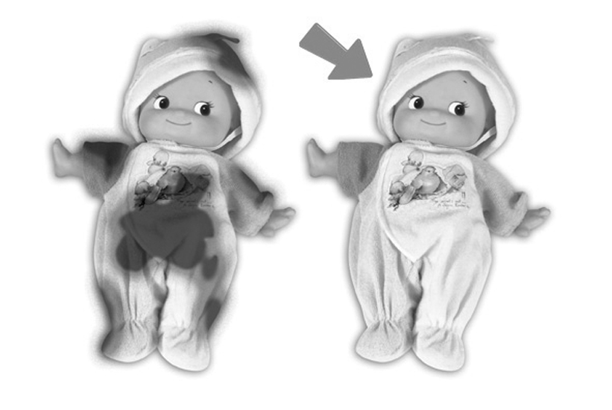
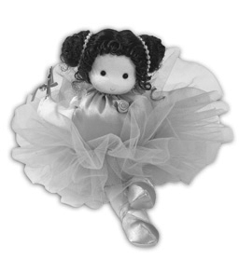

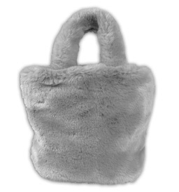
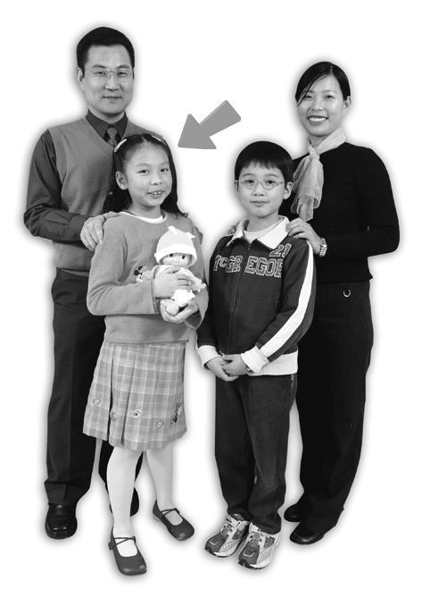
d. e. f.
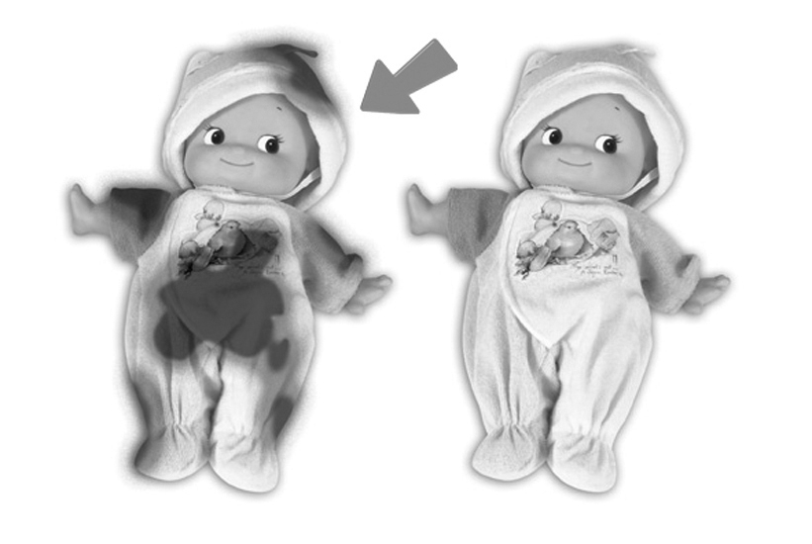

B. Listen and circle. 聽一聽，將聽到的單字圈起來。16%(每題2分)
1. dot socks 2. cut pot 3. cat bug
4. mop bed 5. hug cup 6. kiss rock
7. up nut 8. mug pig
- Listen and check. 聽一聽，將聽到的句子打勾。10%(每題2分)
1. Is that your mother? 2. She is good.
Is she your friend? She is nice.
3. The pig is on the bus. 4. Don’t be sad.
The girl is under the tree. Be happy.
5. It’s OK.
It’s alright.
D. Listen and write . 請寫出聽到的母音。8%(每題2分)

1. b____g 2. h_____t 3.______x 4. r_______d
E. Fill in the blanks填入適當的單字 12%(每題2分)
1. ＿＿＿＿＿＿＿＿＿＿＿＿ bag is beautiful. (My/ I)
2. Are you ＿＿＿＿＿＿＿＿＿＿＿＿, Jane? (girl / OK)
3. My ＿＿＿＿＿＿＿＿＿＿＿＿ Jane. (name/ name’s)
4. The girl is ＿＿＿＿＿＿＿＿＿ (under / to) the tree.
5. No, ＿＿＿＿＿＿＿＿ isn't. (his / he)
6. The bag is in ＿＿＿＿＿＿＿＿＿ (an / the) tree.
F. Fill in.請將下列 的英文字 填入空格中。14%(每題2分)
she | not | Yes | Where | in | on | under | brother | Is

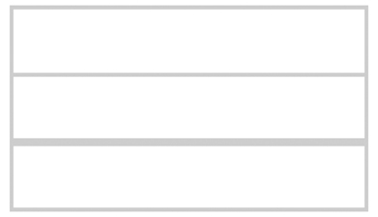
- A: Is he your ?
B: No ,he' s my brother.
- A: your mother?
B: , she is my mother.
- A: is the book (書)?
B: It’s the apple. (請依圖示回答)

G. Write the words. 請重組並寫出正確的英文單字。8%(每題2分)
e/n/l/c/a/ l/d/o/l
1. 2.

t/s/s/i/r/e y/i/d/t/r
3. 4.

H. Choice questions選擇題20%(每題2分)
1. ( ) My doll ＿＿＿＿＿＿＿＿＿ big. (1) is (2) are (3) am
2. ( ) My doll ＿＿＿＿＿＿＿＿＿ long legs. (1) has (2) is (3) am
3. ( ) The apple is ＿＿＿＿＿＿＿＿＿＿ the tree. (1) to (2) an (3) under
4. ( ) A: Goodbye. B: (1) See you later. (2) Yes, she is. (3) He is my brother.
5. ( ) I ＿＿＿＿＿＿＿＿＿＿ my doll. (1) has (2) love (3) am
6. ( ) ＿＿＿＿＿＿＿＿＿＿ is the pig? (1) What (2) Where (3) This
7. ( ) I ＿＿＿＿＿＿＿＿＿＿ my mother a hug. (1) love (2) am (3) give
8. ( ) A: Where‘s the bug?
B: (1) Yes,it is here. (2) He is my friend. (3) It is in the box.
9. ( ) Is ＿＿＿＿＿＿＿＿ your grandmother? (1) that (2) her (3) his
10. ( ) Hi , I’m ＿＿＿＿＿＿＿＿＿ brother? (1) Jim (2) Jim’s (3) Jane

