台南縣仁德國小九十七學年度第二學期期中評量英語科試題家長簽名:____________
命題範圍:何嘉仁版第六冊Unit 1至Review 1 五年____班____號 姓名：___________

A. Listen and Mark 仔細聽，聽到句子與圖片相符請打勾，不相符請打╳。10%(每題2分)
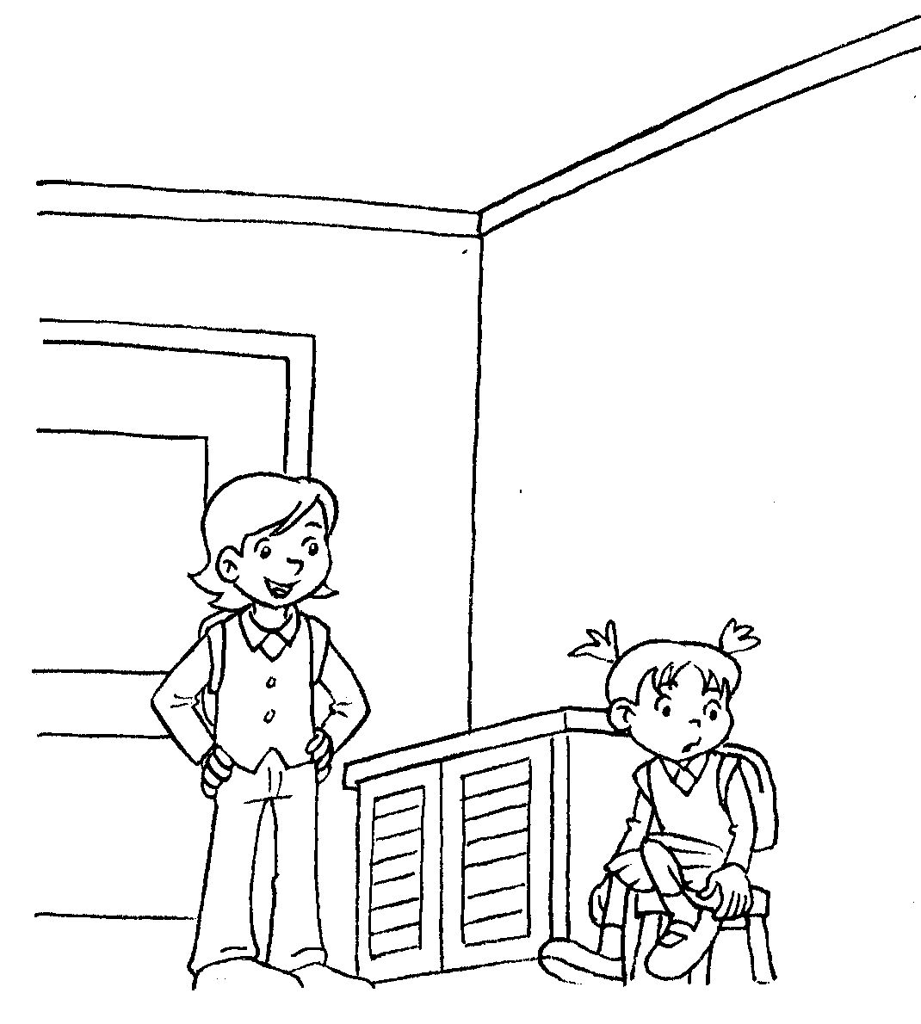
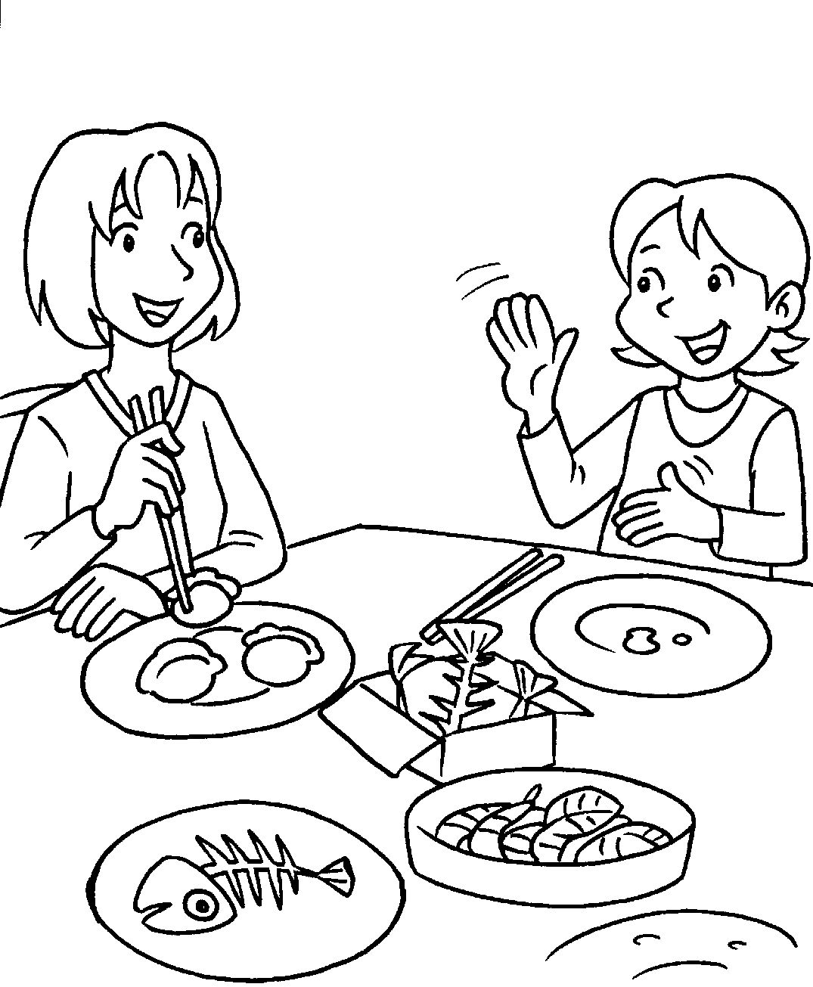
(1) (2)

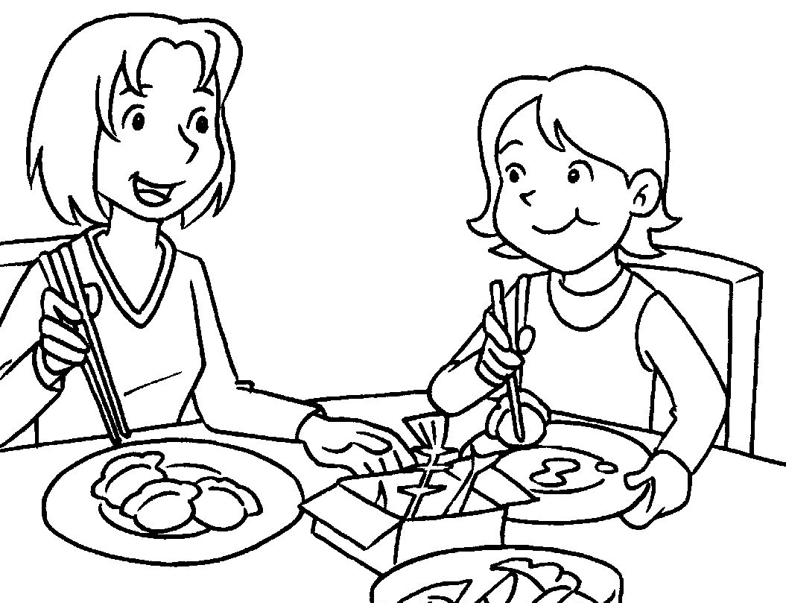
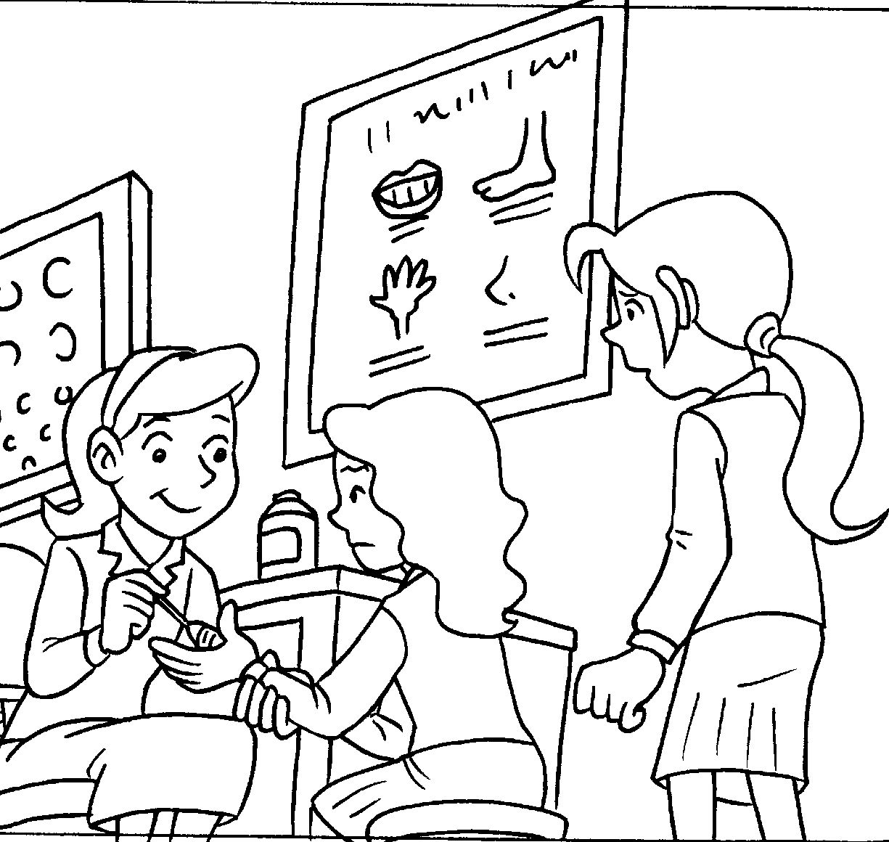
(3) (4)

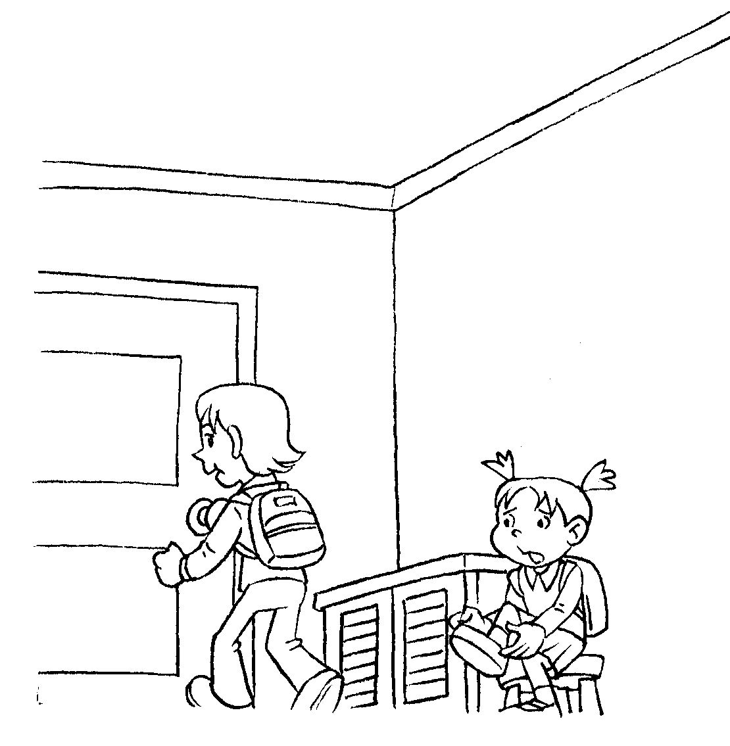
(5)

B. Listen and fill in the blanks 10%(每題2分)
在空格處填入正確的代號，完成下列對話。
A. dinner B. go to school
C. dumplings D. go see the doctor
E. leg F. go home
G. go to the nurse H. wash your hands
I. noodles J. wash your face

A: What’s wrong with you?
B: My (1) hurts.
A: Clam down. Let’s (2) .
B: Thank you.
B: What time is it?
A: It’s 5:00. Time to (3) .
B: Okay.
A: What do you want for dinner?
B: I want (4) .
A: Go (5) .

C. Listen and Choose仔細聽，選出適當的答句。
10%(每題2分)
(1) ( ) a. I want to play dodge ball.
b. My left hand hurts.
(2) ( ) a. It’s 11:50. Time for lunch.
b. I want two sandwiches.
(3) ( ) a. No, thanks.
b. Wait a minute.
(4) ( ) a. It’s 4:00. Let’s play basketball outside.
b. Oh, no. I’m late for school.
(5) ( ) a. Take your time.
b. Are you okay?

D. Phonics 選出與前者畫線部分發音相同的字10%(每題2分)
1. ( ) blow ( a. plane b. blue c. bicycle)
2. ( ) float ( a. friend b. bloat c. flower)
3. ( ) cup ( a. Cindy b. call c. cell)
4. ( ) goat ( a. game b. gin c. giant)
5. ( ) city ( a. rice b. cool c. cup)

E. Choice questions選擇題10%(每題2分)

( )1. A: Get up. It’s 7:00 in the morning.
B: It’s Sunday.
(a) Let me help you. (b) Let’s go to school.
(c) Let me sleep. (d) Time for lunch.
( ) 2. A: I don’t want to do my homework.
B:
(a) Go to the nurse. (b) You’re lazy.
(c) You’re beautiful. (d) Time for lunch.
( ) 3. A: This cake is for you. B:
(a) Thanks. (b) Here you are.
(c) Watch out. (d) Take your time.
( ) 4. A: What’s wrong with her? B:
(a) She is right. (b) She goes to school.
(c) He is tall. (d) Her leg hurts.
( ) 5.A: How’s your hand? B:
(a) I have long feet. (b)It’s better now.
(c) Go wash your teeth. (d) Take your time.

F. Complete the sentences完成句子10%
(每題2分)
A | B |  | C
7:00 | 12:00 |  | 4:00
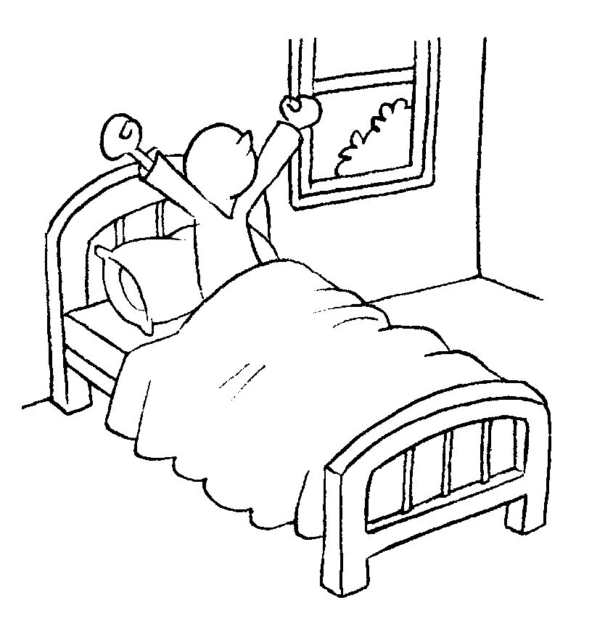 | 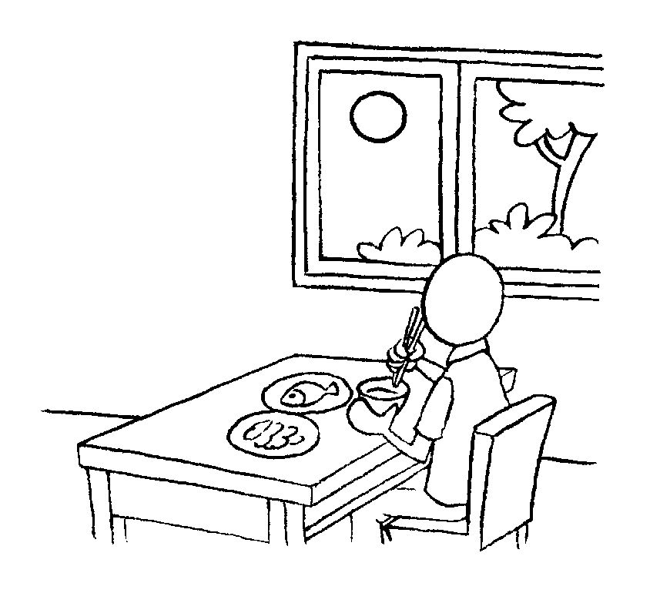 |  | 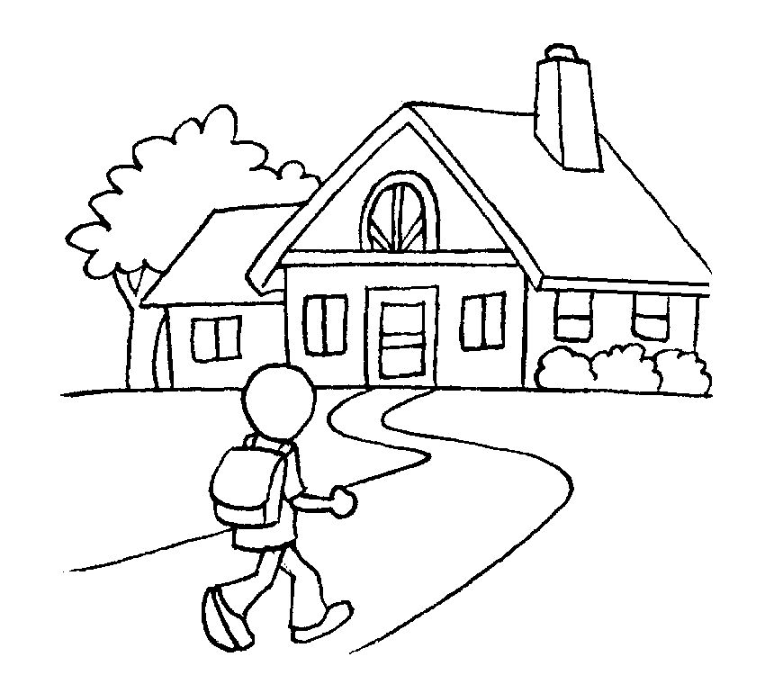
D |  | E
6:30 |  | 9:00
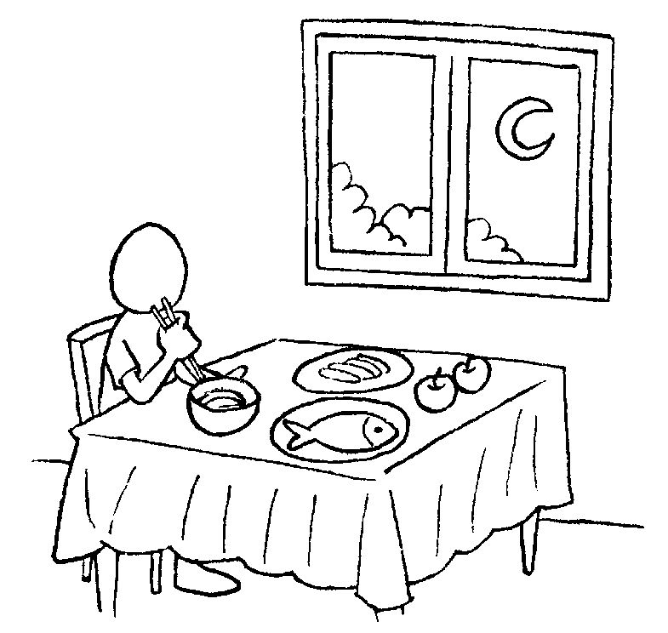 |  | 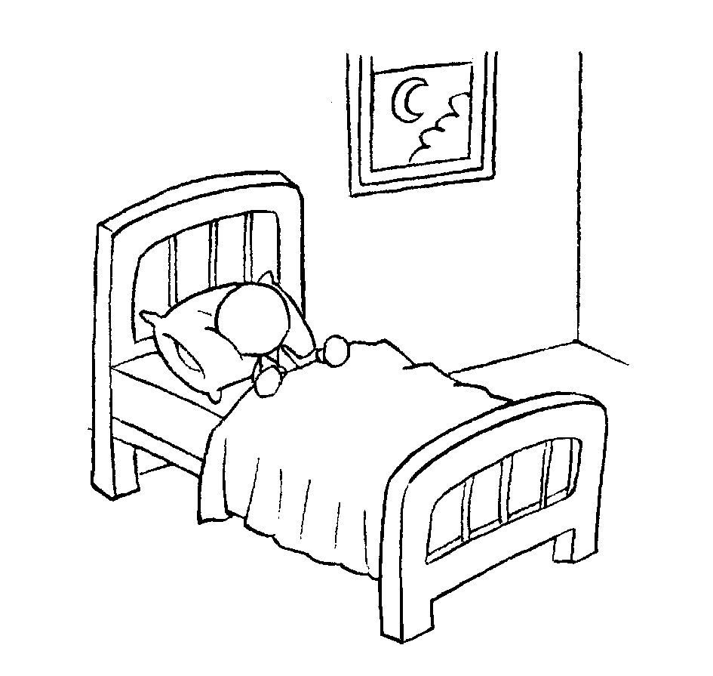
(1) It’s 12:00.
Time ___________________________
(2) It’s 9:00.
Time ___________________________
(3) It’s 4:00.
Time ___________________________
(4) It’s 6:30.
Time____________________________
(5) It’s 7:00.
Time ___________________________
G.刪除句中多餘的單字並重寫句子10%
(每題2分)
1. What do you want for a lunch?
à______________________________
2. My legs are hurt.
à______________________________
3. It’s 6:30. Time for to take a shower.
à______________________________
4. What’s wrong are with him?
à______________________________
5. Let’s go to a the dentist..
à______________________________
H. Check and cross判斷句子，對的打勾錯的打叉10%(每題2分)
A | B | C
7:00     | 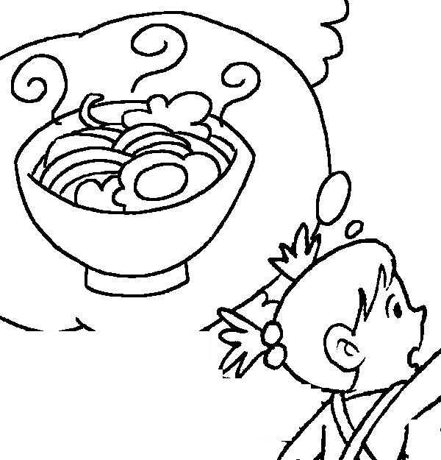  6:30 | 12:00  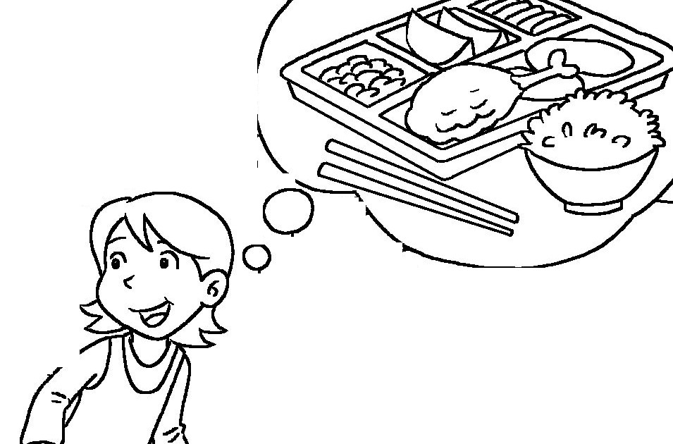
(1) ( ) It’s 6:30. I want noodles for dinner.
(2) ( ) A: What do you want for breakfast, Mom? B: I want two sandwiches.
(3) ( ) A: What do you want for lunch, Allen? B: I want rice.
(4) ( ) It’s 7:00. Time for breakfast.
(5) ( ) A: What do you want for dinner, Maggie? B: I want rice.
I. Translation翻譯8%（每題2分）
1.這些是你的麵。
→________________________________
2.我的左手好痛。
→________________________________
3. 晚餐吃什麼？
→________________________________
4. 刷牙的時間到了。
→________________________________
J. Order 排出對話順序 12%（每格2分）
(1) ( C )→( )→( )→( )→( B )
A. I want dumplings.
B. Ok, let’s go to the restaurant.
C. What time is it?
D. It’s 7:00. Time for dinner.
E. What do you want for dinner?
(2) ( A )→( )→( )→( )→( C )
A. Time to get up. Go brush your teeth.
B. My tooth hurts.
C. Let’s go to the dentist.
D. I can’t.
E. What’s wrong?

