台南縣仁德國小九十七學年度第二學期期中評量 何嘉仁英語第4冊
四年 班 號 姓名： 家長簽名

一、聽力測驗：30分，每格1分ead anddraw)
- (CD曲目12)
Listen and Check 仔細聽，勾選出聽到的句子。

(1)  ( )  (a) | a. | b.
(2)  ( )  (b) | a. | b.
(3)  ( )  (b) | a. | b.
(4)  ( )  (a) | a. | b.
(5)  ( )  (b) | a. | b.
2. Listen and Choose 仔細聽，勾選出聽到的句子。

(1) (左)  ( ) We can draw. | ( ) We can’t draw.
(2) (右)  ( ) What do you do? | ( ) What can you do?
(3) (右)  ( ) Good job! | ( ) Take it easy.
(4) (左)  ( ) I can talk. | ( ) I can cook.
(5) (左)  ( ) Good job! | ( ) Take it easy.
(
- (CD曲目15)
Listen and Fill in the Blanks 仔細聽，將聽到的單字填入句子中。

sing | can | speak English
dance | talk | ride a bike

(1) Willy can ____________________.
(talk)
(2) Betty can ____________________.
(sing)
(3) Allen can’t ___________________.
(dance)
(4) Wendy can __________________.
(ride a bike)
(5) Yes, I ___________.
(can)
Listen and Number 仔細聽，依序將圖片編號。

( 3 )  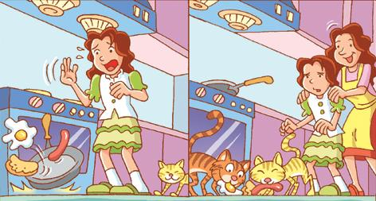 | ( 1 )  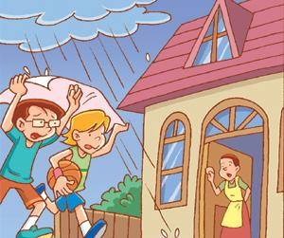 | ( 5 )  

( 4 )   | ( 2 )  
CD曲目18)
- (CD曲目27)
Listen and Circle 仔細聽，圈選出聽到的發音字。

(1)   cap cape  (cape) | (2) 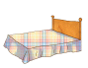  bed bead  (bed) | (3)   tap tape  (tape)
(4) 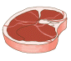  met meat  (meat) | (5) 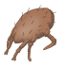  nit night  (nit)
- (CD曲目28)
Listen and Mark 仔細聽，母音發音為Long A者打○；發音為Long E者打△；發音為Long I者打╳。

- feed | △
- bite | ╳
- mate | ○
- play | ○
- tight | ╳

二、配合題：每格2分
- (A) I don’t know. (B) Good job!
(C) Come inside. (D) No problem.
(E) Take it easy.

(1) ( ) (B) (2) ( ) (C) (3) ( ) (E)

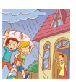

(4) ( ) (D) (5) ( ) (A)
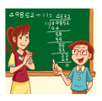
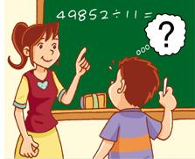

三、寫出正確的單字：每題2分

__________________

__________________

- (rainy
__________________

w)
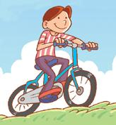

____________________
(ride a bike)

5.
Hello!

____________________

(四、重組句子：每題2分
- the/weather/?/How’s

→ ____________________________
(How’s the weather?)
- rainy/cold./It’s/and

→ ____________________________
(It’s rainy and c(We can’t write and read.ride a bike?)
- can’t/much/!/Your/do/friends

→____________________________
(Your friend can’t do much!)
五、判斷句子，對的打圈錯的打叉：每格2分
- ( ) It’s a sunny.
()
- ( ) Can Willy do sing?
- ( ) Allen can speak English.
()
- ( ) Bella cans sing.
(╳)
六、選出正確的答句：每格2分
- ( ) How’s the weather? (b)
a. It’s an orange.
b. It’s windy.
- ( ) What can you do? (b)
a. I draw.
b. I can draw.
- ( ) Can Amy sing? (a)
a. Yes, she can.
b. Yes, she can ride a bike.
七、畫線部分發音相同打圈不同打叉：每格2分
- ( ) mad maid
(╳)
- ( ) snake lay
(○)
- ( ) pay daily
(○)
meat peat
( )
(○)
whale wheel
( )
(╳)
seed read
( )
(○)
night nit
( )
(╳)
win wine
( )
(╳)
light kite
( )
(○)
十七、依照圖示回答問題：每題3分

- Is it cold?
→ _________________________
(No, it isn’t. It’s h

- How’s the weather?

→ _________________________
(It’s rainy and cold.)


- What can you do?

→_________________________
(I can read and write.

- What can’t you do?

→_________________________

