台南縣仁德國小九十七學年度第二學期期中評量英語科試題家長簽名:____________
命題範圍:佳音版第二冊Starter至Review 1 三年____班____號 姓名：___________
A. Listen and write. 聽一聽，將聽到的單字標上A~F順序。12%(每題2分)
1. 2. 3.




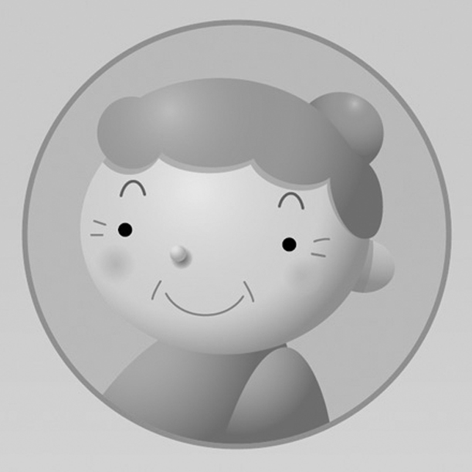


4. 5. 6.

B. Listen and circle. 聽一聽，將聽到的單字圈起來。18%(每題2分)
1. fat cat 2. hit dig 3. leg desk
4. wig hit 5. ten jet 6. jet leg
7. hat mat 8. cap ant 9. sit pit
- Listen and check. 聽一聽，將正確的回答打勾。10%(每題2分)
1. I’m fine. 2. Hello, Mr. Lin.
I’m Meg. Hello, Mrs. Lin.
3. Yes, she is. 4. Thank you.
Yes, he is. Hi, Tina.
5. No, she is.
No, she is not.
D. Listen and write the number. 請寫出所聽到的數字。4%(每題1分)

1. _________ 2.__________ 3.____________ 4._____________

E. Fill in the blanks填入適當的單字 10%(每題2分)
- _________________ you. (Thank/ Thanks)
- _________________, he's not. (Yes / No)
- _________________ is my cat. (The / This)
- This is ______________ hen. (you / your)
- Who's ______________? (my / he)?

F. Match. 將圖片和正確的句子連起來。10%(每題2分)

1   |   2 |   3 |   4 | 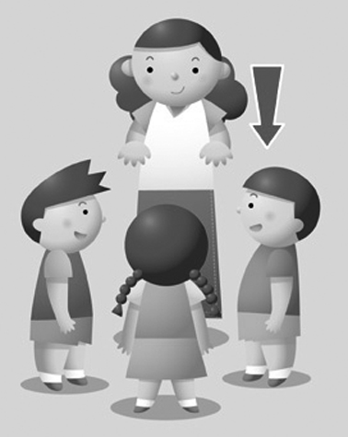  5
˙ | ˙ | ˙ | ˙ | ˙

˙ ˙ ˙ ˙ ˙
Put down your hand.
Be quiet.
Come here. .
Listen.
Raise your hand.

G. Write the number. 寫出正確的數字。16%(每題2分)

1.  thirteen  ________ | 2.  fifteen  ________ | 3.  eleven  ________ | 4.  twenty  ________
5.  eighteen  ________ | 6.  twelve  ________ | 7.  sixteen  _________ | 8.  nineteen  ________

H. Choice questions選擇題20%(每題2分)
( ) 1. This is my ＿＿＿＿＿. He's tall. (1) sister (2) mother (3) father
( ) 2. She ＿＿＿＿＿＿＿ my friend. (1) × (2) am (3) is
( ) 3. He is my ＿＿＿＿＿＿＿＿. (1) friend (2) mother (3) sister
( ) 4. He's ＿＿＿＿＿＿＿＿. (1) a cute (2) cool (3) pig
( ) 5. ＿＿＿＿＿＿ Lin is Jim's mother. (1) Mr. (2) Mrs. (3) Mis
( ) 6. Is ＿＿＿＿＿＿＿ your bed? (1) the (2) its (3) this
( ) 7. Who's ＿＿＿＿＿＿＿＿ ? (1) you (2) she (3) my
( ) 8. Yes, she ＿＿＿＿＿. (1) is (2) am (3) are
( ) 9. I'm ＿＿＿＿＿＿＿. Thank you. (1) great (2) mother (3) five
( ) 10. This is ＿＿＿＿＿ cat. (1) my (2) I (3) she

