台南縣仁德國小九十七學年度第一學期期末評量英語科試題 家長簽名:____________
命題範圍:何嘉仁版第五冊Unit 4至Review 2 五年____班____號 姓名：____________________

一、聽力測驗：30%(每小題2分)
(CD曲目47)
1 Listen and Check 根據錄音內容，找出每個人的交通工具，在空格中打勾。
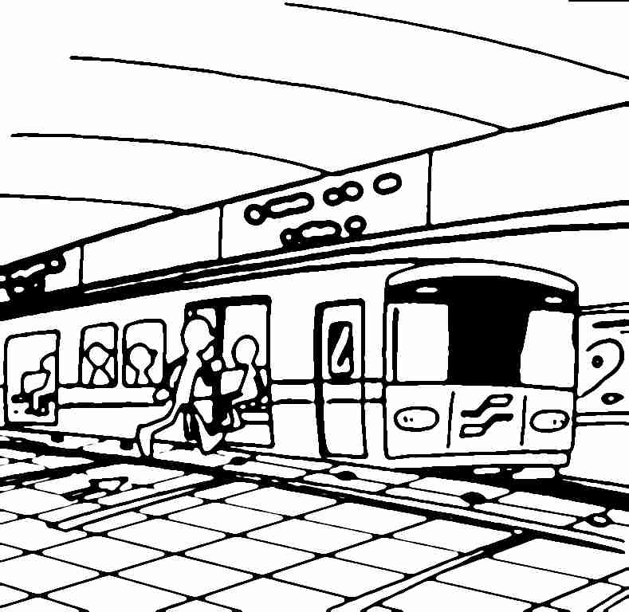
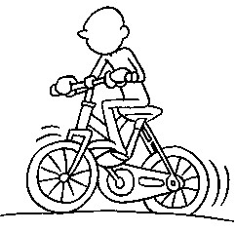
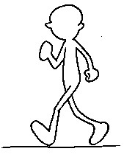
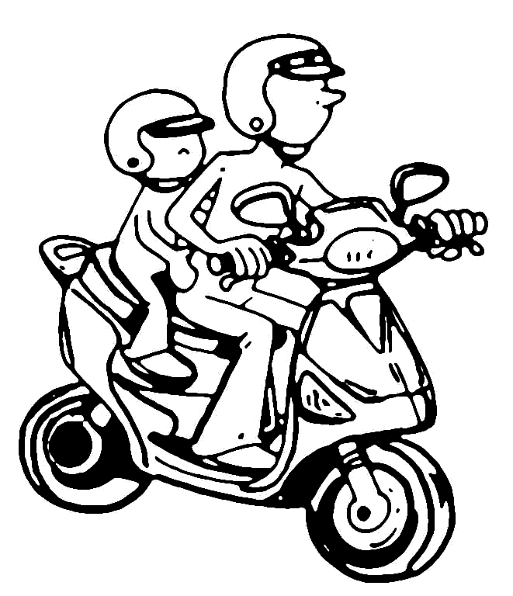
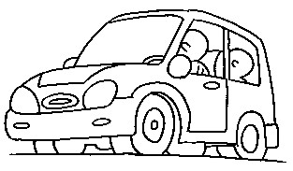

    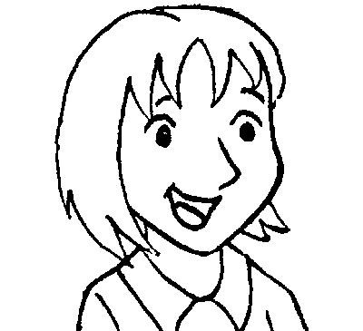      (1) |  | (by bike)
(2) |  |  | (by scooter)
(3) |  |  |  | (on foot)
(4) | (by MRT)
(5) |  |  |  |  | (by car)
(CD曲目40)
2.Listen and Circle 根據錄音內容，圏出正確的答案。
(1) | 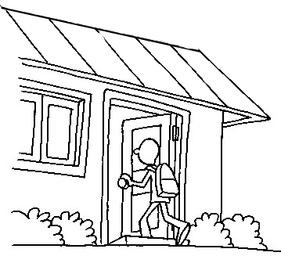  9:00 | 4:30 (○右圖)
(2) | 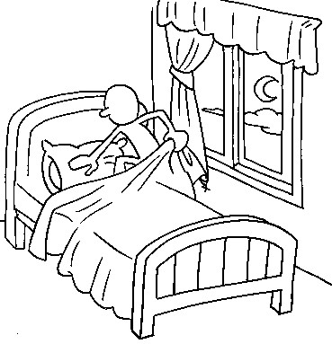  4:10 | 10:40 (○右圖)
(3) | 7:15 (○左圖)  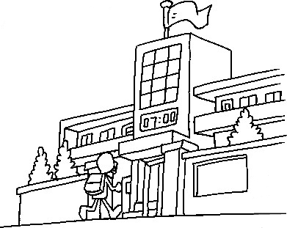 | 7: 50
(4) | 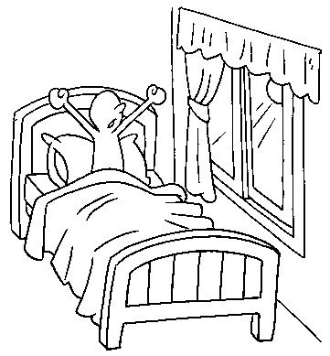  9:45 | 6:00 (○右圖)
(5) | 5:20 (○左圖)  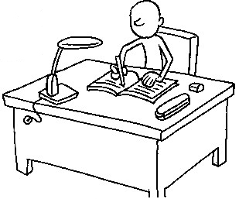 | 11:55

(CD曲目33)
3.Listen and Fill in the blanks 仔細聽錄音內容，將課程代號填入下列課表中。
A. Chinese B. art C. PE D. music E. English

Monday | Tuesday | Wednesday | Thursday | Friday
(B) | (D) | (A) | (C) | (E)

二、寫出正確的單字：10%(每題2分)
1.

________________________
(get up)
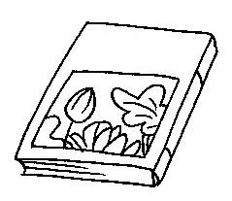
2. 2.
國語

_________________________
(Chinese)
3.
________________________
(by car)
4.

________________________
(on foot)
5.
your
________________________
(do your homework)
三.克漏字選擇10%(每題2分)
1. ( ) No, I _____. I go to the shop on foot.
(a) do (b) don’t (c) does (b)
2. ( ) Nancy, is _____ your card?
(a) this (b) the (c) these (a)
3. ( ) I go home _____ foot.
(a) to (b) by (c) on (c)
4.( ) A: _____ do you go to school? B: By bike.
(a) What time (b) How (c) What (b)
5. ( ) Do you go to the park _____ bus?
(a) on (b) at (c) by (c)
四、勾選出正確的答句：10% (每題2分)
1. Do you do your homework at 8:20?
No, I don’t. I do my homework at 7:10.
No, it isn’t.
(上No, I don’t. I do my homework at 7:10.)
2. Do you have English on Wednesday?
I study English at 4:30.
Yes, I do.
(下Yes, I do.)
3. How do you go to school?
I go to school at 7:20.
I go to school by bus.
(下I go to school by bus.)
4. What time do you do your homework?
I do my homework at 6:40.
I go home at 5:40.
(上I do my homework at 6:40.)
5. What classes do you have on Thursday?
I go to school by bike.
I have art and Chinese.
(下I have art and Chinese.)

五.判斷句子，對的打勾錯的打叉10%(每題1分)
1. ( ) I go to school by MRT.(ü)
2.( ) How does you go to the park?(╳)
3. ( ) I go home on scooter.(╳)
4. ( ) Do you go to school by car?(ü)
5. ( ) Yes, I don’t. I go to the library by bus. (╳)
Mon. | Tue. | Wed. | Thur. | Fri. | Sat.
math | English | music | art | Chinese |   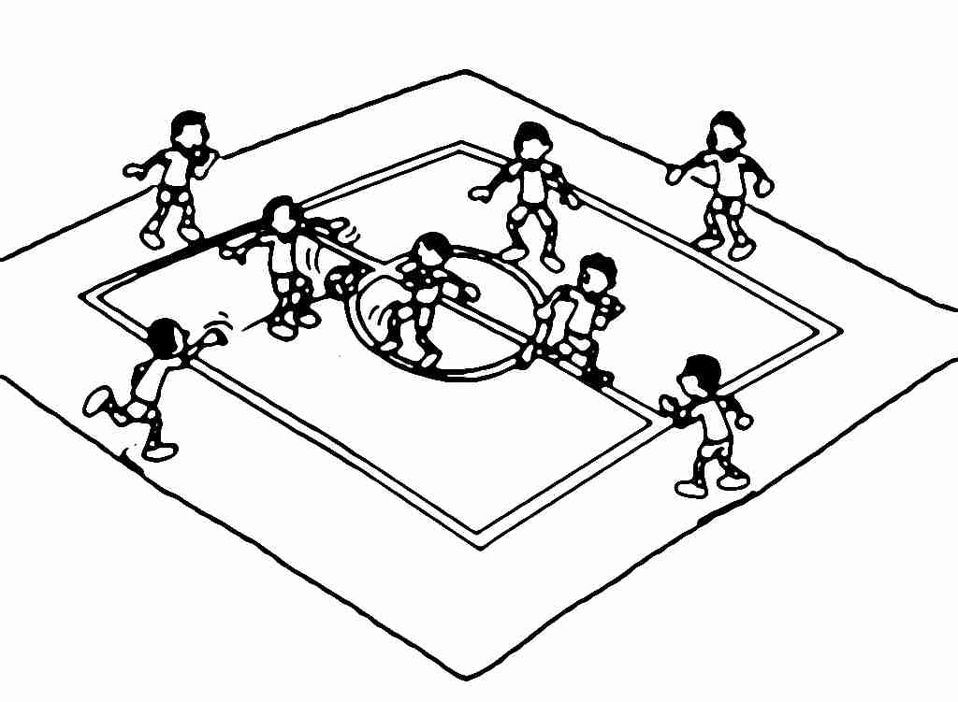
math | English | Chinese | math | PE
依照上表判斷句子對錯。
(6) ( ) I have music on Monday.(╳)
(7) ( ) I have English and PE on Thursday.(╳)
(8) ( ) I have Chinese on Friday.(○)
(9) ( ) I have music and Chinese on
Wednesday.(○)
(10) ( ) I play basketball on Saturday.(╳)

六.畫線部分發音相同打圈不同打叉10%(每題2分)
1.( ) then when(╳)
2. ( ) other that(○)
3.( ) whose wheat(○)
4. ( ) what weather(╳)
5.( ) thick this(╳)
七、重組句子：15% (每題3分)
1. I/No,/the/park/I/don’t./by/./go/scooter/to
→__________________________________
(No, I don’t. I go to the park by scooter.)
2. have/PE/Do/you/?/on/Tuesday/and art
→__________________________________
(Do you have PE and art on Tuesday?)
3. at/Do/you/home/go/four/?/o’clock
→__________________________________
(Do you go home at four o’clock?)
4. go/./to/I/school/bike/by
→__________________________________
(I go to school by bike.)
5. on/Monday/I/and English/have/./music
→__________________________________
(I have music and English on Monday.)
八.連連看:5%(每題1分)
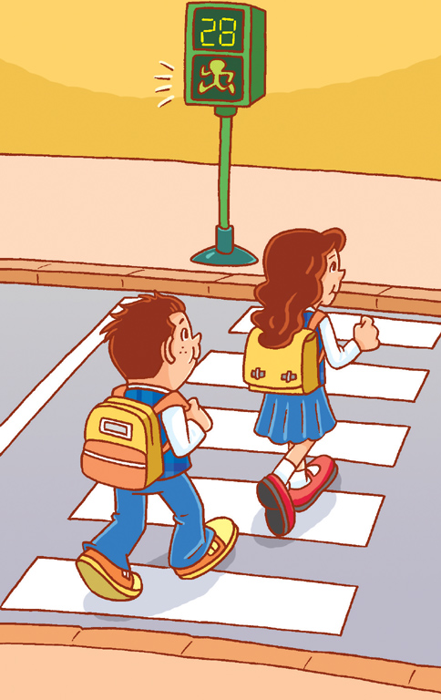
(1)
l l Excellent!
(Walk.)
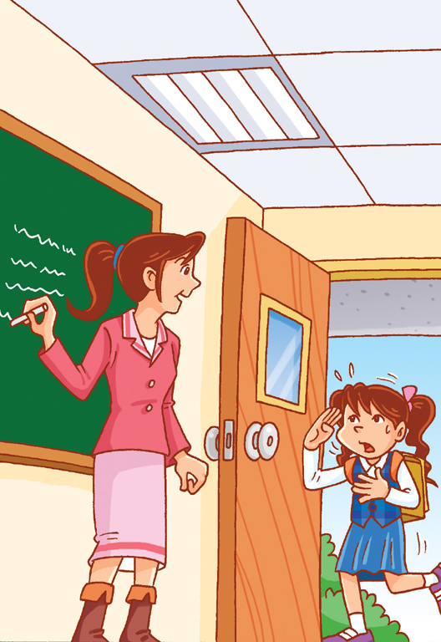
(2)
l l Stop!
(Sorry, I’m late.)

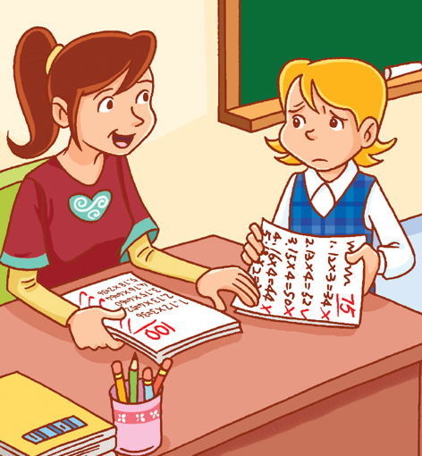
(3)
l l Sorry, I’m late.

(Study harder next time.)
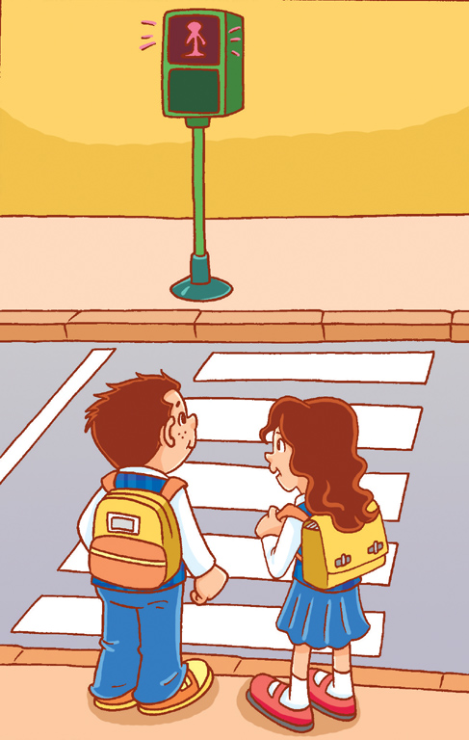
(4)
l l Study harder next time.
(Stop!)
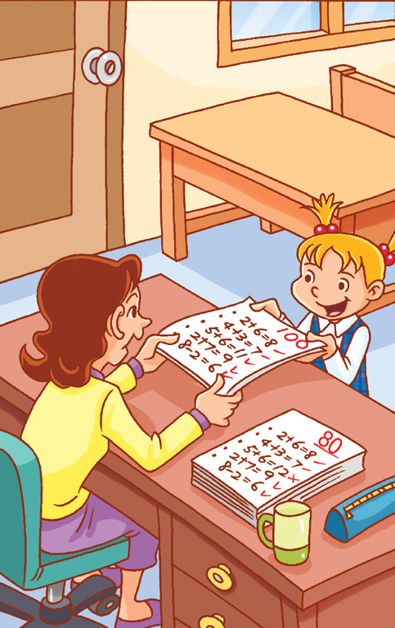
(5)
l l Walk.
(Excellent!)
一、聽力測驗聽力稿
(CD曲目47)
1 Listen and Check 根據錄音內容，找出每個人的交通工具，在空格中打勾。
(1) I go to school by bike.
(2) I go home by scooter.
(3) How do you go home? I go home on foot.
(4) How do you go to school? I go to school by MRT.
(5) DO you go to the library on foot? No, I don’t. I go to the library by car.

(CD曲目40)
2.Listen and Circle 根據錄音內容，圏出正確的答案。
(1) What time do you go home?
I go home at 4:30.
(2) What time do you go to bed?
I go to bed at 10:40.
(3) What time do you go to school?
I go to school at 7:15.
(4) Do you get up at 6:00?
Yes, I do.
(5) Do you do your homework at 11:55?
No, I don’t. I do my homework at 5:20.

(CD曲目33)
3.Listen and Fill in the blanks 仔細聽錄音內容，將課程代號填入下列課表中
(1) I have art on Monday.
(2) I have music on Tuesday.
(3) I have Chinese on Wednesday.
(4) What do you have on Thursday? I have PE on Thursday.
(5) Do you have art on Friday? I have English on Friday.

