仁德國小九十七學年度第一學期期末測驗英語科 四年 班姓名 座號
何嘉仁 英語第3冊 Unit4~Review2 得分 家長簽名

一、聽力測驗：

- (CD曲目43)
Listen, Check, and Match 仔細聽，勾選出聽到的句子並填入對應圖片的代號。(每個答案1分)

(1) ( )
A
Merry Christmas!

Have a nice day!
(C. Merry Christmas!)

(2) ( )
B
Time for class.

In a minute, please.
(D. In a minute, please.)

(3) ( )
C
No eating.

No drinking.
(B. No eating.)

(4) ( )
D
Happy birthday!

Happy holidays!
(E. Happy birthday!)

(5) ( )
E
Not here.

Here you are.
(A. Here you are.)

- (CD曲目47)
Listen and Choose 仔細聽，請依照聽到的題目選出最適合的回答。(每個答案2分)

(1)  B | (A) They’re cold. | (B) It’s cold.
(2)  A | (A) They’re sweet. | (B) It’s sour.
(3)  B | (A) Watch out!  They’re hot. | (B) Watch out!  It’s hot.
(4)  B | (A) They’re sour. | (B) It’s sour.
(5)  A | (A) Thank you. | (B) You’re welcome.

- (CD曲目50)
Listen and Number 仔細聽，將圖片依聽到的順序編號。(每個答案2分)




(2 5 4 3 1)
- (CD曲目55)
Listen and Check 仔細聽，勾選出單字代表的圖片。
(1) (右zip)

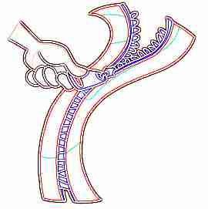


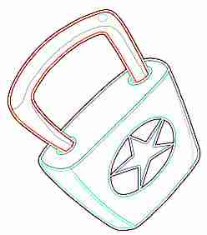
(2) (左lock)

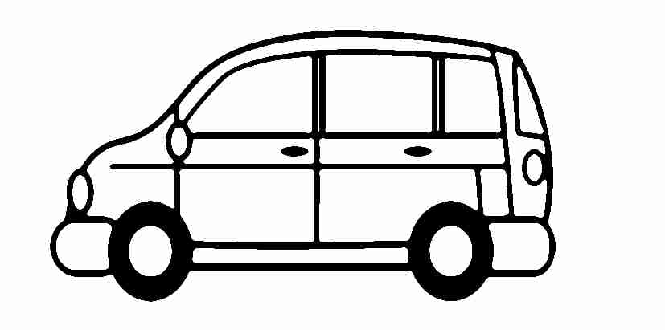
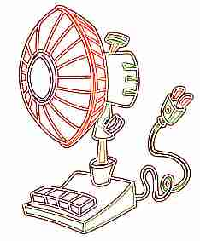
(3) (右fan)

(4) (右vat)
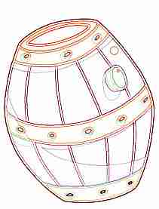
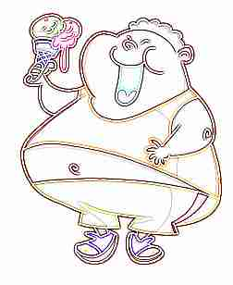

(5) (左sack)



- (CD曲目56)
Listen and Write 仔細聽，寫出單字的字首字母。
(1) (2) (3)
___ at ___ ock ___ ip
(v) (l) (s)
(4) (5)
___ ast ___ ap
二、圈出正確的單字：(每個答案2分)
- How ( many / much ) is the Christmas tree?
(much)
- The candy canes ( are / is ) sweet.
(are)
- The grape juice ( is / are ) cold.
(is)
- ( How / May ) I help you?
(May)
三、寫出正確的單字：(每個答案2分)

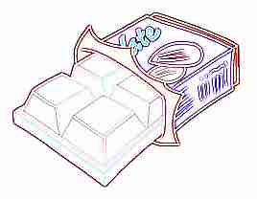

ochaotcel
(candy cane)

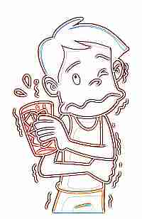

docl
(cold)

ucije
(juice)



ewtse
(hot dog)

ymymu
(yummy)
四、刪除句中多餘的單字並重寫句子：(每個答案2分)
- Time for a lunch.
→______________________________
(Time for lunch.)
- Merry you Christmas!
→______________________________
(Merry Christmas!)
- Me, too, three.
→______________________________
(Me, too.)
- May I help here you?
→______________________________
(May I help you?)
- Watch it out! It’s hot.
→______________________________
(

(Watch out! It’s hot.)
五、選出正確的答句：(每個答案2分)
- ( ) Can I have some cookies? (b)
a. It’s $100.
b. Yes, you can.
- ( ) May I help you? (a)
a. Yes, I want some cookies, please.
b. Here are some cookies.
- ( ) Here is your chocolate cake. (a)
a. Thank you.
b. I’m thirsty.
- ( ) How much are the pizza and a cola? (b)
a. It’s $99.
b. They’re $100.
六、選出正確的句子：(每個答案2分)
- ( )
(a) a. The cake is sweet.
b. The pizza is yummy.
- ( )
(a) a. The juice is sour.
b. The juice is sweet.


- ( )
(a) a. The hamburger is yummy.
b. The cookies are yummy.

七、中翻英：(每個答案1分)
- 茶好燙。
The ________ is _________.
(The tea is hot.)
- 可樂好冰。
The ________ is _________.
(The cola is cold.)
八、排出會話順序：(每個答案1分)

- (a) How much are they?
(b) Here you are.
(c) They’re $50.
(d) May I help you?
(e) Yes, I want a juice and two sandwiches, please.

(1) ( d )→ (2) ( )→ (3) ( )→ (4) ( )→
(5) ( )
(1. d→2. e→
(sandwich)

