台南縣仁德國小九十七學年度第一學期期末評量英語科試題家長簽名:____________
命題範圍:何嘉仁版第三冊Unit 4至Review 2 三年____班____號 姓名：___________
一．Listing聽力測驗: 50%
1.Listen and write. 聽一聽，寫出聽到的字母大小寫。20%(每題2分)

1. 2. 3. 4. 5.

6. 7. 8. 9. 10.

2.Listen and check. 聽一聽，將聽到的句子打勾。12%(每題2分)
1. That’s OK. 2. `It’s a sun. 3. It’s big.
It’s OK. It’s a fan. It’s an ant.

4. You’re a pig. 5. Yes, she is 6. What is it?
You’re big. Yes, he is. Is it a rat?

3.Listen and check. 聽一聽，將正確的圖打勾。8%(每題2分)
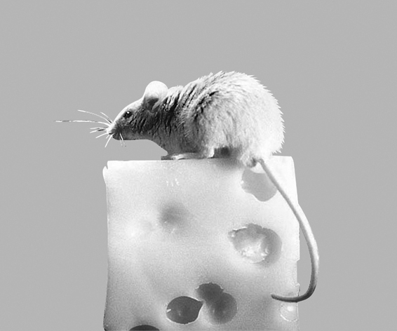
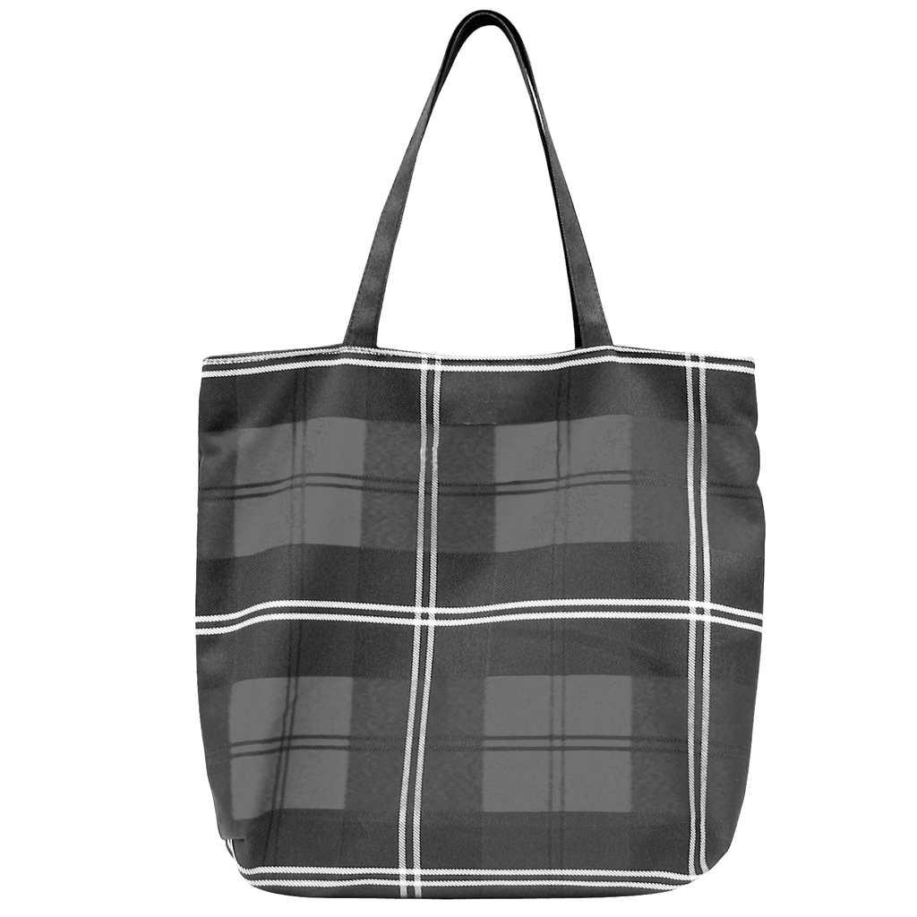
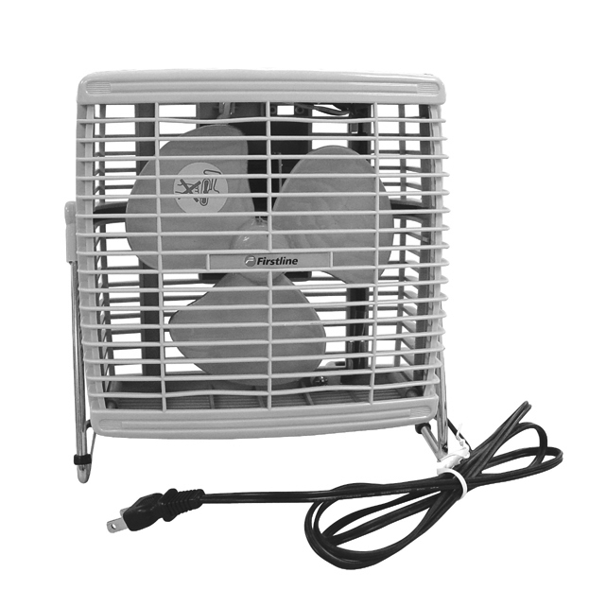

1. 2.

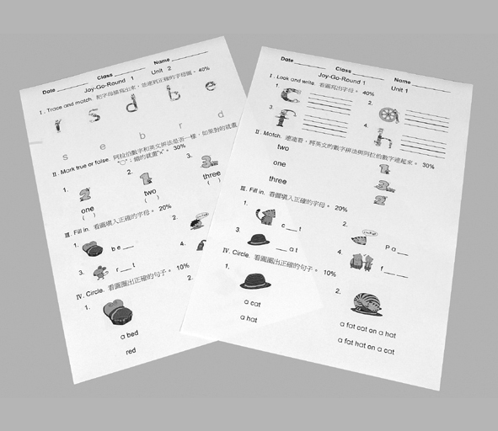
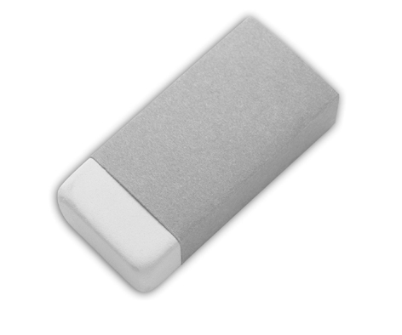
3. 4.
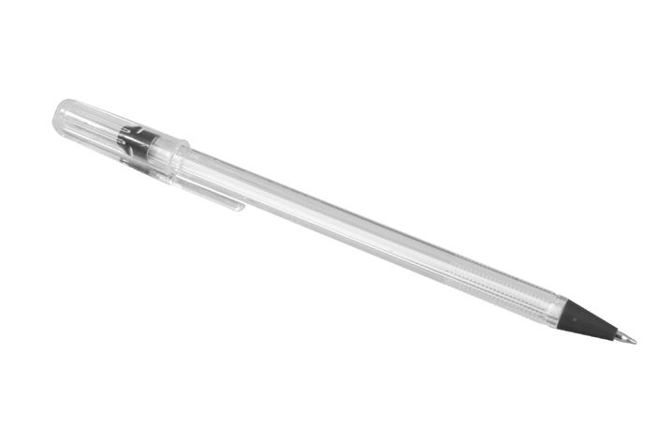


4.Listen and circle. 聽一聽並看圖，將正確的回答圈起來。10%(每題2分)
1. box bag 2.ten wet

3.vest yam

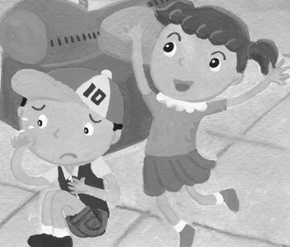
5.. (a) Yes, she is.
(b) No, she’s not.

6,. (a) Yes, he is.
(b) No, he isn’t.
二. Write Aa-Zz 請寫出Aa到-Zz 26%(每個字母1分)

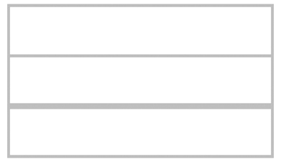
1. 2. 3. 4. 5. 6. 7. 8. 9. 10. 11. 12 13.

14. 15. 16. 17. 18. 19. 20. 21. 22. 23. 24. 25. 26.

三．choice questions 選擇題10%(每題2分) 14%(每題2分)
( ) 1. Are you ＿＿＿＿＿＿? (1) neck (2) happy (3)apple
( ) 2. It ＿＿＿＿＿＿ a book. (1) is (2) are (3) am
( ) 3. No, she ＿＿＿＿＿＿. (1) is (2) aren’t (3) isn’t
( ) 4. You ＿＿＿＿＿＿ a wolf (1) are (2) is (3) am
( ) 5. It’s an ＿＿＿＿＿＿. (1) eraser (2) book (3) Tina
( ) 6. You’re＿＿＿＿＿＿. (1) pig (2) duck (3) big
( ) 7. ＿＿＿＿＿＿ you! (1) OK (2) Black (3) Thank

四．Vocabulary 單字10%(每題2分)
( )1. (a)wet (b)yam 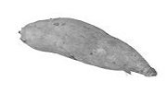

( )2. (a)banana (b)apple 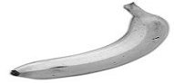

( )3. (a)box (b)black 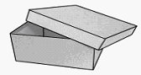

( )4. (a)zip (b)small 

( )5. (a)vest (b)box 