台南縣仁德國小九十七學年度第一學期期中評量英語科試題 家長簽名:____________
命題範圍:何嘉仁版第七冊Unit 1至Review 1 六年____班____號 姓名：____________________

一、聽力測驗：15%(每小題1分)
(CD曲目29)
1. Listen and Number 仔細聽，依錄音內容序順將圖片編。
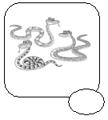
(3) (2) (4)
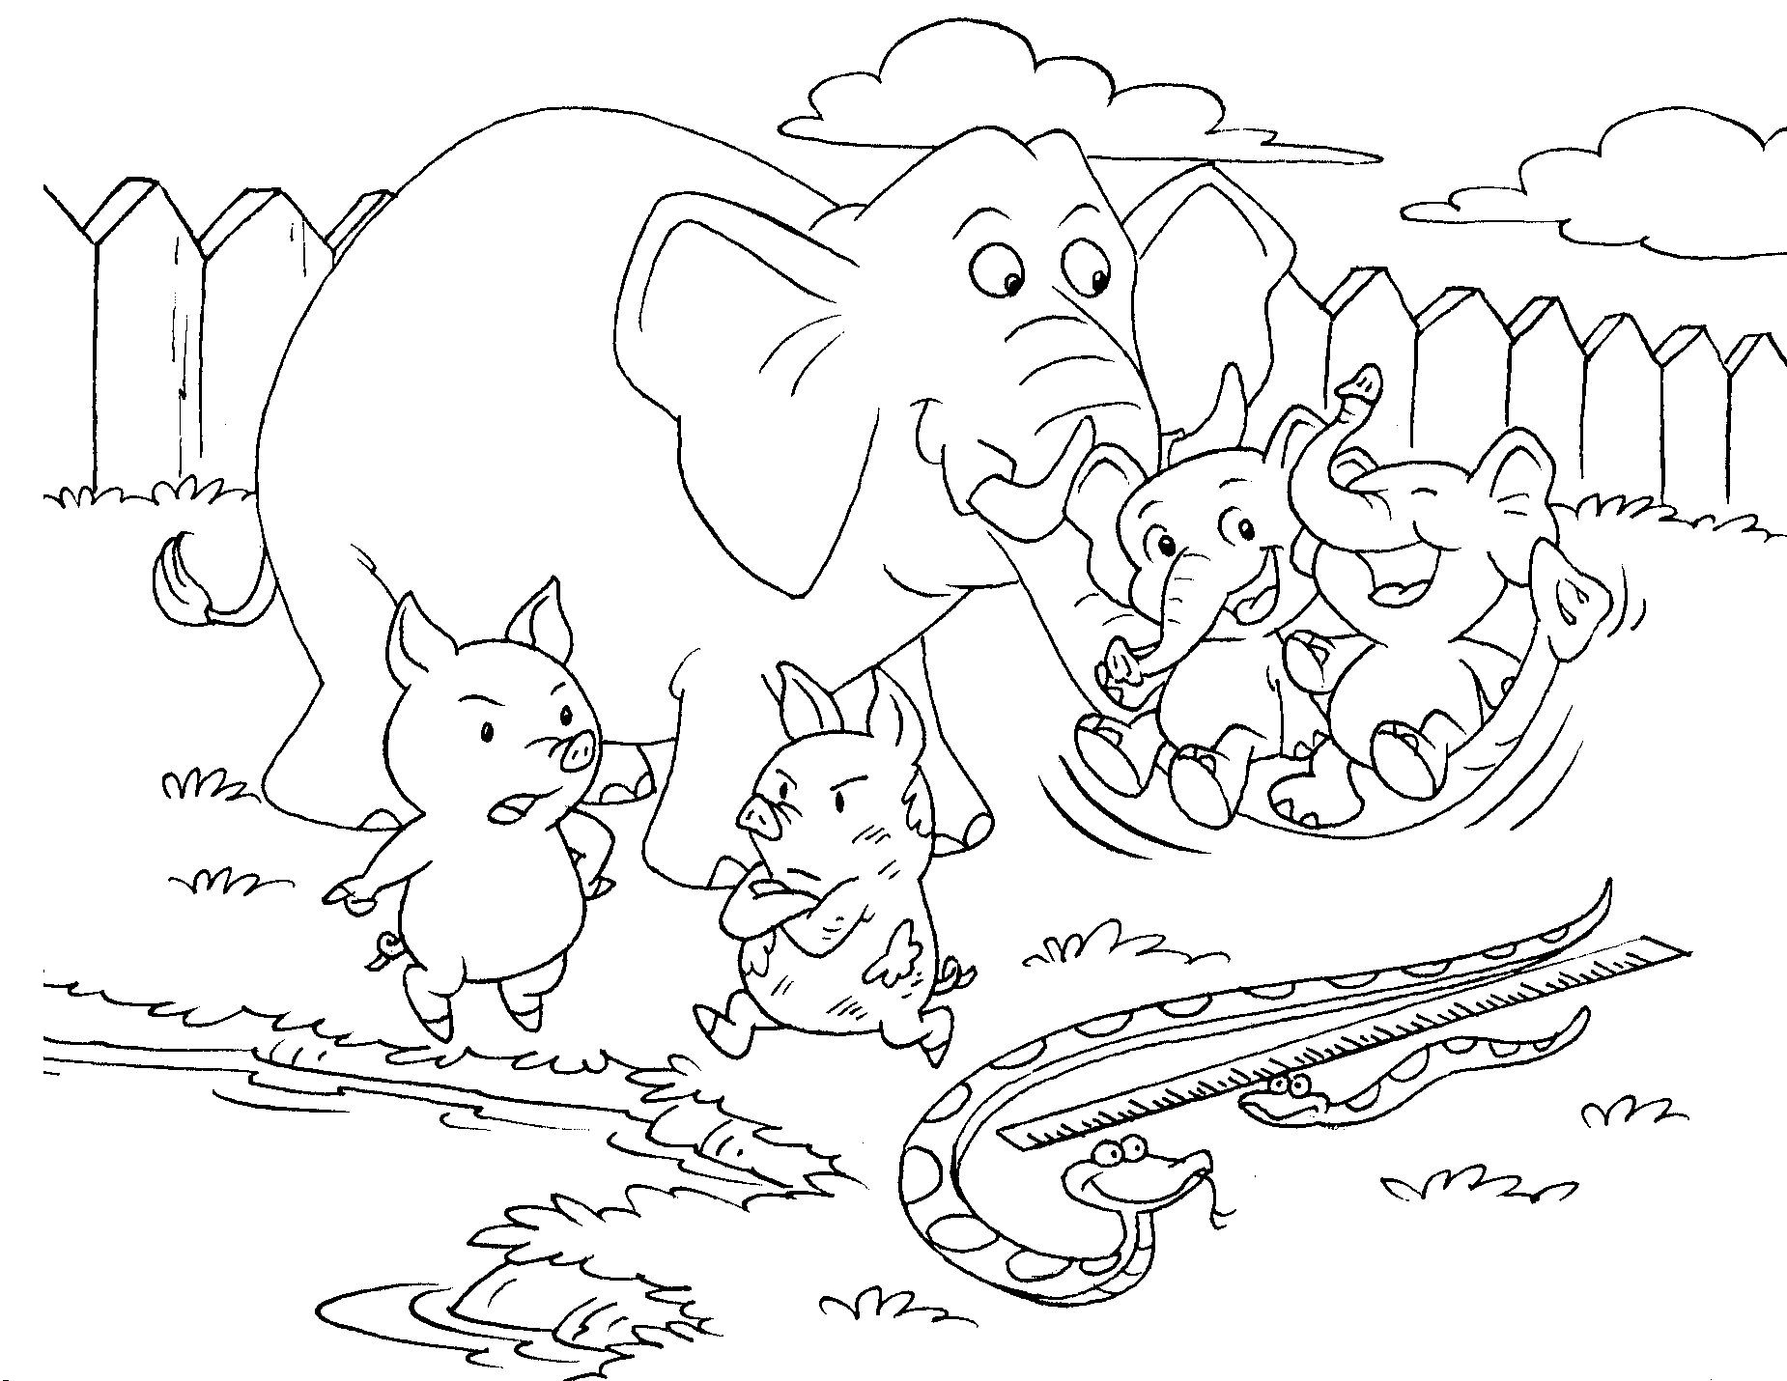
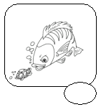
(1) (5)
(CD曲目28)
2.Listen and Circle 仔細聽，圈選出聽到的發音字。
(1)
skate
snake

(snake)
(2)
skirt
shirt

(skirt)
(3)
knight
knife

(knight)
(4)
sky
spy

(sky)
(5)
spider
stairs

(stairs)
(CD曲目26)
3. Listen and Check 仔細聽，勾選出適當的答句。
(1) It looks big.
I see eight elephants.
(下I see eight elephants.)
(2) I feel sleepy.
I see two tigers.
(上I feel sleepy.)
(3) I feel tired.
They look clean.(上I feel tired.)
(4) Yes, I do.
Yes, they are.(上Yes, I do.)
(5) I see three pigs.
Yes, they are.(下Yes, they are.)

二、寫出正確的單字：10%(每題2分)
1.

_______________
(excited)
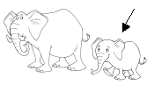
2.

______________
(small)
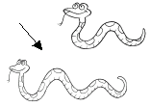
3.

______________
(long)

4.

__________________
(tigers)
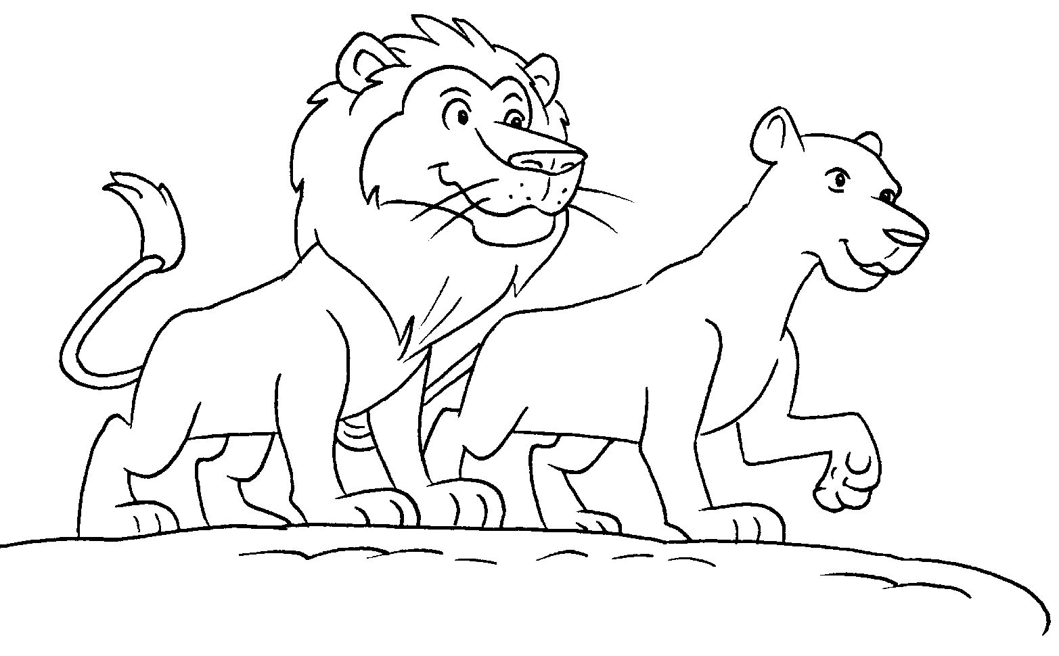
5.

__________________
(lions)
三、選出正確答案:10% (每題2分)
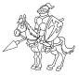
1. ( ) (b)
a. night
b. knight
c. kite
2. ( ) (a)
not圖
a. knot
b. not
c. knock
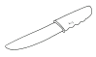
3. ( ) (c)
a. knit
b. knight
c. knife
4. ( ) (b)
knock圖
a. knot
b. knock
c. nock
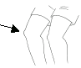
5. ( ) (c)
a. keel
b. kneel
c. knee
四、寫出缺空的單字：20% (每格2分)

- A: Do you see _______ tigers?

B: No, I ________. (any/don’t)
2. A: What’s ________?

B: I _______ sleepy. (wrong/feel)

3. A: How do you ________?

B: I feel ________. (feel/tired)

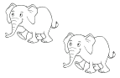
4.
There _____ two elephants.

They look s .
(are/small)


5. There _______ a snake.

(is)
It ________ long. (looks)

五、字彙選擇：10% (每題2分)
1. ( ) Do you see any _______? (b)
(a. snack b. snakes c. snake)
2. ( ) There are four ______. (c)
(a. pig b. big c. pigs)
3. ( ) There _____ a small tiger. (b)
(a. does b. is c. are)
4. ( ) A: How do you feel? B: I feel _____. (c)
(a. long b. home c. sleepy)
5. ( ) How _____ lions do you see? (a)
(a. many b. much c. are)
六、重組句子：15% (每題3分)
1. do/now/How/?/feel/you
→_______________________________________________
(How do you feel now?)
2. are/six/There/there./birds/over
→_______________________________________________
(There are six birds over there.)
3. tigers/you/many/see/?/How/do
→_______________________________________________
(How many tigers do you see?)
4. pig/cute/looks/The/./so
→_______________________________________________
(The pig looks so cute.)
5. snakes/see/you/?/any/Do
→_______________________________________________
(Do you see any snakes?)

七、配合題： 10% (每題2分)
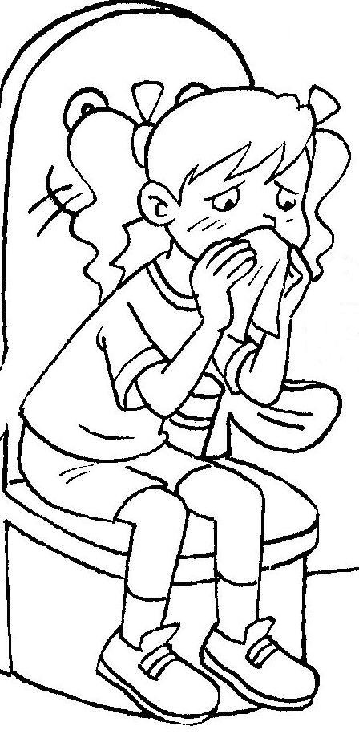

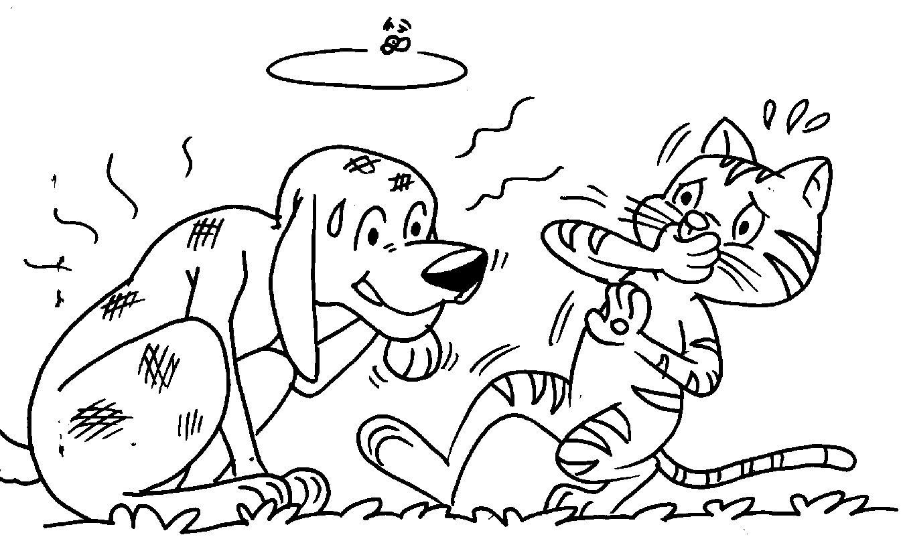
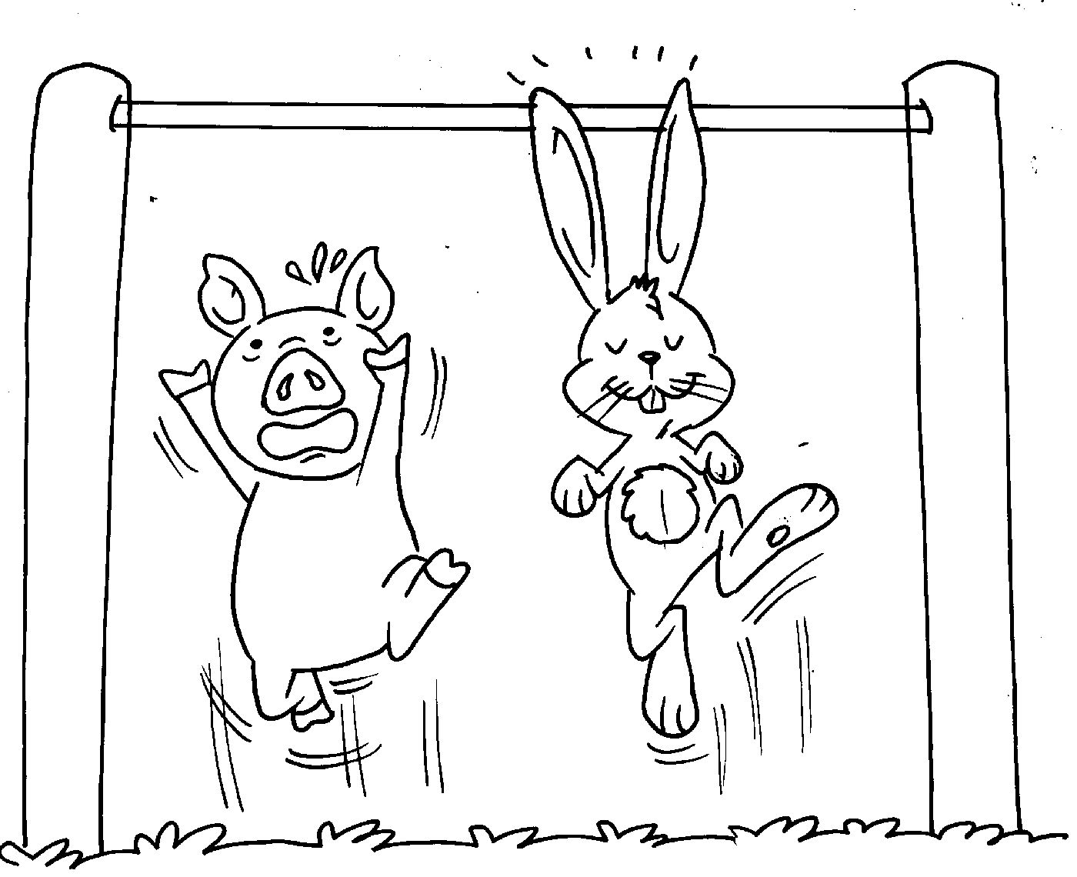
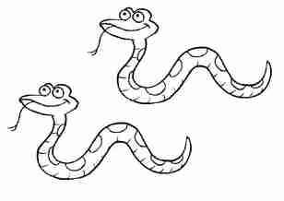
A
B
D
E
C

1. ( ) There are a dirty dog and a clean cat. (E)
2. ( ) I feel excited. I want to dance. (B)
3. ( ) The rabbit’s ears look so long. (D)
4. ( ) I feel sick. I want to go home. (A)
5. ( ) There are two short snakes. (C)
八.看圖回答 : 10 %(每題2分)
(2)

(1)

(1) How do you feel, Bella?
(I feel bored.)_________________________
(2) What’s wrong, Amy?
(I feel sick.)__________________________
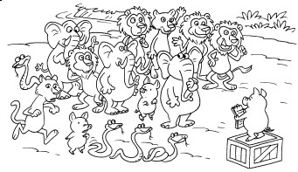

(2) How many snakes do you see?
____________________________________
(I see four snakes.)
(4) Do you see any elephants?
____________________________________
(Yes, I do.)
(5) Do you see any fish?
____________________________________
(No, I don’t.)

