台南縣仁德國小九十七學年度第一學期期中評量英語科試題 家長簽名:____________
命題範圍:何嘉仁版第五冊Unit 1至Review 1 五年____班____號 姓名：____________________

一、聽力測驗：20%(每小題1分)

1. Listen and Circle 仔細聽，圏出正確的圖片。
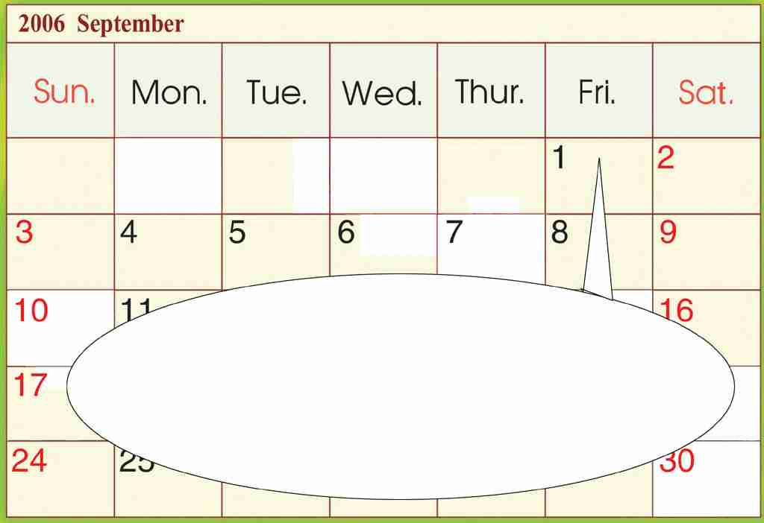
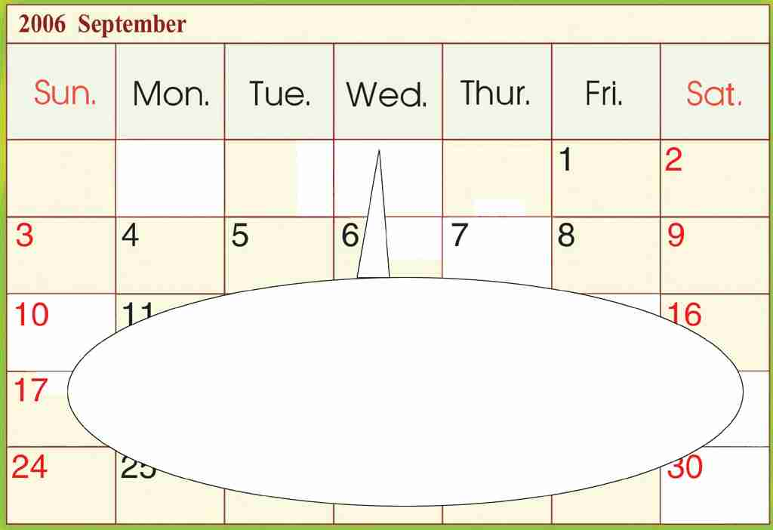
(1)
星期五
星期三

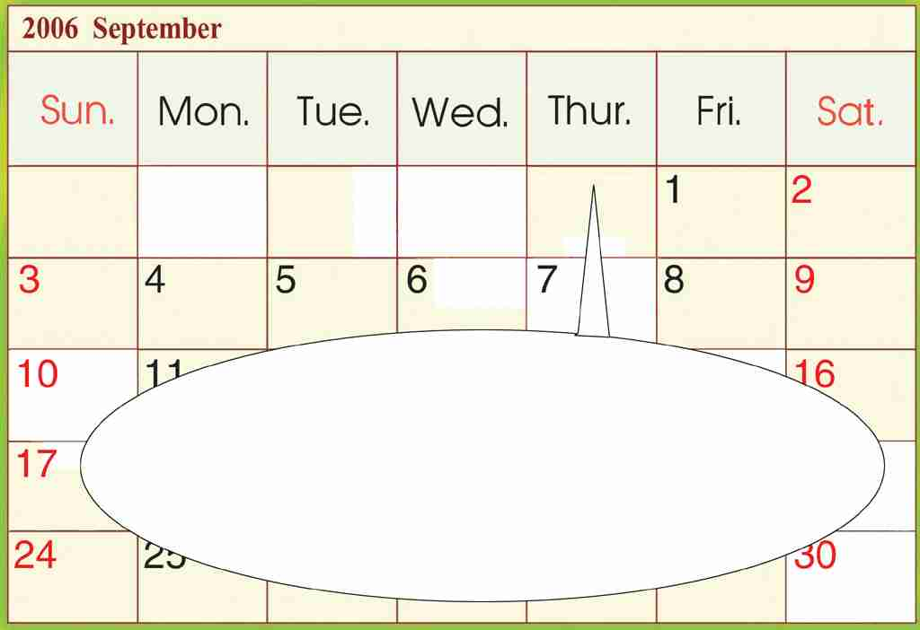
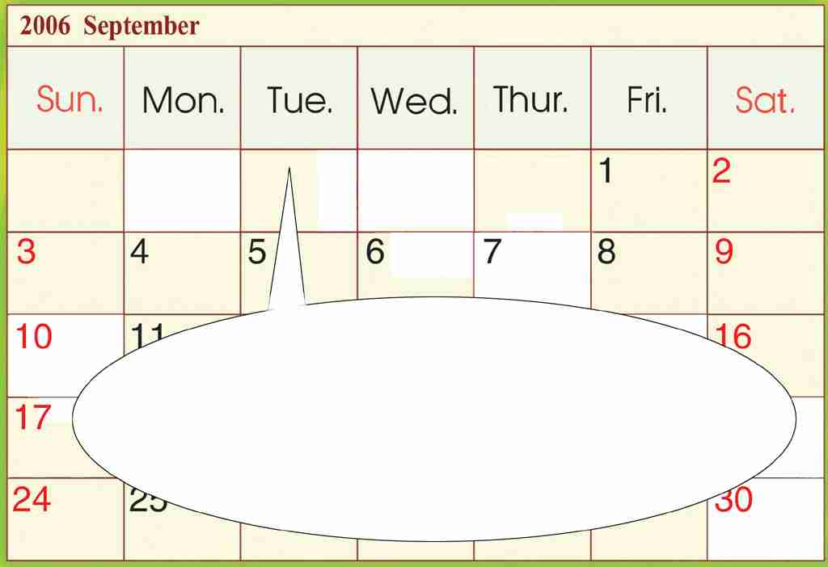
(2)
星期四
星期二

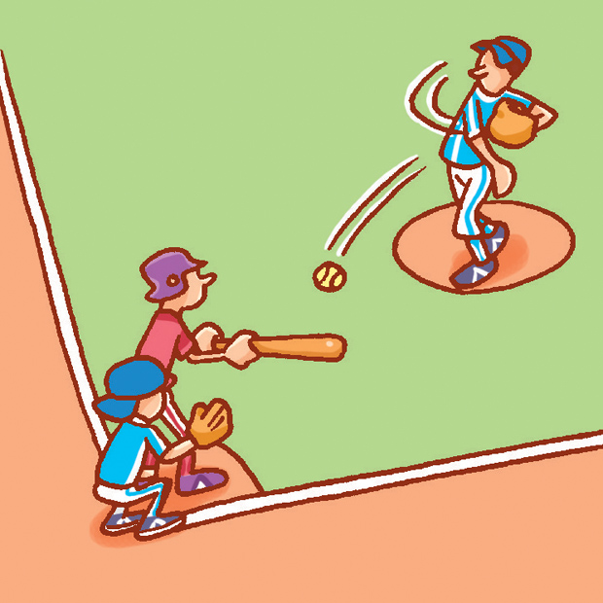
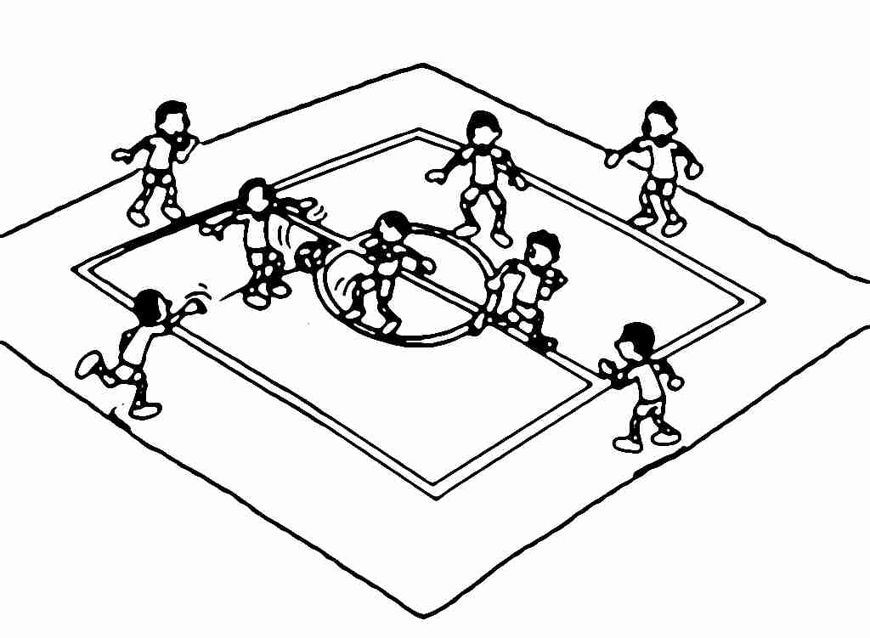
(3)

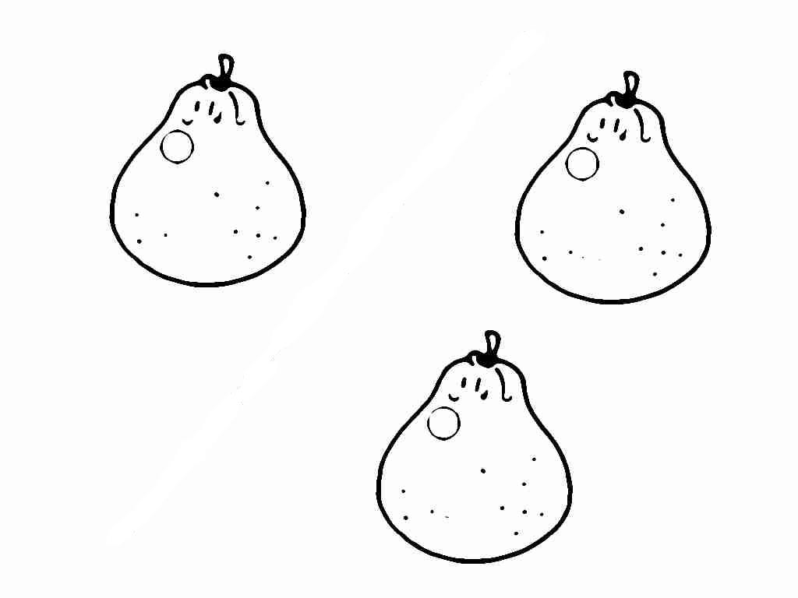
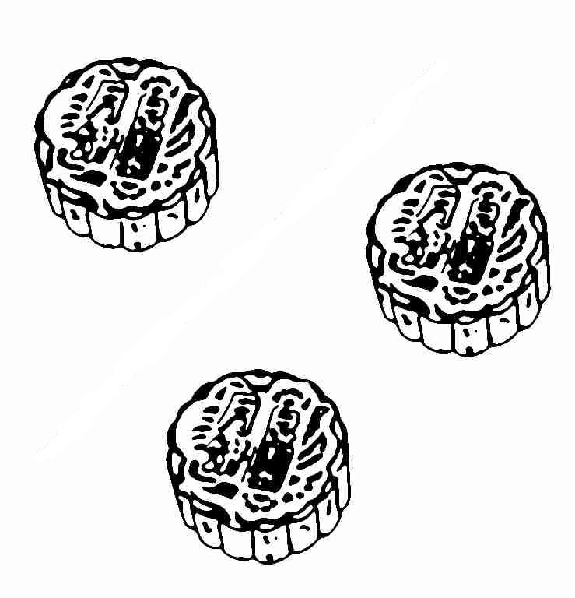
(4)

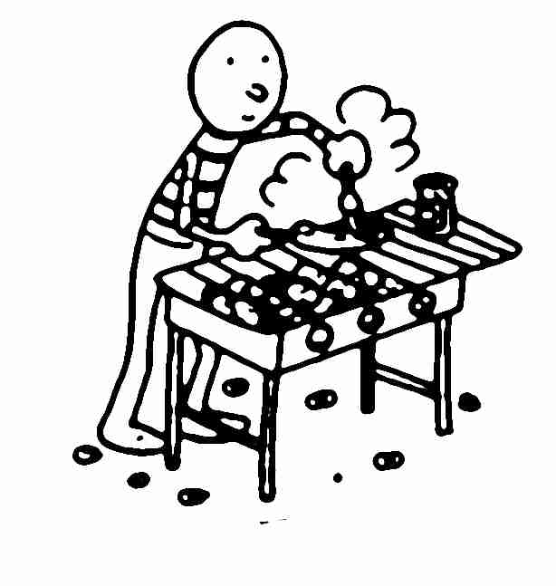
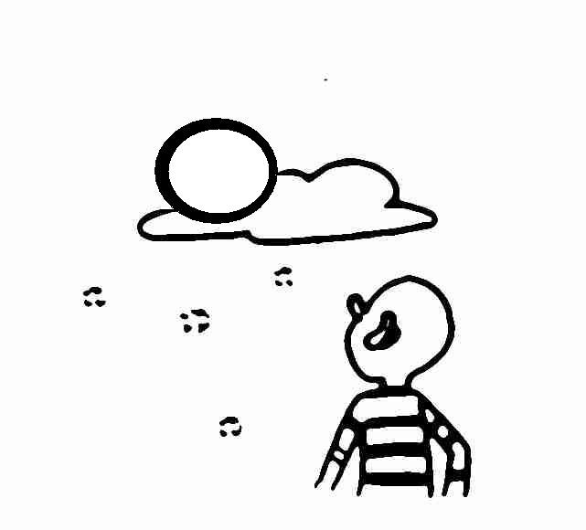
(5)

2. Listen and Write 仔細聽，寫出缺空的發音字。
sh ch/tch ph

(1) (2)
__ __ ark hu __ __

(3) (4)
su __ __ pi __ __ __

(5)
__ __ onic

3. Listen and Choose 仔細聽問句，選出適當的答句。
(1) ( )
(a) I play basketball on Saturday.
(b) I play dodge ball on Sunday.

(2) ( )
(a) No, I don’t. I like moon cakes.
(b) They’re pomelos.
(3) ( )
(a) Yes, it is.
(b) It’s Friday.
(4) ( )
(a) No, they aren’t.
(b) They’re moon cakes.
(5) ( )
(a) Yes, it is.
(b) Yes, it’s Thursday.

4. Listen and Number 仔細聽，依序將圖片編號。
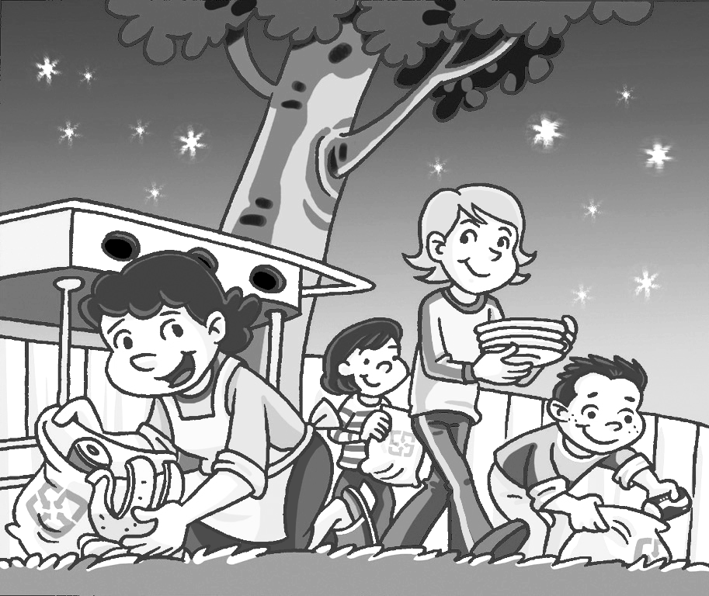
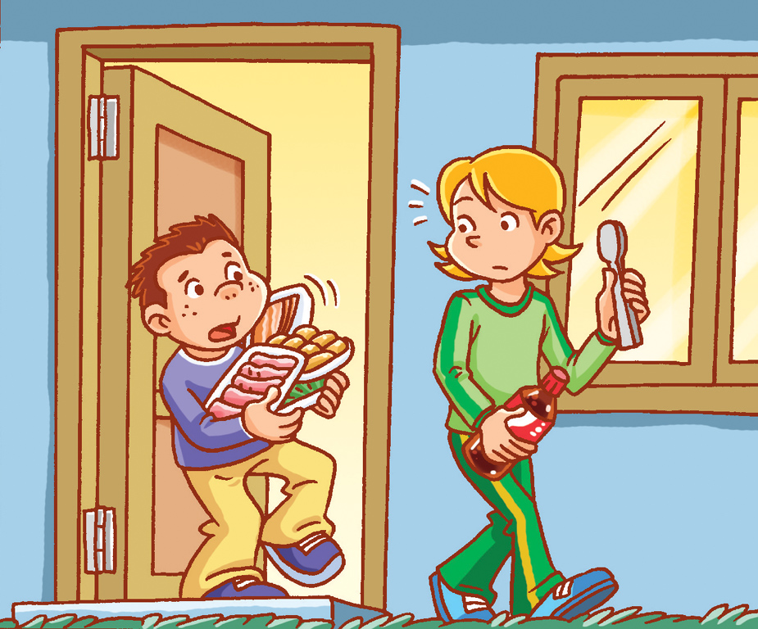
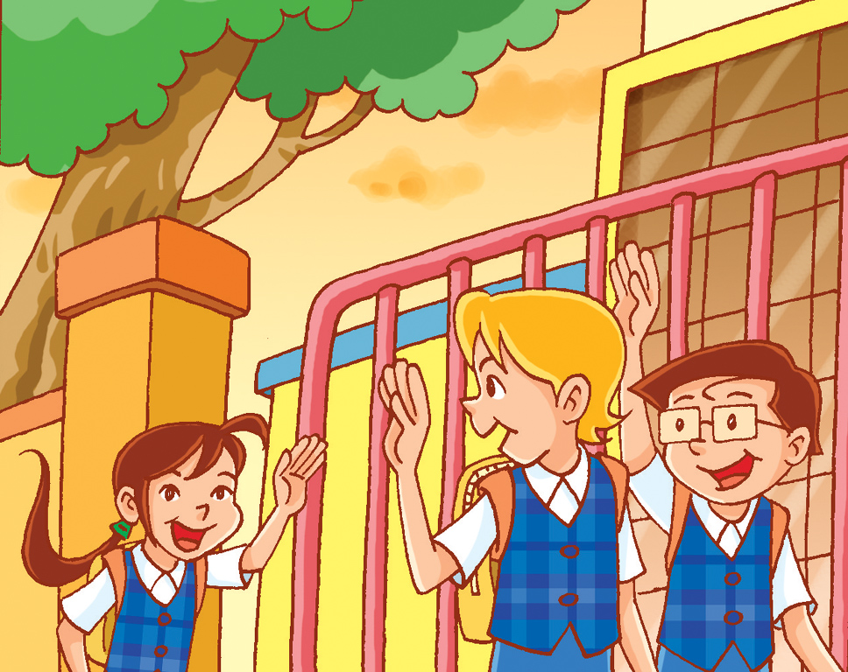
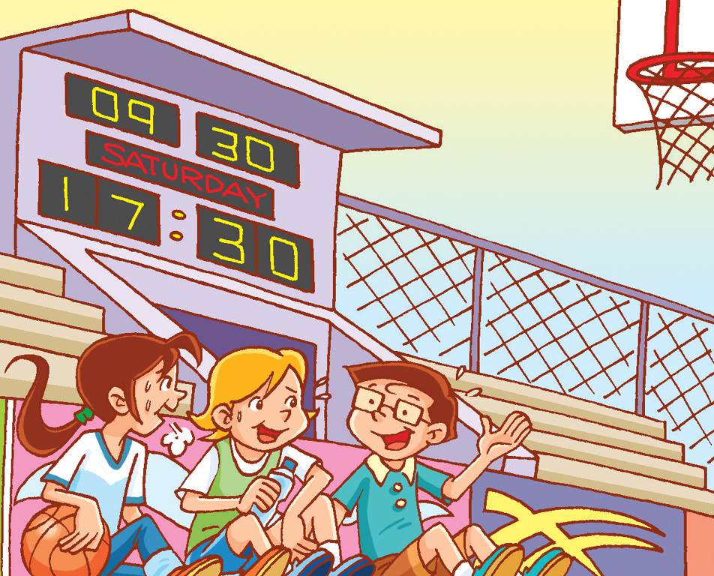
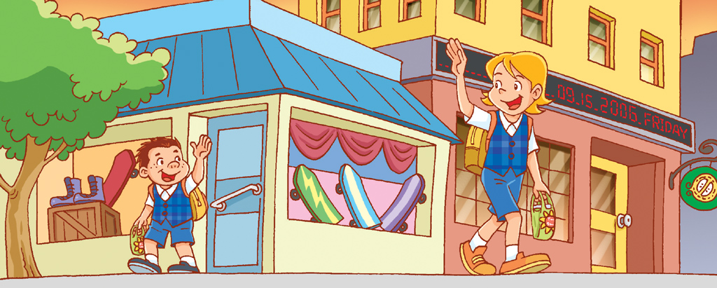

( ) ( ) ( )

( ) ( )

二、寫出正確的單字：10%(每題2分)
1.

________________________

2.

________________________

3.
9
星期三

________________________

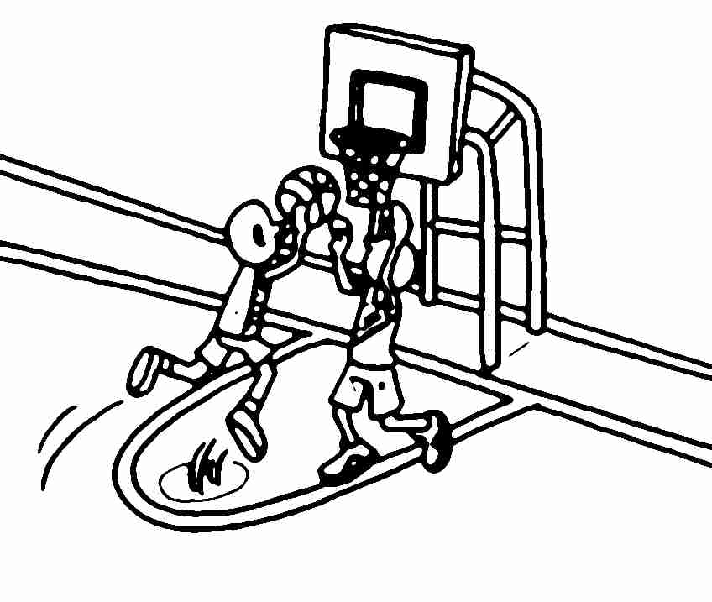
4.

________________________

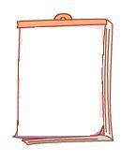
5.
17
星期四

________________________

三、勾選出正確的答句：10% (每題2分)
1. Do you like the pomelo?
No, I don’t. I like the moon cake.
I don’t like the moon cake.

2. Is today Thursday?
Yes, it is. It’s Tuesday.
No, it isn’t. It’s Tuesday.

3. What do you do on Saturday?
I play baseball on Saturday.
See you on Saturday.

4. What are these?
It’s a hamburger.
They are hamburgers.

5. What day is today?
Yes, it is.
It’s Friday.
四、畫線部分發音相同打圈，不同打叉：10% (每題2分)
1. ( ) match march
2. ( ) hone phone
3. ( ) bush shower
4. ( ) touch trash
5. ( ) point photo

五、寫組：15% (每題3分)
1.you/cake/Do/?/like/moon/the
→______________________________________

2.Moon/you/?/on/Festival/What/do/do
→______________________________________

3.have/barbecue/a/We/.
→______________________________________

4.too/./I/the/watch/moon,/full
→______________________________________

5.Moon/is/Today/./Festival
→______________________________________
六、克漏字選擇：15% (每題3分)
1. ( ) What do you do ____ Sunday?
(a) ╳ (b) on (c) at
2. ( ) ____ are moon cakes.

星期五
(a) The (b) It (c) They
3. ( ) What day ____ today?
(a) is (b) are (c) the
4. ( ) It’s ____ Thursday.
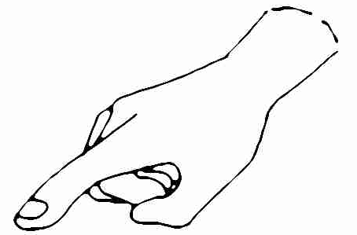
(a) and (b) not (c) the
5. ( ) What are ____?
(a) those (b) this (c) these

七、配合題：20% (每題2分)
(a) Give me a hand, please. (b) Let’s call it a day.
(c) Let’s clean up. (d) Have a nice weekend.
(e) We have a barbecue on Moon Festival.

(1) (2) (3)

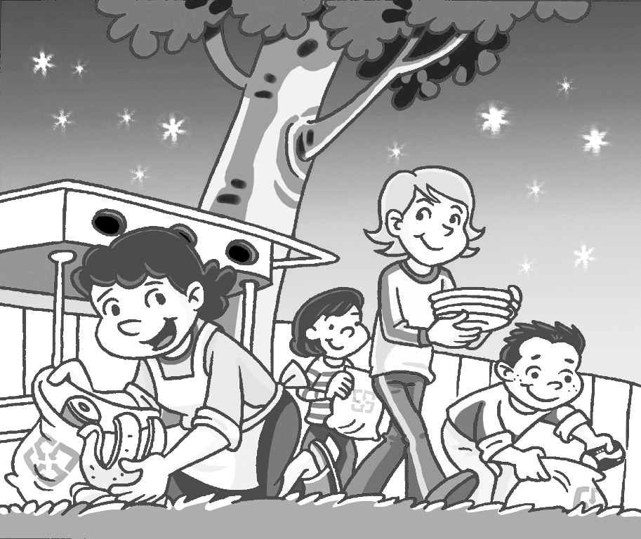
(4) (5)

2008 September
Sun. | Mon. | Tue. | Wed. | Thur. | Fri. | Sat.
(A) watch the full moon (B) play basketball
(C) play dodge ball (D) have a barbecue
(E) play baseball

(1) I ________ on Monday.
(2) I ________ on Saturday.
(3) I _______ on Wednesday.
(4) We _______ on Sunday.
(5) I _______ on Tuesday.

