仁德國小九十七學年度第一學期 英語科期中學力測驗何嘉仁第3冊
四 年 班 號 姓名： 家長簽名

一、聽力測驗：(每題10分)
- (CD曲目4)
Listen and Write 仔細聽，寫出聽到的數字。
(1) (40) | (2) (55) | (3) (30)
(4) (25) | (5) (15)
- (CD曲目5)
Listen and Check 仔細聽，勾選出正確的圖片。
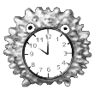
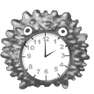
(1)

(右two o’clock)
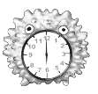
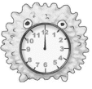
(2)

(左twelve o’clock)
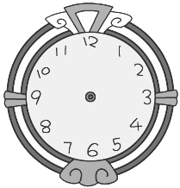
(3)

(左four o five)
(4)

(右three thirty)
(5)
07:50
06:40

(左seven fifty)
- (CD曲目10)
Listen and Circle 仔細聽，圈選出聽到的單字。
(1)
guava
grape

(guava)
(2)
orange
apple

(apple)
(3)
hungry
orange
apples
grapes
bananas
pizza

(orange)
(4)

(grapes)
(5)

(bananas)
- (CD曲目18)
Listen and Number 仔細聽，依序將圖片編號。
  ( 3 ) |  | ( 1 ) |  | 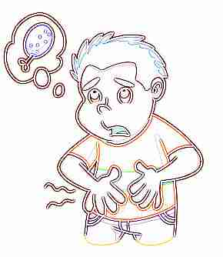  ( 5 )
 |   ( 4 ) |  | ( 2 )

- (CD曲目22)曲目26)
Listen and Check 仔細聽，依錄音內容勾選出適當的答句。
(1)
Yes, it is.
It’s twelve thirty.
(上Yes, it is.)
(2)
Here is some pizza.
Here is some milk.
(下Here is some milk.)
(3)
It’s ten thirty.
No, it isn’t.
(上It’s ten thirty.)
(4)
Sure!
Yes, it is.
(Sure!)
(5)
Here is an apple.
No, not now.
(下No, not now.)

聽力測驗結束 請翻背面繼續作答

二、圈出正確的圖片：(每題2分)
- It’s twelve o’clock. (右)

- It’s eleven twenty. (右)
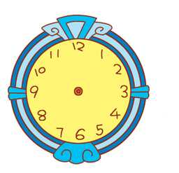

- It’s eight fifteen. (右)

三、圈出正確的單字：(每題2分)
(bad)
 | doll tall
  
  den ten
 | 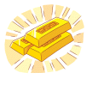  cold gold
  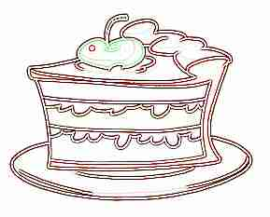
  cake lake
(cake)
四、寫出正確的單字：(每題3分)

__________________
(fifty)
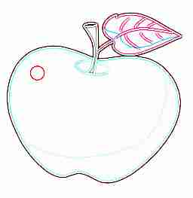

__________________
(fifty-four)
五、重組句子：(每題3分)
- time/What/it/?/is

→______________________________t time is it?
- fifty/./It’s/ten

→______________________________
(It’s ten fifty.)
- is/some/pizza/./Here

→____________________________
(Here is some pizza.)
- thirsty/I/am/.

→____________________________
(I am thirsty.)
六、重組單字：(每題3分)
(thirsty)
- gyhrun

→____________
(hungry)
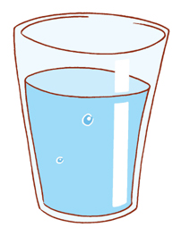
- raewt

→____________
(water)
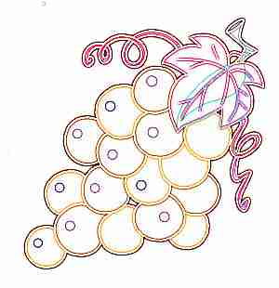
- raspge

→_______________
(grapes)
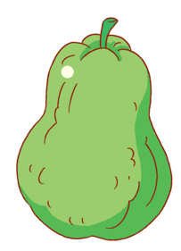
- agvau

→_______________
(guava)
七、勾選出與圖片相符的句子：(每題2分)
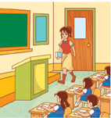
Time for a break

Time for class.
(下Time for class.)


2. No eating.

No drinking.

(下No drinking.)


3.
Do you want some?

What time is it?

(上Do you want some?)

仔細檢查喔 注意字母大小寫和標點符號

