台南縣仁德國小九十六學年度第二期末評量英語科試題
Rainbow English 第八冊 第三、四單元 六年___班 座號：___ 姓名：________

A、Listen and cross out the
pictures. 聽聽看，並將字首
發音不同的圖打X：3﹪×4＝12﹪

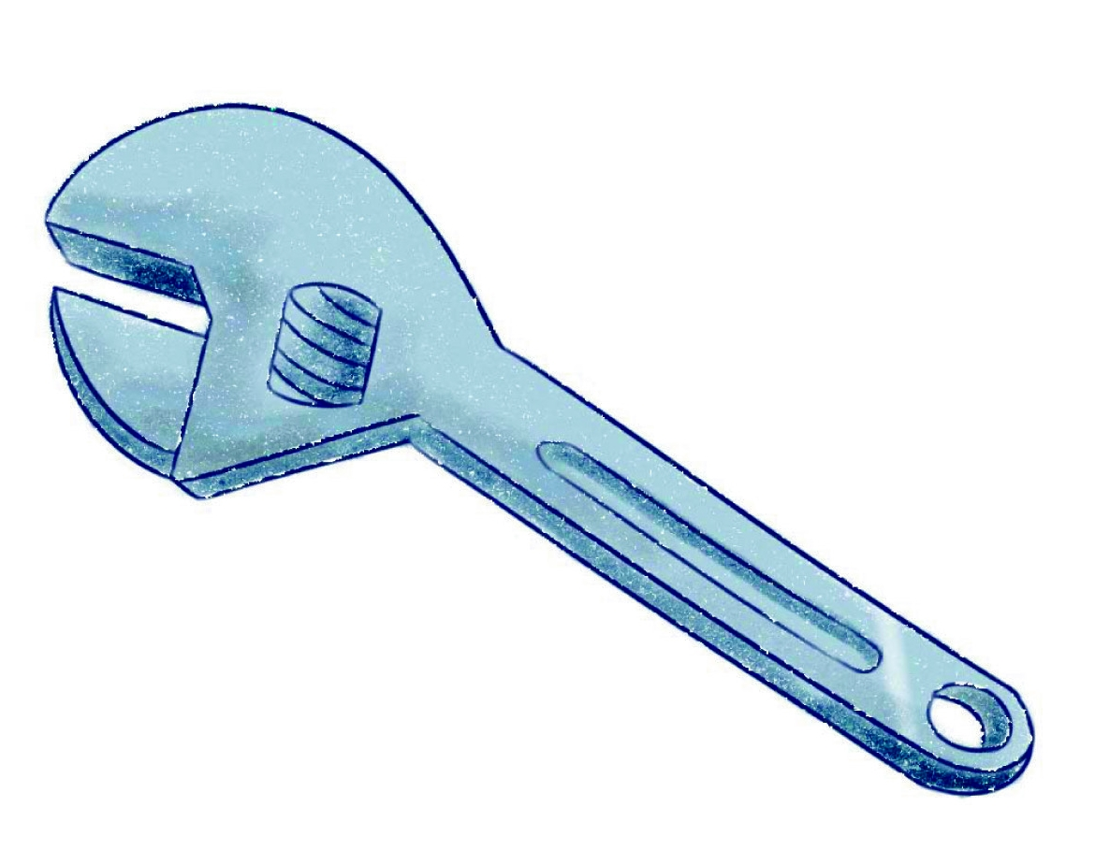



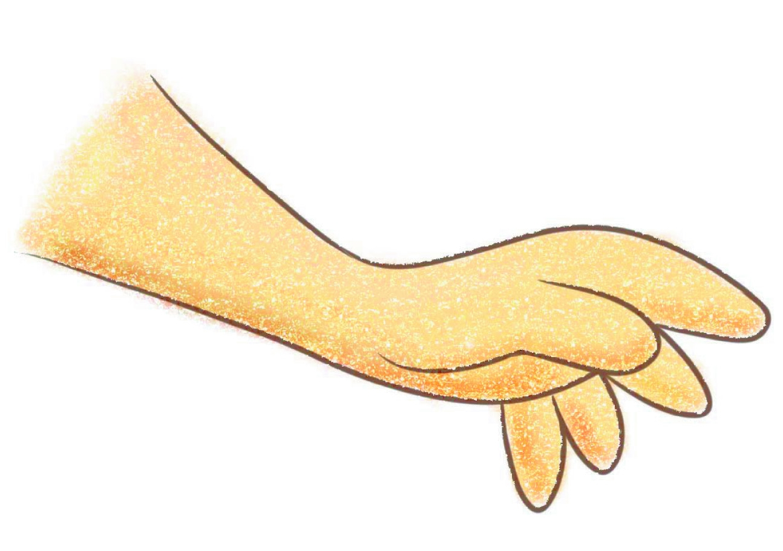
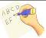

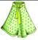
1.

2.

3.

4.

- Listen, match and write.
聽聽看，將圖片填上正確的編號：12﹪


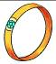


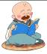
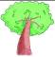
1. 2.
nk
ng
ki_ _
nk
ng
ri_ _
nk
ng
dri_ _
nk
ng
mo_ _
nk
ng
tru_ _
nk
ng
lo_ _

3. 4.

5. 6.

C、

C、Vocabulary單字拼寫： 2%x10=20%
100
80
1. 2.

one ___________ __________

3. 4.
90
60

___________ _________

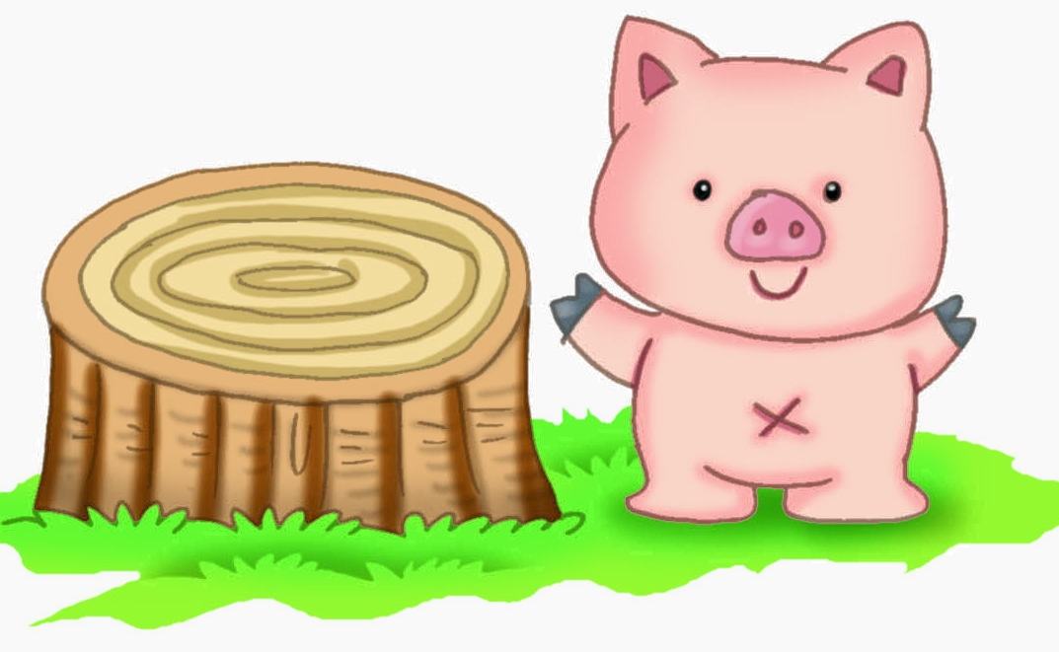
5. 6.
70

__________ _______ to
7.
.. 8.

_____ _______ _____ _______

D. Read and check the right sentence.
對的打○，錯的打x：(3%x6＝18%)
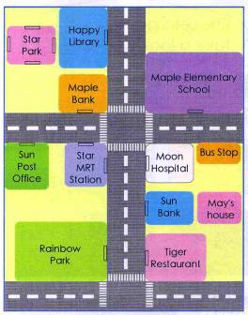

（ ）Moon Hospital is across from Star Park.
（ ）Sun Bank is in back of May’s house.
（ ）Rainbow Park is across from Tiger Restaurant.
（ ）Sun Post Office is next to Star MRT Station.
□Maple Elementary School is in front of Maple Bank.
□Happy Library is in front of Star Park.

- 讀一讀，將文章中缺少的單字填上8%
sale shopping window shoes
It’s Sunday afternoon. Linda and Mary are ________. They like to go shopping very much. Linda sees some great _____ in a _______. They ask the shopkeeper about the shoes. Wow！ They are on_____. Linda is very happy.
F. 選正確答案 (2% x 5=10﹪)
( )1.How much(A)are(B)is
C)do(D)does the egg?
( )2.How much(A)are(B)is (C)does the skirts?
( )3.They are two hundred
(A) dollar(B) dollars
(C) of dollars.
( )4.(A)Is(B)Am(C)Are it two hundred NT dollars.
( )5.How (A) does(B)do(C)is
I get to the library.

G. Read and unscramble.
重組句子 (20%)
1. / Go straight / for
and turn left / two blocks.

2.stand/I/the teacher./ in back of
______________________________________
_____________
3. dollars./ NT / It’s
/two thousand and four hundred
____________________________
_____________________________
4. buy/want to/I/it.
That’s cheap. ________________

5.you should/first/ask Mom/I think
______________________________

