台南縣仁德國小九十六學年度第二學期期末評量英語科筆試試題
命題範圍：Hess Hi! English版第六冊第 U4 單元至第 R2 單元 五年 班 號 姓名：________
第一大題 Read, look and write. (每題2分, 14%)
家長簽章：
請依提示在空格中選填適當的單字,並依句子作適當的變化.
請書寫整齊. 字跡潦草將酌予扣分.
Word bank 參考字彙
do | watch | comb | eat
turtle | play | brush | study

Ex. 例: Bella ( does ) her homework at night.
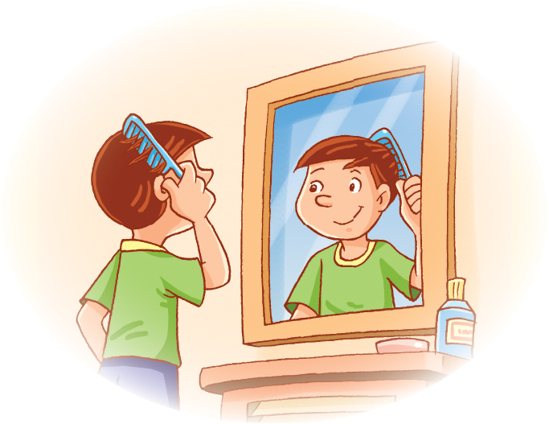
- I ( __________ ) TV at night.
- You ( __________ ) your hair in the morning.
- He ( __________ ) the piano every day.
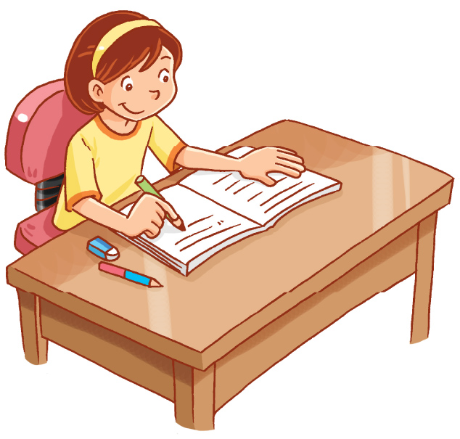
- Maggie ( __________ ) English on Wednesday.
- Willy’s mother ( __________ ) her teeth every day.
- They ( __________ ) breakfast every day.
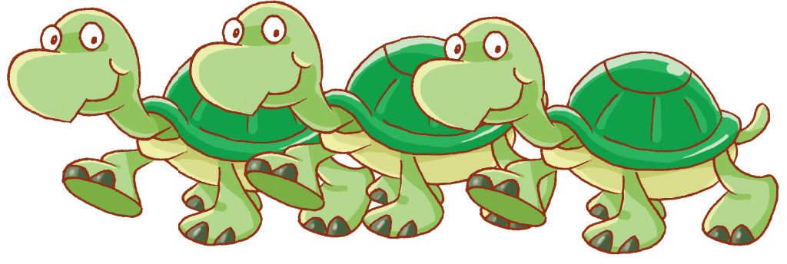
- He has three ( __________ ) .
第二大題 Read, look and write. 請依提示寫出完整答句。 (16%。)
請書寫整齊. 字跡潦草將酌予扣分. 本大題每個字母、標點符號、及空格錯誤各扣一分。
每個單字錯誤各扣二分。十六分扣完為止。

Word bank 參考字彙
at night | in the morning
in the evening | in the afternoon
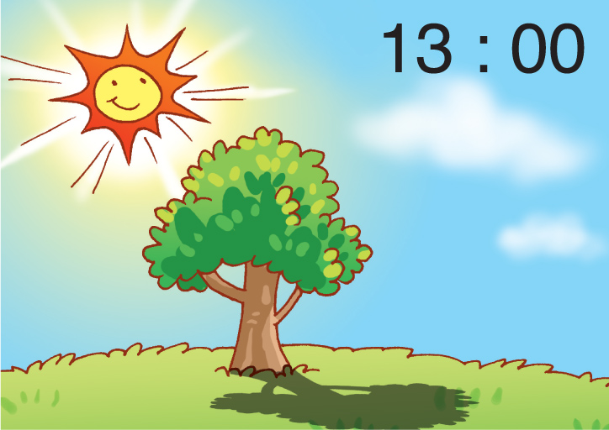
- When do you go home? (10%)

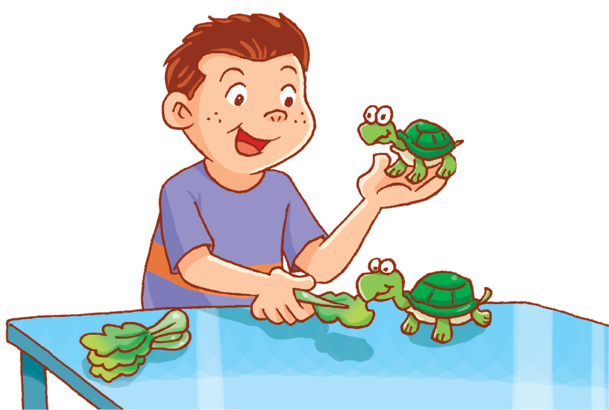
- Does Willy have a dog? (簡答) (6%)

＊ 本試卷共有兩面, 背面還有題目，請翻頁繼續作答！ ＊
第三大題 Listening comprehension. 聽力測驗
Part A Listen and check. 請將正確的答案打勾（每題2分 20%）
  1.（ ） | 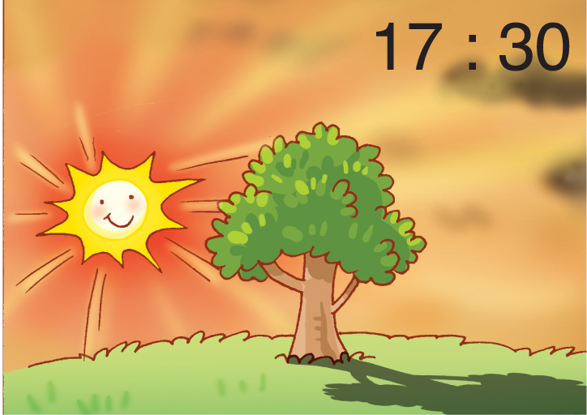  2.（ ） | 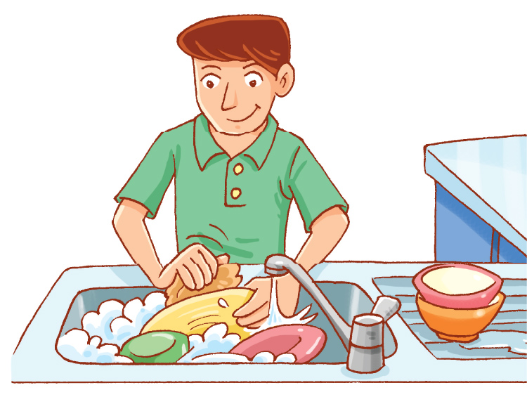  3.（ ） | 4.（ ） | 5.（ ）
（ ） | 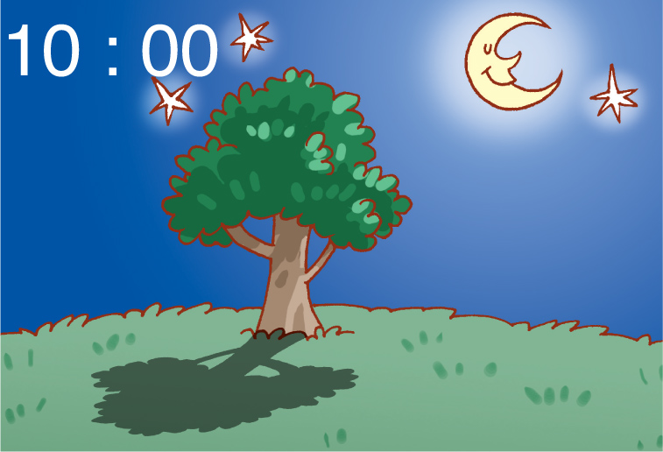  （ ） | 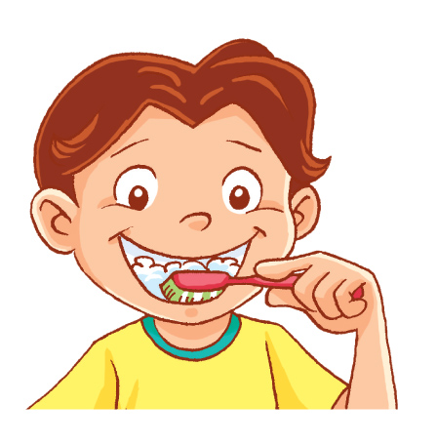  （ ） |   （ ） | （ ）
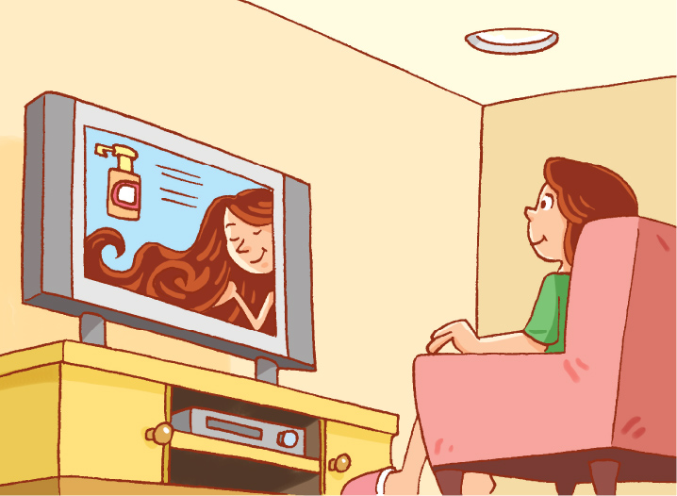  6.（ ） | 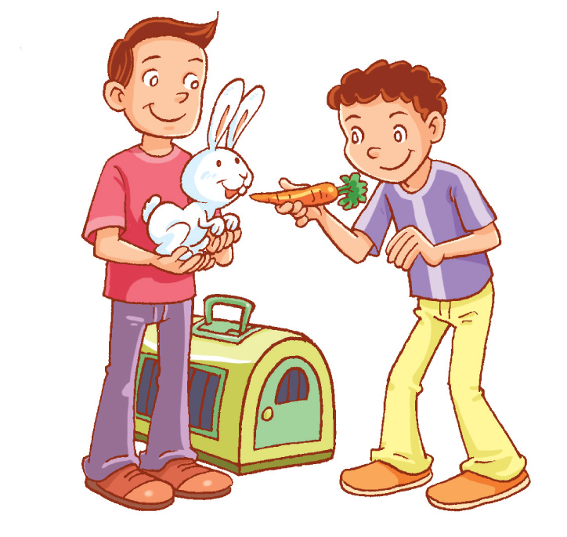  7.（ ） |   8.（ ） | 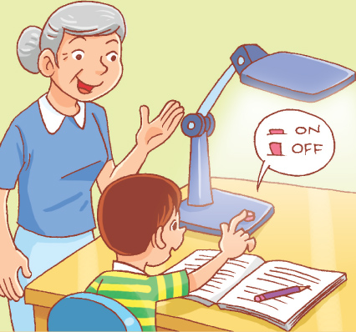  9.（ ） | 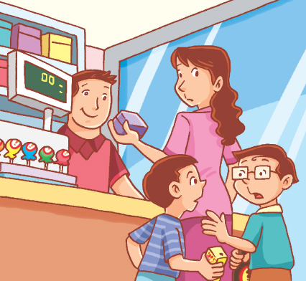  10.（ ）
（ ） | 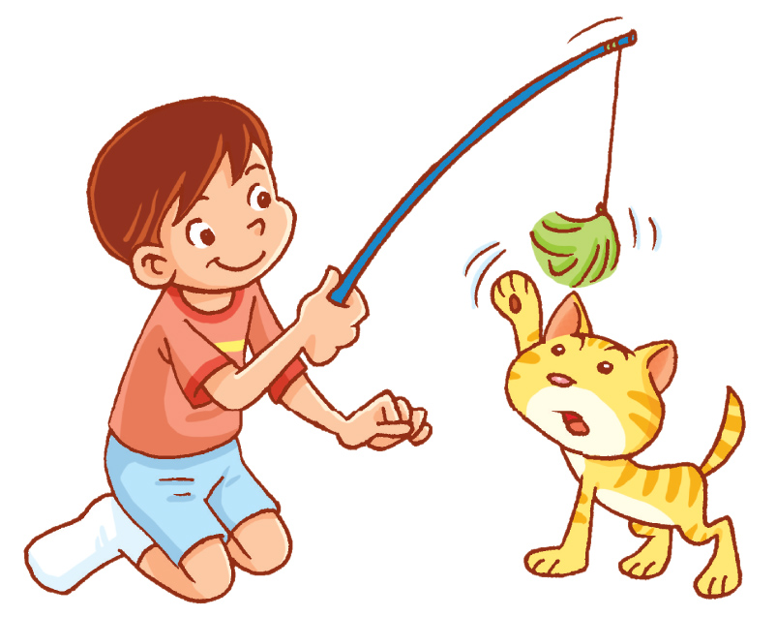  （ ） | 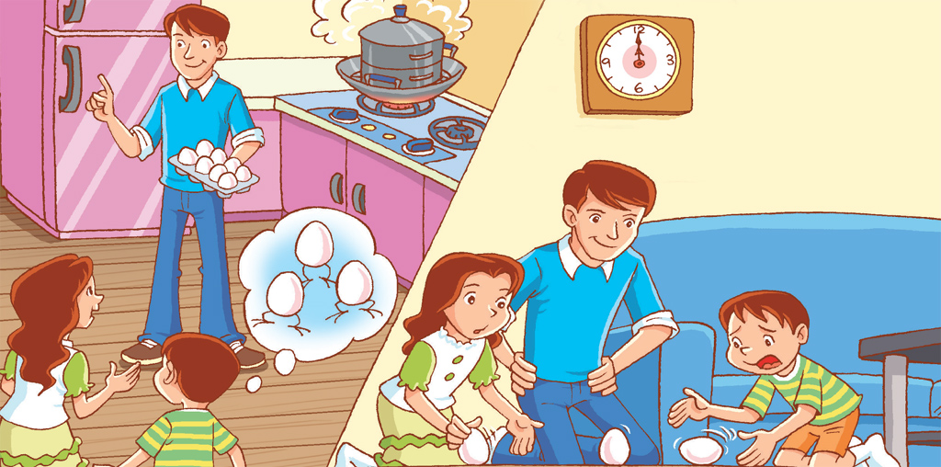  （ ） | 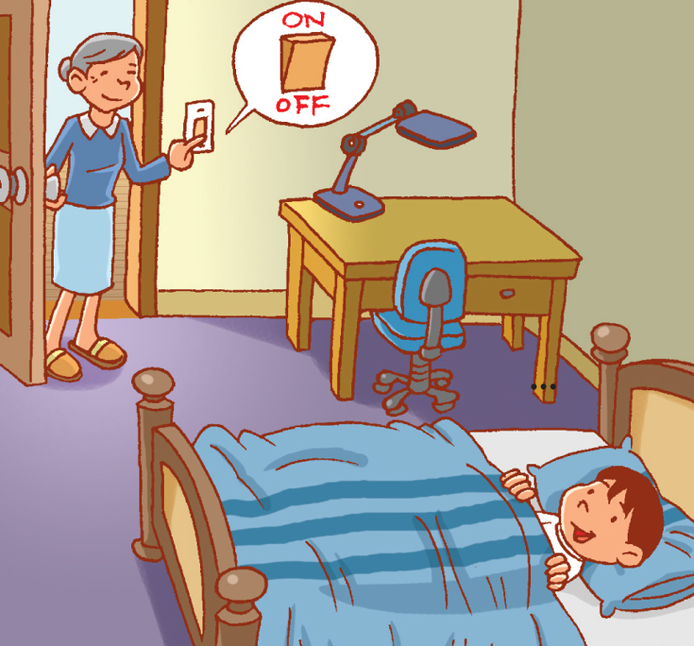  （ ） | 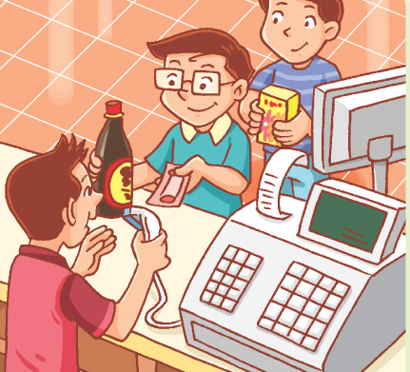  （ ）
Part B Listen and check. 請將正確的答案打勾（每題2分 10%）
1.  ( )price  ( )place  ( )prince  ( )please | 2.  ( )grass  ( )glass  ( )green  ( )grapes | 3.  ( )trash  ( )truck  ( )rain  ( )train | 4.  ( )slide  ( )sleep  ( )sleeve  ( )slow | 5.  ( )brush  ( )brick  ( )prick  ( )pleat

筆試及聽力到此結束，請仔細檢查後再休息哦！☺
台南縣仁德國小九十六學年度第二學期期末評量英語科口試試題
命題範圍：Hess Hi! English版第六冊第 U4 單元至第 R2 單元 五年 班 號姓名：_______
口試Aural test（40%）
No | Contents |  | Evaluation
No |  |  | Excellent  8 | Very good 6 | Good  4 | O.K.  2 | Try harder. 0
1. | When do you do your homework?  (go to sch./comb ur hr/take a shower)  I do my homework in the morning.  (in the mor./aft./eve./at night)
2. | What does A/K do in the afternoon?  (in the mor./aft./eve./at night)  She/He plays the piano in the afternoon.  (walk/w TV/wa dsh/study)s
3. | What do the boys/girls have?  What does he/she have?  They have fish.  He/She has (cats/dogs/rabbits/turtles/birds).
4. | Sound It out. | Good  4 | O.K.  2 | Try harder. 0 | Good  4 | O.K.  2 | Try harder. 0
4. | Sound It out. | ❶ |  |  | ❷
4. | Sound It out. | ⬥ |  |  | 

