仁德國小九十六學年度第二學期期中評量英語科試題
何嘉仁版第二冊第一單元至Review 1 三年 班 號 姓名： 家長簽章:

一、聽力測驗：(每題3分)
- (CListen and Write
仔細聽，寫出聽到的大寫字母。
1. n__p (a) 2. f__n (i) 3. p__n
4. b__ll (e) 5. p__t
- Listen and Number
仔細聽，依序將圖片號。
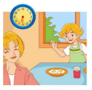  ( 2 ) | 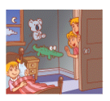 ( 3 ) |  ( 4 )

  ( 5 ) |   ( 1 )

- (
Listen and Circle仔細聽，將聽到的圖片圈起來。
1. |  | (○右)  
2. |  | (○右)  
3. | (○左)   | 
4. | (○左)   | 
5. |  | (○右)  

二、寫出正確的單字：(每題3分)


c
k



r
m

3

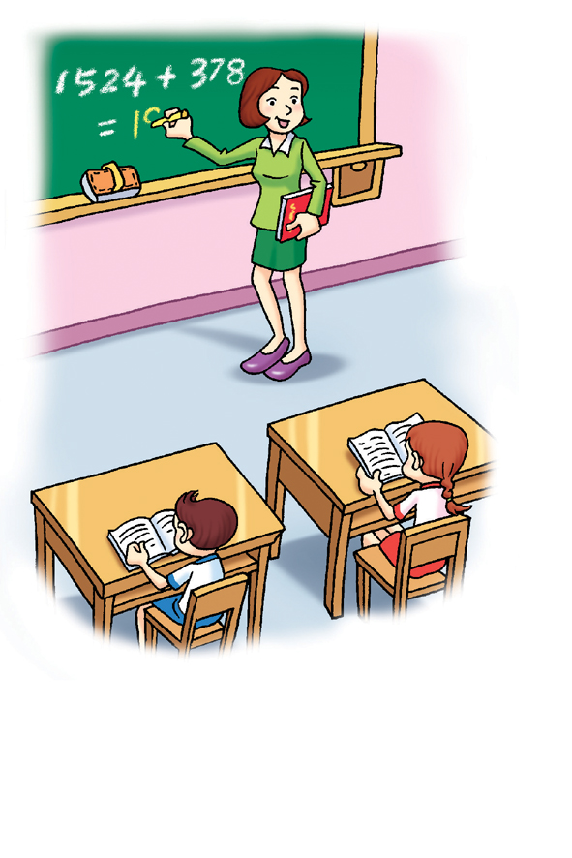
r
t


s
g


r
d

(do
三、將正確的單字打勾：(每題2分)
- 2.


□ ax □ jut
□ ex □ jet
3. 4.


□ map □ in
□ mop □ an
5.


□ bad
□ bed
四、選出正確答案：(每題3分)
- 2.

□ Make a circle. □ Good night.
□ You’re right. □ Pay attention.
3. 4.

□ Raise your hand. □ Line up.
□ Put down your hand. □ Try again
5.
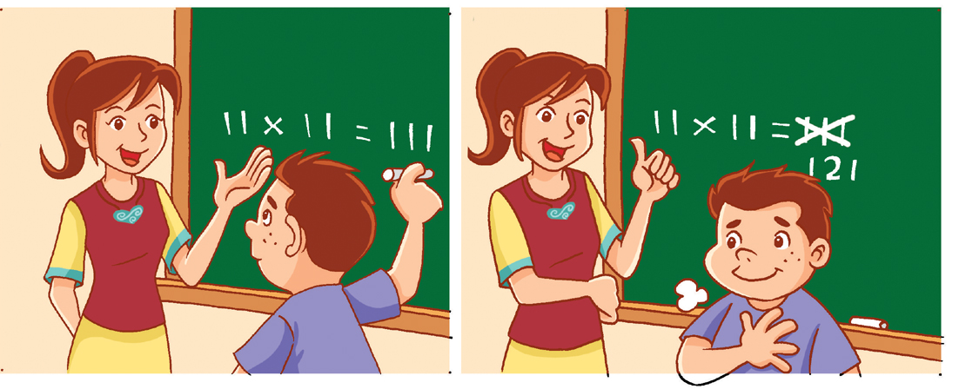
□ Make a circle.
□ You’re right.
五、選出正確的句子：(每題3分)
- ( a ) a. She’s my mother.
. b. She’s my father.
- ( a ) a. Is your father tall?
b. Is your father tall.
- ( b ) a. No, she is. She’s a cook.
b. No, she isn’ t. She’s a cook.
- ( a ) a. My sister is short.
b. My sister is no short.
- ( b ) a. Is he doctor?
b. Is he a doctor?

