台南縣仁德國小九十六學年度第一學期期末評量英語科試題
答案卷
Rainbow English 第七冊第四單元至第五單元 年_____班_____號 姓名：____________

I、Listening 聽力測驗(30%)
家長簽章：

一.圈出正確的單字(8分)
1. 2.
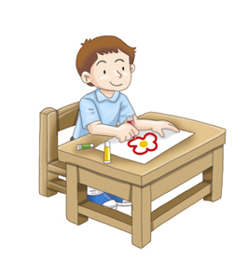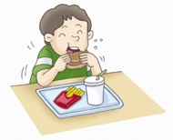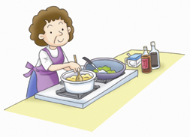

3. 4.
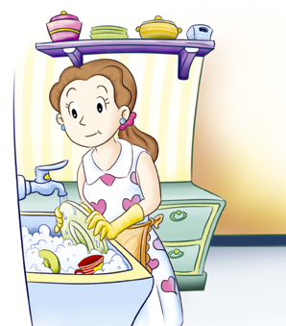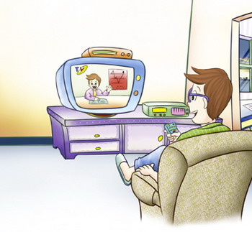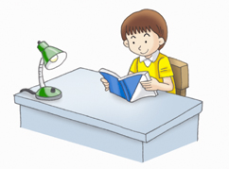

二 、Listen and Cross out(6分)
請將字首的雙連音不同於前面發音的圖片畫×

br
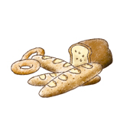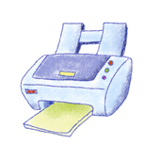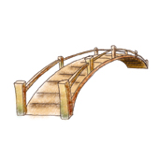

×
dr
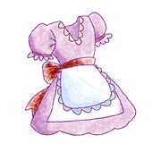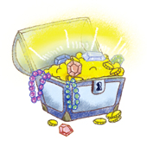

× ×
三、Listen and number. 將聽到的對話順序寫出(8%)

2-1-4-3

四. Listen and circle. 聽聽看,並圈出所聽到的答案 (8%)
- My mom and dad (is, are) cooking.
2. My (mom, dad) and I are watching TV.
3. Are Betty and Ken (laughing, eating)?
- Tina and May are (drawing, crying).

聽力原稿
一.1.drawing a picture
2.cooking
3.listening to music
4.watching TV

二.1. bread printer bridge
2.dress train treasure

三、1.What are they doing up there?
2. I’m not sure.
3. What are you doing, girls?
4. We’re dancing.
四. 1. My mom and dad (is, are) cooking.
2.My (mom, dad) and I are watching TV.
3. Are Betty and Ken (laughing, eating)?
4.Tina and May are (drawing, crying).
II、寫出圖片的單字 (12分)
- cleaning my room
- reading a book / doing my homework
- dancing
- laughing
- singing
- watching TV
III. Choose the correct answer 選擇題 (14%)
- a
- b
- b
- b
- a
- a
- a
IV. 將下列人名以改為人稱代名詞(注意大小寫)(6%)
  - You
  - We
  - They
V. 找出句中錯誤的單字, 並寫下正確的(8%)
- do—are
- Is—Are
- draw-drawing
- dance-dancing
VI、寫出完整的句子。(共15分)
1.I am reading a book.
2. Is Tom washig the dishes?
3. What is Tina doing?
4. Are you drawing a picture in your room?
5. They are cooking in the kitchen.
VII、回答下列的問題。(共15分)
- Yes, he is.
- No, he is not. He is doing homework.
＝No, he is doing homework.
3. They are eating.
4. No, they are singing.
5. They are cooking.

