台南縣仁德國小九十六學年度第一學期期中評量英語科試題
Rainbow English 第七冊第一單元至第三單元 年_____班_____號 姓名：____________

I、Listening 聽力測驗
家長簽章：
一.圈出正確的單字(8分)
1. 2.


3. 4.
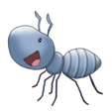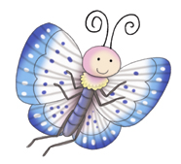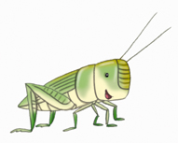

二 、勾選出正確的單字圖 (12分)
1. the words that begin with “pl”

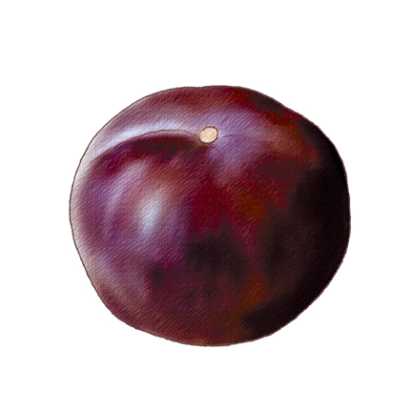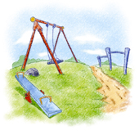

2. the words that begin with “cl”

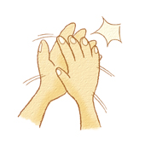

3. the words that begin with “gr”

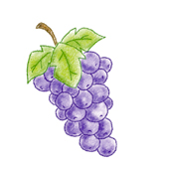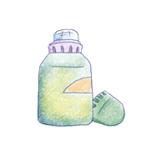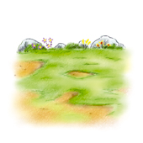

三、Fill in the numbers. 聽聽看，將正確的號碼填
入空格中(10分)

1. 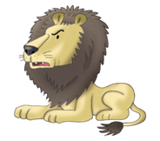 2.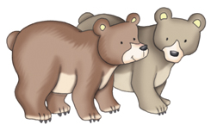 3.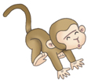 4. 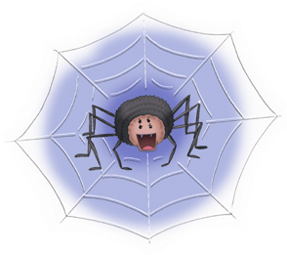 5.

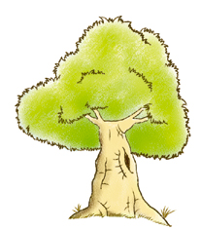

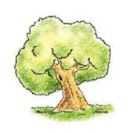


II、寫出圖片的單字 (12分)
1. 2.


_____________________ ________________________

3. 4.

______________________ ______________________

5. 6.

______________________ ______________________

III. 看圖，並選出符合的句子 (共12分)

1.( )

(A) There are ants in the rocks.
(B) There are ants between the rocks.
(C) There are ants on the rocks.

2.( )
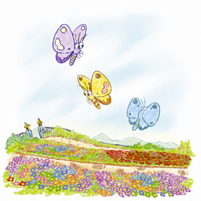
- There are three spiders in the sky.
- There are three butterflys in the sky.
- There are three butterflies in the sky.
3. ( )
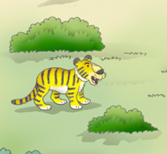
Q: Is there a tiger on the grass? A:________.
(A) Yes, there is.
(B) No, there isn’t.
(C) No, there is a bear on the grass.

4. ( )
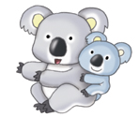
Q: Are there monkeys in the tree? A:________.
- Yes, there are monkeys in the tree.
- No, there are koalas in the tree.
- No, there ae bears in the tree.

5.( )
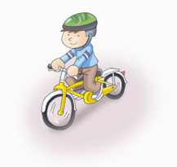
Q: Do you take a trip on the weekend? A:_________
(A) No, I don’t.
(B) Yes, I do.
(C) No, she doesn’t.

6.( )
Q: _____________ A: Yes, she does.
(A) Do you ride your bike on the weekend?
(B) Does she ride a bike on the weekend?
(C) Does she take a trip on the weekend?

IV、圈入正確的字 (16分)
1. There is (a / an) bee in the box.
2. There are (an / many) spiders in the tree.
3. ( Is / Are) there bears in the zoo?
4. How many (koalas / koala ) are there in
the zoo?
5. Is there a butterfly in the sky? Yes, there (is / are).
6. (Do / Does) you take a trip on the weekend?
7. (Do / Does) she watch TV(看電視) on the weekend?
8. Yes, I (do / does). I ride my bike on the weekend.

V、寫出完整的句子。(共15分)
1. in the there is zoo. a

_____________________________________________
2. six There are in the tree.

______________________________________________


3. There is on the flower. a

______________________________________________

4 . I / / on the weekend.

______________________________________________
5. You / / on the weekend / ?

______________________________________________

VI、回答下列的問題。(共15分)

1. How many ants are there ?

_________________________________________

2. Is there a bug on his hand? (肯定簡答)

_____________________________________________

3. Is there a tiger on the grass? (否定簡答)

__________________________________________
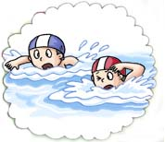

4. What do you usually do on the weekend?

_______________________________________________

5. What do you usually do on the weekend?

_______________________________________________

Good luck.

